Mozart’s Magical Flute
A Didactic to Living Life as the Path to Initiation

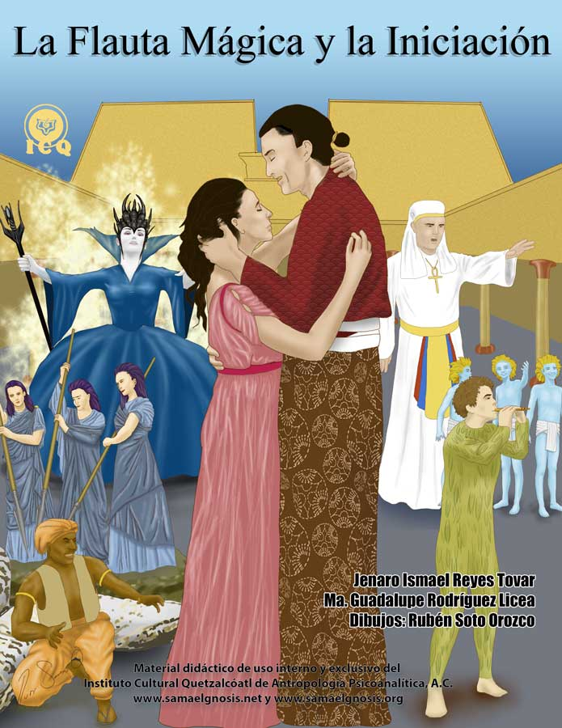

Text
Jenaro Ismael Reyes Tovar and
María Guadalupe Rodríguez Licea

Cover and Pictorials
Rubén Soto Orozco

Translation
Ricardo Santana-Laracuente

© All rights reserved, January 2017.
Registry Number: …

Didactic material for the exclusive use of the students of the
Quetzalcoatl Cultural Institute (ICQ) of Psychoanalytical Anthropology, A.C.
www.samaelgnosis.net
www.samaelgnosis.org
www.samaelgnosis.us

The content of this book is based on the spoken works and the writings of Master Samael Aun Weor.

This work is the result of disinterested effort and dedication of gnostic instructors and volunteers who make up and support the Quetzalcoatl Cultural Institute of Psychoanalytical Anthropology, who work for the common good and the end of suffering of humanity.

The Magical Flute (Die Zauberflöte) is a popular opera (singspiel) comprised of two acts. Music composed by Wolfgang Amadeus Mozart on a script by Emmanuel Schikaneder. The Magical Flute was first performed on September 30, 1791.
Table of Contents

INTRODUCTION 7
A Summary of Mozart’s Magical Flute 7
Overture 7
A Word of Caution 9
Chapter One – The Power of the Word 11
The Three Ladies 13
Papageno 16
Who Are We? 17
Lie and Deceit 18
The Punishment of Papageno 18
The Portrait 19
The Queen of the Night 21
Truthfulness 22
The Golden Flute and the Silver Carillon 23
Three Boys 25
Chapter Two – Love and Desire 27
Monostatos and Papageno 29
Papageno has no Papagena 29
Love, the Threshold to Divinity 31
Chapter Three – The Three Temples 34
The Relationship between Spiritual Maturity and the Three Virtues 35
The Three Paths 37
The Eternal Night 39
The Sounds of the Golden Flute and the Silver Carillon 40
Sarastro Arrives 41
Pamina and Tamino 42
The Tests Begin 43
Chapter 4 – Osiris and Isis 44
The Triumph of the Being 45
The Three Factors of the Revolution of the Consciousness 46
The Deceit of Society 47
Tests We Receive in Life 47
The Guru or Spiritual Guide 48
Isis and Osiris 48
Chapter 5 – The Test of Silence 51
Our Mission in Life 52
The Internal Silence 53
Eve-Venus 53
Venus-Eve 53
Venus-Urania 53
Urania-Venus 53
Temptation 54
Chapter 6 – Vengeance and Forgiveness 57
The Astral Light 58
Vengeance 59
Forgiveness 60
Chapter 7 – Temptation is Fire 63
Papagena 64
The Bread of Substance 65
The Wail of Pamina 66
Chapter 8 – Admission into the Mysteries 69
The Guardian of the Threshold 71
The Suffering that Comes from Impermance 74
Chapter 9 – Free Will 77
Chapter 10 – Senselessness 81
The Silence of the Mind 82
Arcanum 21 – The Fool of the Tarot 83
A Talisman of Protection 86
Chapter 11 – The Tests of the Four Elements of Nature 87
Overcoming the Fear of Death 88
The Four Tests at the Times of Ancient Egypt 88
The Same Tests, Here and Now 90
Woman, Love and Gnosis 90
The Qualities of the Sphynx 92
The Test of Fire 93
The Test of Air 94
The Test of Earth 95
The Test of Water 96
Chelas or Lanus 97
Chaper 12 – Papageno and Papagena 98
Mantra for the Development of Clairvoyance 101
Chapter 13 – The Temple of the Sun 103
The Ray of Cosmic Justice 104
The Death of the Ego 105
The Temple of the Sun 105
The Supreme Crown 106
Appendix A – The Path of Initiation 108
The Trials of the Guardian of the Threshold 108
The Trials of the Hall of Fire 108
The Tests of the Four Elements 108
The Probationary Path 108
The Three Mountains 108
Appendix B – The Gnostic Myth 109
Supreme Divinity 109
Emanation and Pleromatic Fall 109
Architectural Demiurge 109
Pneuma of the World 109
Dualism 109
Savior 109
Return 109
Appendix C – The Twenty Two Arcana of the Tarot in the Magical Flute 110
Arcanum 1 – The Magician 110
Arcanum 2 – The Priestess 110
Arcanum 3 – The Empress 110
Arcanum 4 – The Emperor 110
Arcanum 5 – The Hierophant 110
Arcanum 6 – The Indecision 110
Arcanum 7 – The Triumph 110
Arcanum 8 – Justice 110
Arcanum 9 – The Hermit 110
Arcanum 10 – Retribution 110
Arcanum 11 – Persuasion 110
Arcanum 12 – The Apostolate 111
Arcanum 13 – Immortality 111
Arcanum 14 – Temperance 111
Arcanum 15 – Passion 111
Arcanum 16 – Fragility 111
Arcanum 17 – Hope 111
Arcanum 18 – The Twilight 111
Arcanum 19 – Inspiration 111
Arcanum 20 – Resurrection 111
Arcanum 21 – Transmutation 111
Arcanum 22 – The Return 111
Appendix D – Comments from VM Samael Aun Weor 112
Bibliography 114

INTRODUCTION

The Magical Flute is a fusion of ancient and sacred teachings where we find elements of kabbalah, magic, alchemy, hermetic philosophy, and the psychology of self-knowledge, all delivered in an inspirational environment of musical tones and harmonies that nourish the superior emotional center of man. Mozart’s work synthetizes the teachings that are necessary to discover the path that leads us out of our spiritual darkness and into the light of the Spirit.

The Magical Flute offers the sincere seeker the means to find the secret and mysterious path of initiation and brings back into the light immortal wisdom, by giving the listener all of the elements necessary to live life with intensity, with the ultimate purpose of rising to a state of self-perfection.

Each scene shows both, the psychological defects that have become obstacles and the virtues we must develop in an effort to find the hermetic path that for long has been meant only for a selected few.

A Summary of Mozart’s Magical Flute
Somewhere in the lands of Egypt, a Japanese prince of name Tamino is being chased by a terrible serpent and when the serpent is about to take his life, Three Ladies armed with silver spears come to his rescue. These women are servants of the Queen of the Night, a woman characterized mostly by her ability to deceit. A solar priest devoted to the cults of Isis and Osiris, of name Sarastro, decides to separate Princess Pamina from her mother, the Queen of the Night.

Through her misleads and lies, the Queen of the Night convinces Prince Tamino and a bird-catcher of name Papageno to rescue her daughter, while providing them with a golden flute and a carillon of silver bells. This work represents the ways and means in which we should incarnate what all wise men have referred-to as “the Truth” and achieve our mission and our purpose on life itself.

Realizing they had been tricked by the Queen, Prince Tamino and Princess Pamina decide to join the devotional practice to the Gods Osiris and Isis (the internal divine Father-Mother) but to do so they must face and successfully overcome a series of tests – all metaphors of the many adversities we find in our lives.

Noteworthy of Mozart’s masterpiece are the sacredness of sound, the power of the word, love as the means to overcome the force of evil, and the veneration to the wisdom of the internal Father-Mother as the key to escape ignorance. The Magical Flute highlights the superior virtues that must be developed as well as the internal power that exists in potentiality within every human being; a power that when put to adequate use, enables both man and woman to regenerate and rise victorious, like a Phoenix from the ashes of suffering.

Overture
Mozart opens Act One with five solemn and distinct sounds that are more of a secret invitation for the audience to seek the mysteries of the secret path. That is because “five” is of Kabbalistic significance as it stands for “rigor”, “teaching” and “the law of action and consequence (karma)”. As an invitation, these five sounds suggest “all things must be done in accordance to a superior law” which for the sincere seeker means to walk the path of life as a means to reach the internal initiation we must life live on a conduct that is both edifying and essentially dignifying.

The music envelops the listener with its sacred sounds and midway through the overture there are nine other sounds that repeat throughout key stages of Mozart’s work. As with the number five, Kabbalah relates the number nine to the “mysteries of the ninth door”, or the hermit of the Egyptian Tarot which is the work of initiation and the transmutation of the creative force that brought us into existence.

The overture concludes with three key sounds associated with the three primary laws of creation.

In the context of Kabbalah, the collection of these five-, nine- and three-sounds offer a superior teaching to the sincere seeker that could be synthetized as follows: “live life uprightly (five-) and walk through the ninth door so you can realize the work of the alchemist (nine-), which will result you incarnating the divine trinity of the Father, the Son and the Holy Spirit (three-sounds)”.

One stands in ecstasy when listening to The Magical Flute of Mozart, which reminds us of an Egyptian initiation.
(Samael Aun Weor, 1953)

Mozart effectively portrays the sacred mysteries in the light of the ancient Egyptian culture, whose origin lies within the teachings of the ancient Atlanteans.

We invite you, dear reader, to accompany Prince Tamino and Princess Pamina with enthusiasm and faith, as theirs’ is your very own path towards self-realization.

A Word of Caution

The characters on Mozart’s Magical Flute should not be seen or considered literal or historical, but as symbols of emotions, sentiments and thoughts; they stand for defects, passions and virtues. We should make an effort to keep ourselves from seeing them as a representation of an event that took place somewhere in a time past but rather, see them as a reflection of our individual and particular psychological space, here and now.

There are both negative and transcendental and divine forces in a constant battle to conquer the internal universe of the human being. These forces are symbolized, passively, by the black and white elements of a chess board and actively, in the sacred ball games of the cultures of Mesoamerica. Black and White just like Light and Darkness, are the animic powers of good and evil that palpitate within each one of us.

So to provide our readers with a frame of reference, we offer a brief description of the meaning of each character as this may help facilitate the understanding of the teaching, offered by Mozart’s work in the light of Gnosis:

The Queen of the Night
Queen of the forces of darkness and evil. She is fanaticism, ignorance and mistakes; the negative forces of the moon.

Sarastro, the Solar Priest
Divine Law. The positive solar force.

Princess Pamina
Daughter of the Queen of the Night. The virtues of the soul, love, kindness, courage. The Spiritual Soul.

Papageno, the Bird-Catcher
The human being who is satisfied living a life that is constructive but with no spiritual longings.

Monostatos, a servant of Sarastro
The human being who lives in delinquency, steals, lies, adulterates. It is lust, violence and animal passion.

Three Ladies, servants of the Queen of the Night
Symbol of the creative power that can be used to redeem or degenerate the human being.

Three Boys, guides of Tamino and Papageno
The awakened consciousness, the Voice of the Silence. The elemental forces of nature.

The Golden, Magical Flute
It is a symbol of wisdom, gnosis. The magnetic, masculine force.

The Silver Carillon
Comprehension and love. The magnetic, feminine force.

We encourage the reader to listen to each of the corresponding elements of Mozart’s work (acts, duets, arias, and choirs) and accompany Mozart’s work with the reading of this book, as it will serve as a complement to penetrate the realms of sacred sound and gnostic wisdom in vibrant harmony.

Chapter One – The Power of the Word
Act One, Scene 1

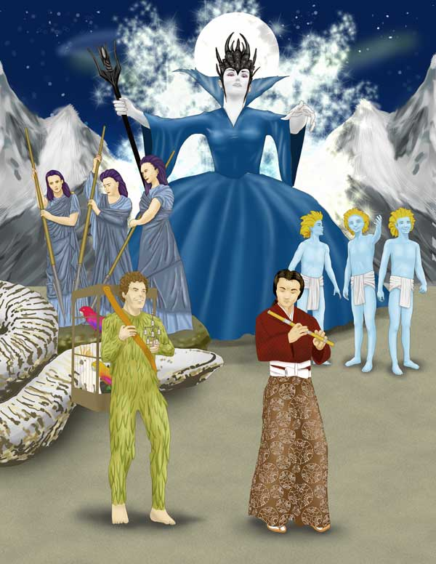

Throughout all ages and history across the world we find in every legend, fairy tale, story, and especially in every sacred text, the eternal battle between good and evil. It should be of no surprise that this incessant battle described by the wise, great masters of humanity, takes place within the depths of our yet-to-be-explored internal universe.

These forces of light and darkness are represented by two temples in Mozart’s Magical Flute; one of them is dedicated to the Moon – led by the Queen of the Night – and the other, dedicated to the Sun and led by the Solar Priest Sarastro.

Sun and Moon have served as main symbols for mankind and the sincere seeker must rely on their intuition (a faculty of the heart) to comprehend them. Obviously, the solar ideals represented by Sarastro are the ones that guide the practitioner through a path of righteousness, wisdom, kindness, love, and truth, while those of the Queen of the Night invite vengeance, hatred, and rancor and represent the many psychological defects we carry within.

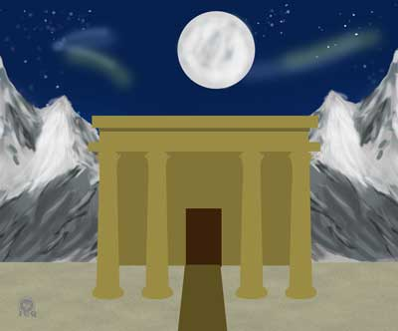

If the reader were to use their creative imagination, they would be able to transport themselves to an enigmatic land of Ancient Egypt and see themselves before a Temple between mountains of rock, with nothing more than a few scattered trees; this is the domain of the Queen of the Night. This atmosphere of mystery suggests there is a need to inquire about the sacred secrets of self-knowledge.

Mozart’s Magical Flute begins in such a location because the temples of mysteries are raised in areas where rocks are visible and prevalent, just as “chiseling the rock” is the work taught by the Apostle Peter (Peter is the modern name for Patar, which means “stone”); a superior work of transmutation of our creative waters.

In his work Parsifal Unveiled, Master Samael Aun Weor speaks of the Temple of the Holy Grail:

The place of the scene, rather than gloomy is severe and mysterious…
The indispensably austere, rock-strewn ground, in accordance with initiatic traditions, shines in the center, in a very clear space.
(Samael Aun Weor, 1971)

The great master Jesus makes use of his parables to provide clarity on why the great work must be based on the “stone”; he makes reference to a man who builds his house on a foundation of stone and not on [an unstable] foundation of sand. The sand stands for our intellect and theories, as it is irrelevant how much we may read; if the teaching is not put into practice, the strong winds and floods of adversity will inevitably lead us into failure.

In the Magical Flute, a giant snake threatens Prince Tamino who holds a bow on his hands but he carries no arrows:

TAMINO:
Help me! oh, help me! or I am lost,
condemned as sacrifice to the cunning serpent –
Merciful gods! It’s coming closer!
Ah! save me, ah! defend me!
(Mozart & Schikaneder, 1791)

The characters in the Magical Flute are representations of our behaviors and ways of being; they are a representation of ourselves before the circumstances of life, all symbols of our Level of Being and perhaps, the spiritual development we have achieved.
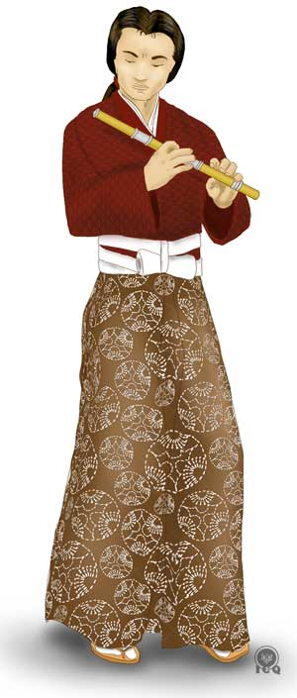
Tamino is the sincere human being who seeks the path of Truth and who longs to be reunited with divinity. As the human being who strives to return to the light, he is a rather rare character in the world we live in; he is the prototype of the human being we long to become and to whom gnosis is meant to be given.

Though unarmed, Tamino makes an effort to fight the negative serpent – the Midgard Serpent of the Nordic Eddas, which according to the Prose Edda Old Norse writings (Sturluson, 1220), is the serpent before which the world succumbs. This serpent is a crude reality of our time, a symbol of the brutal passions that exist within each and every one of us and, in spite of the Prince’s best efforts, he is unable to fight it because he has “no arrows”; just like many of us, Tamino lacks the knowledge and the necessary instruments to fight.

This is the same condition of the sincere human being who makes an effort to fight his brutal passions but lacks the science and the keys of gnosis to be triumphant. However, Tamino’s effort is worthy of reflection, as he acknowledges his shortcoming and implores the help of the gods; which is a level of sincerity we must embrace. We must make an effort to avoid being proud and arrogant, to recognize our internal misery and acknowledge we are in need of help from a force that is both superior and exists beyond the mind, asking of it with all the strength of our soul and our heart.

Tamino gives his best fight but falls defeated – unconscious – before the serpent.

The Three Ladies
From within the temple three women emerge, their faces veiled, each one carrying a silver spear and together, they valiantly attack the serpent, killing it.

THREE LADIES:
Die, monster, by our power!

Victory! Victory!
Accomplished is the heroic deed!
He is free, thanks to our bravery.
(Mozart & Schikaneder, 1791)

Alchemy, Kabbalah and the science of numbers allow us to understand the meaning of these symbols.
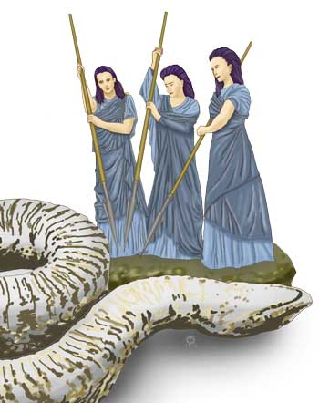
The Number 3 is present throughout Mozart’s work as it is a representation of material and spiritual production, creation, aesthetics, art, the Celestial Mother, creative power, and the Holy Spirit. The number three will assume any of these meanings depending on the message that is interpreted.

Alchemically, the metal of silver represents the woman and the feminine forces in action, which means the spears are symbols of the adequately transmuted sexual libido when it is used to destroy the “serpent” of our animal passions.

Last, the women are veiled with the “veil of the mystery”, a representation of the veil of the goddess Isis (our Divine Mother) which can only be removed by those who have learned to have complete dominion over themselves.

These three women are a symbol of the creative forces that brought us into existence, they are the force behind the creation of worlds, beasts, men, and universes and as the most powerful force in the infinite cosmos, the force that can be used to either liberate man from the tenebrous serpent, or a force becoming an instrument of self-slavery that would ultimately bring us misery and suffering.

In Mozart’s work, these three women represent the power of the forces of creation, capable of destroying the “serpent” of our animal passions and they also represent chaos when the forces are used incorrectly; as shown by the conflict amongst them when they argue over who should stay behind taking care of the unconscious Prince. The fascination they experience with the beauty of the Prince is a reflection of the effect of the inadequate use of the sexual force.

FIRST LADY (observing him)
A pleasing youth, gentle and fair!

SECOND LADY
The fairest I have ever seen.

THIRD LADY
Yes, that’s true, pretty as a picture.

ALL THREE
If I ever gave my heart away,
it could be to none but this youth.
Let us hasten to our Queen and report this news to her.
Perhaps this handsome man can restore her peace of mind.

FIRST LADY
You go and tell her, then;
meanwhile, I’ll stay here. –

SECOND LADY
No, no, you go ahead;
I’ll keep watch over him!

THIRD LADY
No, no, that may not be;
I’ll protect him!

FIRST LADY
Meanwhile, I’ll stay here...

SECOND LADY
I’ll keep watch over him...

THIRD LADY
I’ll protect him myself...

FIRST LADY
...I’ll stay...

SECOND LADY
...I’ll keep watch...

THIRD LADY
...I’ll protect him...

FIRST LADY
...I!

SECOND LADY
...I!

THIRD LADY
...I!

ALL THREE (each to herself)
Then I must go! Aha, very nice!
They want to be alone with him.
No, no, that’s out of the question!
What would I not give to live with this youth!
If only I had him to myself!
Still no one goes; it is not to be.
I had better go.
O youth so fair and loveable,

O faithful youth, farewell until I see thee again.
(Mozart & Schikaneder, 1791)

The Three Ladies finally part towards the doors of the temple and leave Tamino behind, unconscious, and soon after he awakens. He notices the dead serpent at his feet and hears the approaching music of a pan flute; it is Papageno the Bird-Catcher who, dressed like a bird, walks playfully and singing. Papageno carries a bird cage on his back, which he intends to deliver to the Queen of the Night at the temple of the Moon, in exchange for wine, bread and figs.

Papageno
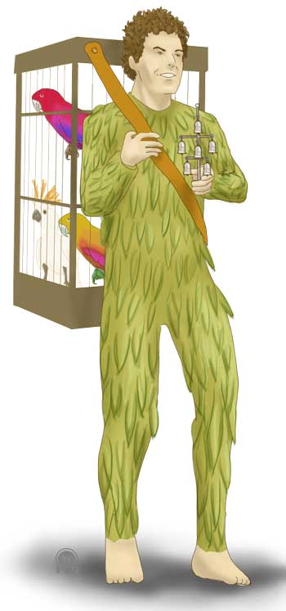
Papageno is the human being who seeks to do well, to live life without committing any crimes and who strives to be a good housekeeper, but with no spiritual longings. He is a symbol of those who take care of their duties at home; good parents, good children, good citizens, but who have no interest in pursuing the internal revolution that comes from the work in the secret path of initiation.

His clothing is made of feathers because it symbolizes of the exaggeration of our animal nature. Based on his singing, his interest is limited to that of finding a woman who can spend the rest of her life with him, but shows no interest at all in anything of a mystical or transcendental nature.

PAPAGENO:
The bird catcher am I – and always merry, tra la la!
As the bird catcher I am known by old and young throughout the land.
I know how to set decoys and whistle just like my prey!
So merry and carefree can I be, knowing all the birds belong to me.
The bird catcher am I – and always merry, tra la la!
As the bird catcher I am known by old and young throughout the land.
I wish I had a trap for girls –
I’d catch them by the dozen then.
I’d keep them in a cage at home, and all the girls would be mine alone.
If all the girls were mine alone, some I’d trade for high-grade sugar, then to the one I liked the best I’d give all the sugar she wanted.

And if she then kissed me tenderly, she’d be my wife and I her husband.
She would sleep beside me and I would rock her like a child.
(Mozart & Schikaneder, 1791)

Papageno’s aspirations outline the Arcanum 6 of the Egyptian tarot, he is the lover and his only longing is that of a wife, but for no superior motive.

Who Are We?
Tamino takes shelter and listens to Papageno’s joyful music then, realizing there is no danger, comes to greet him. “Who are you?” He asked, to which Papageno replies “I am a simple human being, like everyone else”. As Tamino presents himself, he interjects stating he is important: he is the son of a King, a ruler of many counties.

Here the Magical Flute starts unveiling the fundamental requirements for the work of initiation; we cannot aspire to see the blossoming of the divine wisdom of Gnosis if we still do not know who we are, just as if we are still fooled by the false concepts of self, portrayed by both the simple person of Papageno and the “important” persona of the Prince. Both replies are inherently superficial, vane and hollow of any true significance.

We tend to allow our psychology to rest on the foundation of our own considerations; we tend to believe we are important because we may exercise certain control over people, as Tamino does, and think that power is a representation of ourselves; yet these things are of no relevance to the spirit. On the other hand, the ignorance of Papageno (as he is unaware of anything that happens in these locations and is even ignorant of his own birth) is the very ignorance of us as a humanity; we know nothing about things which are transcendental in nature.

It becomes important for us to start observing ourselves so that we can develop the concept of “knowledge of self” as self-knowledge, as that is the only way we can tear apart the false illusions we have created about ourselves. Our considerations of prestige, possessions, properties, social status, titles, etc. are nothing but vane mental formations that have no real value, yet we protect them as if they were treasures, hold on to them and inevitably carry them into the grave.

One person rests upon their position, one other on their possessions, etc. What results interesting is that whether we are rich or poor, we need of each other and our living depends on everyone else, even when we are full of pride. We tend to believe we are powerful and yet we are extremely weak. Self-observation from moment to moment becomes urgent, so that we can gain an understanding of what is the true foundation upon which we rest; when one discovers that which offends him the most, at any given instant, discovers the foundation over which their psychology is set.
Samael Aun Weor, Lecture: The Study of Self

Lie and Deceit
As their conversation evolves, Tamino notices Papageno’s bird adornments and contemplates him, which causes Papageno to feel threatened and in fear, he voices that he is strong and powerful. Hearing this, Tamino believes it has been Papageno who has brought death to the serpent, to which Papageno affirms by saying he has killed it “with his bare hands”.

It takes observation of our daily doings to realize how our own negative emotions turn us into liars; and today lies have become so common that even parents encourage children to lie – starting with “white lies” – because we have no understanding of the grave consequences these actions eventually create.

What is most terrible is that negative emotions turn the human being into a liar. The liar creates a mistaken connection, because the energy of the Ancient of Days (our Father who is in Secret, the Truth) flows harmoniously throughout the ten Sephiroth of the Hebraic Kabbalah until reaching Malkuth (or the Kingdom), the physical person, or psycho-physical person. The liar connects himself in a wrong way; with his negative emotions he intentionally produces a dislocation of his mind and consequently a lie emerges, which is a mistaken connection.
(Samael Aun Weor, 1977)

Because lies are the opposite of the truth, when we lie we distance ourselves from the divine spirit. For us to be able to come close to that which has no name, it becomes necessary to observe and carry a conduct that holds affinity with the attributes of the inner Father, who is the Truth; when we distance from the Father, we fall into disgrace.

Before speaking, question what you are about to say; is it true? Useful? Harmonious? Does it abide by the principle of kindness? If it does not, inquire deep into your consciousness. Speak, reflect, look, observe, mediate, and take note… If what you are about to say is not harmonious, take shelter underneath your cape and destroy in silence your disharmonious chord. Notice that everything in nature is bound to rhythm… All is Harmony… Any one word that comes off your lips as a sharp blade that incites your passions, breaks those laws, while the soul of all things, mute and silent, settles and shatters with its rhythmical concert…
(Krumm-Heller, 1930)

The Punishment of Papageno
The Three Ladies of the Queen of the Night were aware of Papageno’s lie and as he handles them the birds, they in return give him water instead of wine, a stone instead of bread, and instead of the usual sweet figs, they seal his lips with a padlock.

When we incorrectly make use of the power of the word, we not only create adverse circumstances in life, but also misuse the force of our creative energies, which is why we see Papageno receive new items (all symbolic) instead of his habitual items of trade.

The Three Ladies commonly gave him a sugarloaf, wine and figs, and bread and wine – these last two being essential elements of the last supper of the Great Master Jesus. But let’s not forget also the instance when Jesus sought figs from a sterile Fig tree and finding the tree void of fruit, asked of it to be eliminated. Mozart uses these certainly not as random symbols; it is worth highlighting the elemental creatures of the department of the Fig trees are intimately related to the power of our creative energies, which are the same forces Papageno taints with his lies.

There is an intimate relationship between the power of our sexual force and our use of the word. As the young adolescent develops their second testicular layer, changes start taking place in the tone of his voice and just as well, as the old man loses his sexual function, his voice also changes. Thus it should not be strange at all to see how Mozart’s Magical Flute shows how using our words to lie affect the natural processes of our sexual energies, in this case symbolized by the padlock (as an inability to communicate effectively) and the other items of trade: ‘water’ of the personality instead of the ‘wine’ of the spirit, and a ‘stone’ to work-with, rather than the ‘daily bread’.

There is an intimate relationship between the sexual glands and the creative larynx. When a young man reaches the age of fourteen, his voice is transformed into the voice of a mature man. That transformation is due to the hormone-releasing activity of his sexual glands. Therefore, the intimate relationship between the sexual glands and the creative larynx is incontrovertible!
(Samael Aun Weor, 1959)

Those who seek to live life as a path to initiation must learn to make appropriate use of their sexual energies, and it becomes impossible to make any progress, regardless of how much effort were invested, if there is no effort to protect the use of the word; if one lies, defames, gives false testimony, or were to use his word for sexual innuendoes, gossip, morbidity, criticism, etc., all the additional work is in vain. The incorrect use of the word changes the polarization of our sexual energy, turning it negative.

This is why the Three Ladies are observed, during the exchange with Papageno, changing the symbols to their opposites; rather than giving Papageno the waters transmuted into wine, as was done by the Great Master Jesus in the weddings of Cana, they give him water; instead of bread they give him a stone and instead of sweet figs, they seal his lips with a padlock.

The Portrait
By order of the Queen of the Night, the Three Ladies offer Prince Tamino a portrait of her daughter, Princess Pamina. This leads the Prince to immediately fall in love with her, as he exclaims with emotion:

TAMINO:
This portrait is bewitching, no eye has ever seen it like before.
I feel as if this angelic picture were filling my heart with a new emotion.
This something I cannot name, but I feel it burning here.
Can this sensation be love?
Yes, yes! This can only be love.

Oh, if only I might find her!
If only she stood before me!
I would – would warmly – chastely – what would I do?
I would, in ecstasy, press her to my ardent heart, and she would be mine forever!
(Mozart & Schikaneder, 1791)

The emotion expressed by the Prince as he contemplates the beauty of the Princess speaks to the effort necessary to conquer the Divine Soul. Our Internal Father (our Spirit or Being), emanates from itself two souls: one human and one spiritual, which are twin souls or twin flames, and their objective is to fuse with one another in perfect matrimony. All the medieval legends speak of the courageous knight who fights for a princess and who is always willing to undergo the greatest sacrifice in her rescue; these are allegories of the need to reach that which is divine and of the sacrifices required to unite what is terrestrial with what is spiritual.

Yet Tamino also speaks of the longing to find love in our lives. Mozart does not present this longing as a way to invite anyone who is married to find that “love” outside of marriage, as that would be an invitation to adultery. Tamino speaks of finding the love we share with our spouse and seeing in them the path to achieve self-realization, but by working together, here and now. To do that, we must become able to see how our many defects have become obstacles: defects like self-consideration, self-importance, jealousy, anger, intolerance, animal passions, lust, etc. affect our internal work as much as our relationship with our spouse, and everyone else.

The Three Ladies tell Tamino the portrait is that of Pamina, the daughter of the Queen of the Night, who had been kidnapped by Sarastro; and they refer to him as a cruel ruler who lives in a heavily guarded palace. This develops in Tamino an immediate urgency to rescue her.

One may perhaps think this is yet another classic rescue attempt of a helpless damsel from the grasp of the forces of evil, but this masterpiece offers a drama that is both profound and common in our daily lives. Sarastro is not a cruel ruler, but a Solar Priest who cultivates the mysteries of Isis (our internal Divine Mother) and Osiris (our Internal Father).

The lie of the Three Ladies creates an internal conflict within Tamino that must be reconciled: there are plenty of instances in our lives where we believe things to be going “right” when in reality things are not, just as there are many other times when we may think things are going “wrong” when in fact they are “right”, and this is because we are influenced by multiple streams of information from society and the world around us.

Looking into our past will reveal many instances where we have made grave mistakes. For example, there was the “Holy Inquisition”, where the name of God was used to torture, murder and cause people to suffer innumerable cruelties. Actions that were “totally wrong” yet the thinking was “this is right”, and the same happens today. In our modern times, things like sexual degeneration, murder, abortion and drugs are considered “normal” and most people will see them as such. Many will see these as a component of our daily lives, while others will perhaps see these as things that are “necessary” and “justifiable”. Obviously these contradictions are an indication we are walking down the wrong path.

Today we see ourselves as evolved and superior and we think we are great, that problems exist “outside of us” and we do not hesitate to point the finger at anyone or anything however, we must make an effort to see our true reflection in the mirror that others play for us. Wars, famine, pestilence, sickness, violence, and crimes we see in the “outside” are not more than a reflection of the inhumanity we carry deep within.

Our self-deceit is sophisticated and resourceful, and our egos will appeal to anything with the purpose of keeping us “normal” in a path of continual mistakes. These egos of self-deceit target our most noble sentiments, presenting themselves masked as love and kindness; they always show in non-threatening and in ways that very convincingly sway us away from the vertical path of life.

The Queen of the Night
Two mountains split open and in the midst of thunder and lightning, the Queen of the Night emerges standing on a throne of stars. She sings to Tamino in the harmony of an exquisite melody and shaking the emotional score of those who listen:

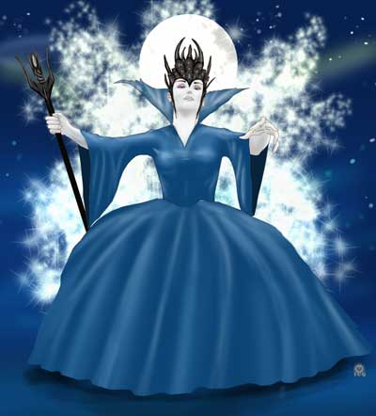
O tremble not, beloved son, you are guiltless, wise and good –
A youth such as you can best console this overburdened maternal heart. –
I am condemned to grief, for my daughter has been taken from me.
With her, all my happiness was lost; a villain abducted her.
I can see her trembling with fearful agitation, shaking with fear, feebly struggling.
I saw her taken from me.
“Ah, help me!” was all she could say – but her appeals were in vain, for my aid was not strong enough.
You shall go to set her free, you shall be my daughter’s savior.
And if you succeed, she shall be yours forever.
(Mozart & Schikaneder, 1791)

The music is ineffable and the singing enchanting, just as the delusions and deceptions from our false society, from our modern science and perhaps our own families as they dwell in the confusion of their own mistakes. These delusions strike a chord in our most sensible fibers and keep us justifying our wrongdoings, perpetuating lies and walking towards an abyss of perdition without us even realizing this is what is happening. Today we are waking a sinister path and meanwhile, we are convinced things are “just fine”.

Keep in mind, the path that leads to hell has been paved with cobblestones of good intentions. ‘Many are called and few are those who are chosen’. Evil men from all times have held the best intentions: Hitler, while filled with good intentions, desecrated many cities and was responsible for the death of millions. The executioner who carries-on with an unjust order of execution, though filled with good intentions, commits murder. We must never forget the Holy Inquisition; back then many inquisitors, with magnificent intentions, condemned many to the stake…
Samael Aun Weor, Lecture: The Study of Self

Once the deceit from the Queen of the Night is set, she retreats and hides in an altar of stars and the mountains once again close. Prince Tamino remains confused and wondering if all he has witnessed has been just but a dream.

Truthfulness
As Papageno approaches Tamino with a padlock affixed to his lips – one that he is unable to remove because of his lies – the Three Ladies emerge from the darkness and absolve him of his punishment, asking of him to never lie again.

We must be consistently cautious with the use we make of our spoken word. Apostle James the Lesser writes (James 3:6): “And the tongue is fire… and setteth on fire the course of nature” (Geneva Bible, 1599), words that invite us to reflect that off the same fountain cannot spring both pure and clear and poisonous waters simultaneously.

But why would the work of the Magical Flute insist so much to convey this and why would this be relevant? The answer to these questions is simple: “because the word is sacred”. In the Lord’s Prayer we say “Hallowed be thy name” in reference to the divine and as an acknowledgement that all of creation has come into existence because of the word. In fact, Greek philosophy associates the name Logos to divinity, which literally means “word, verb”.

The Father is TRUTH, the Christ is LOVE and the Holy Spirit is POWER; every time we lie we create a condition equivalent to an electrical short-circuit between our persona and Divinity. We must learn to speak when the consciousness speaks and remain silent when the consciousness goes silent.

We must cultivate sincerity, because within the substance of sincerity germinate the most beautiful flowers of the spirit.
(Samael Aun Weor, 1953)

As the Three Ladies tell Papageno that the lock by itself is a warning, they reply at unison:

If only every liar had a lock like this upon his mouth:
then would hate, calumny and rancor be replaced by love and brotherhood!
(Mozart & Schikaneder, 1791)

The Greek philosopher Socrates used to say that whenever we make incorrect use of the spoken word, not only we were harming our body, but our soul. Lamentably our daily lives present us with a multiplicity of scenarios and circumstances where our ignorance leads us to incorrectly use our spoken word. We have made the abusing of our words “normal” when in fact the use of the word carries with it a major responsibility. We must become watchful and be cautious of what we say and how we say it.

177. At times, it is a crime to speak, and at other times, it is a crime to be silent.
178. It is a crime to speak when we must be silent, and likewise, it is a crime to be silent when we must speak.
179. There is a need to learn how to control the word and to know how to calculate with exactness the result of what we say.
180. One word can serve as a blessing to one person, yet as an insult to another.
181. Therefore, we must calculate very well the effect of a word before it is uttered.
182. The lords of karma judge the results of actions without taking into account good intentions.
(Samael Aun Weor, 1953)

Love and fraternity would blossom in our homes and by logical consequence, in society, if we learned to make the correct use of the spoken word. But negative emotions are the root cause of the problem, as it is they what turn us into liars.

Though it is tremendously difficult, rather than making our first reaction that of lying or insulting those who hurt us, we should strive for the completely opposite behavior and speak well of them. Master Samael states we must make an effort to utter our best expressions on those who trigger our negative emotions, as doing so safeguards our internal universe.

When you are influenced by a negative emotion, whatever you express must be the best possible within the conditions of the event. If for instance, a negative emotion of envy is eating you up down to the very marrow of your bones, then make an effort and show harmonious behavior, not in favor of envy of course, but in benefit of your neighbor.

If an emotion of anger is stirring us up, then speak with extraordinary kindness and instead of being upset, speak well of the one who has offended us and we will not be hurt internally.

It is not easy to express goodness when one is feeling a negative emotion. But this is the only way it must be.
(Samael Aun Weor, 1977)

The Golden Flute and the Silver Carillon
The Three Ladies hand to Prince Tamino a magical, golden flute with powers to transform the passions of human beings; it can bring joy to those in sadness and lead those who are single into falling in love. To Papageno, they offer him a silver carillon and they offer these so they can use them as instruments of defense before any danger they may face.

FIRST LADY
O Prince, accept this gift sent to you by our Queen.
(gives Tamino a golden flute)
This Magical Flute will protect you even in the gravest misfortune.

LADIES
This flute will confer great power upon you, to transform the sorrows of mankind; the mourner will become merry, the bachelor a lover.

ALL
A flute like this is worth more than gold or crowns, for by its power will human joy and contentment be increased.
(Mozart & Schikaneder, 1791)

There are two fundamental elements in alchemy: gold, which serves as a symbol of the masculine electrical forces, and silver, as a symbol of those forces of the woman, and these are an intimate ingredient for anyone who chooses to live their life as a path to liberation.

Taking life as a path to initiation is not a trivial feat. It requires of super efforts to grow virtues and eliminate defects. Living life as a path of initiation is not for everyone, and though there is a friendly saying amongst people that says “there are many ways to Rome” – implying there is always more than one way to get something done – in this case, that does not apply. The words of Great Masters shed light on the severity of the work.

For instance Gautama, the Buddha says in the Dhammapada:

Few are the people who reach the Far Shore. Others simply scurry along this shore.
(Bhikkhu, 1997)

The words of the Christ:

Among a thousand who seek me, one finds me. Among a thousand who find me, one follows me. And among a thousand who follow me, one is mine.
(Samael Aun Weor, 1956)

And Krishna, in the Bhagavad-Gita:

Out of many thousands of men, hardly one endeavors for the perfection of self-realization, and of those so endeavoring, hardly one has achieved the perfection of self-realization, and of those, hardly one knows Me in truth.
(Bhagavad-Gita, n.d.)

It stands very clear this path is for the few.

Mozart’s Magical Flute is precise as it shows there is work to be done with both “gold” and “silver”: when a matrimony comprised of a man and a woman knows how to make the most of the magnetic forces that both surround them and they carry within, without misusing them, they acquire the power of protecting themselves from all dangers, just as they also become capable of transforming their lower emotions into transcendental energies.

Gold is the Sun, the Father, while the Moon is silver, the Mother; and the product of their union is exactly what is stated in “the Exorcism of Water”, a very ancient prayer attributed to the Wise Solomon:

“Sol ejus pater est, luna mater, et ventus hanc gestavit in utero suo…”
(His Father is the Sun, the Mother the Moon and the wind carried about gestation in the womb)
(Samael Aun Weor, 1974)

These symbols speak of the need to work with the super dynamics of love; we must learn to make use of the golden flute (the masculine magnetic forces) and the silver carillon (the feminine forces). These masculine and feminine principles are the key that enables any creation to come to fruition.

However, the golden flute is also a symbol of Gnosis, which is the knowledge of the Being as an eternal and universal philosophy, and is also a symbol of the natural functioning of the consciousness. “Truth” is an attribute of our internal father and is symbolized by the metal gold, the fire, and the Sun.

The silver carillon associates to creative comprehension, the faculty that allows us to grasp the wisdom of the great mysteries as well as the elimination of our defects and the understanding of others. Comprehension is love, an attribute of the Divine Mother, who is also symbolized by the metal silver, the water, and the Moon.

Three Boys
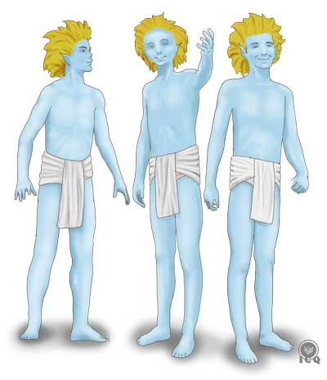
To complete this internal work we will be in need of superior guidance, one that can lead us through the intricate labyrinth of theories and fortunately for us this guidance exists, though we have for the most part, abandoned it. This guidance is the voice of the consciousness, the calling of the Innermost, which is what is represented by the Three Boys. In Mozart’s work, they are the consciousness of both Tamino and Papageno.

“Three boys, young, fair, gentle and wise, will appear to you on your journey.
They will be your guides; follow their counsel and theirs alone.”
(Mozart & Schikaneder, 1791)

Those who learn to follow the guidance of their heart will never find themselves in need. The voice of the consciousness is the Voice of the Silence that we must strive to listen, as its advice will safe keep us from wandering and becoming lost.

The Doctrine of the Eye fortifies the mind. Our mind is the abode of desire; it thinks, reasons, analyzes and wants to resolve everything by itself without taking into consideration the voice of the Internal Master. Therefore, the mind arrives at erroneous conclusions and leads us to erred actions.

The Internal Master does not analyze or reason because his voice is the voice of intuition. The Heart Doctrine opens up the doors to the hall of wisdom.
(Samael Aun Weor, 1951)

Chapter Two – Love and Desire
Act One, Scene 2

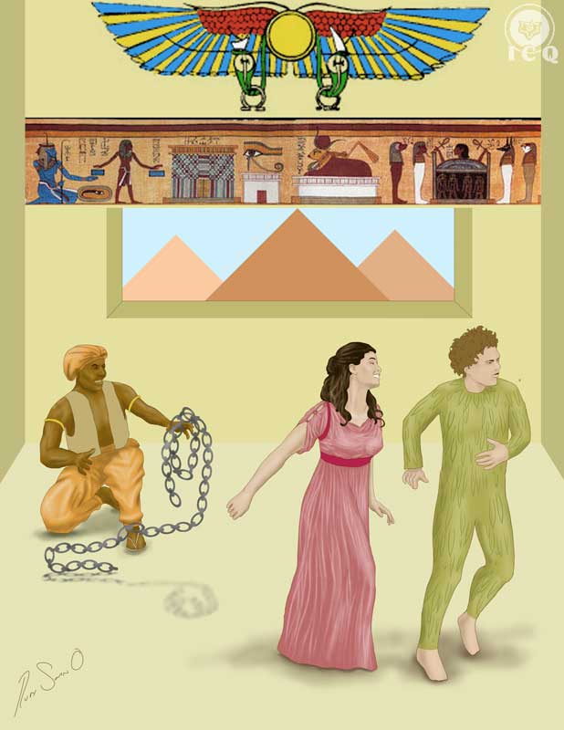

In our modern times when we have become incapable of discriminating between right and wrong, it becomes very easy to confuse the elixir of divine love with the venom of desire; when we are “in love” we are capable of promising, even while shedding tears of blood, that we “love”, yet after a few years, or in many instances after a few months, those promises of love are forgotten and in turn become replaced by adultery, deceit and disillusion.

Any sincere seeker of the truth must learn to make the distinction between these opposite polarities and to do so, we must destroy from our minds and our hearts, the myriad of beliefs society has imprinted in us through the false educational system and the poor utilization of mass media.

It may seem to be an exaggeration but, the fact is that out of a million couples who believe that they are in love, only one couple is really in love. Millions of impassioned couples exist, yet couples in love are very difficult to find.
(Samael Aun Weor, 1963)

Within Sarastro’s palace and in a room adorned in hieroglyphs, Monostatos, a servant of the Temple of the Sun, comes into play. He is the opposite of everything that is represented by Sarastro’s Temple, which portrays a sanctuary of Light. He is lascivious and seeks for an opportunity to take advantage of Princess Pamina, with the intent of derailing her off the path of initiation.
Because Monostatos is a symbol of our brutal passions, he seeks to take advantage and abuse Pamina. Monostatos is the animal passion that lights a fire in our hearts and that blinds our mind, making us unable to do what is right and instead, invites us to commit all kinds of atrocities that inevitably result in more suffering.

Monostatos is also a representation of the common human being, very different from Prince Tamino who is symbol for those who sincerely seek the light of wisdom. Monostatos is not even akin to the bird-catcher Papageno, who regardless that he shows no interest in seeking superior wisdom, he lives his life seeking to not commit any wrong to his fellow men.

In the Bhagavad-Gita, Krishna speaks about three specific qualities called gunas and these are represented by these three characters in the Magical Flute. Harmony, the SATTVA guna relates to Tamino; emotion and passion, the RAJAS guna relates to Monostatos; and laziness and indifference, the TAMAS guna, relates to Papageno.

“When through the perceptual senses of the body illuminating knowledge manifests; know that certainly the mode of goodness (sattvam) predominates. O Arjuna, when greed, restless exertion with great endeavor for furtive activities, agitation of the senses, incessant desire for sensual indulgence; when all these arise the most of passion (rajasy) predominates. O Arjuna, nescience, inertness, neglectfulness and also illusion; when these arise the mode of ignorance (tamasy) predominates.”
(Bhagavad-Gita, n.d.)

Monostatos is that representation of ourselves, when we get carried away by hatred, rancor, and lasciviousness. Because he appears as a servant in the Temple of the Sun, he is also a representation of the false aspirant who, for example, abandons their spouse because “they are not interested or do not agree with their esoteric studies”; or the old man who takes advantage and seduces a young woman using as pretext that he intends to help her in her “spiritual advancement”. Monostatos is everyone who allows themselves to be carried away by animal passions. Princess Pamina faints, Monostatos orders everyone to leave and they are left alone in the room.

Monostatos and Papageno
Papageno peeks through the window and is shocked by Monostatos’ dark skin. On the other hand, Monostatos sees Papageno covered in feathers and believes him to be the appearance of a ghost. Both of these perceptions are a reflection of their ignorance. Thinking they are having the vision of a demon, they both attempt to scare each other and implore for mercy by saying:

Oo! – – that must be – the devil himself!
Have pity – spare me – Oo – Oo –
(Mozart & Schikaneder, 1791)

People who are like Monostatos (lustful and angry) or like Papageno (with no spiritual longing) commonly judge others by their appearance, whether it makes sense or not, reflecting in others the very defects they carry within.

We have simply projected, upon our victim, our very own psychological defects. Perhaps we have seen in that person the worst defect we carry within and no one likes to see themselves like that, let’s say, so mocked. The crude reality is that our victim has become a mirror where we have seen ourselves, just as we are.
(Samael Aun Weor, 1999)

We must eliminate from ourselves this tendency of judging others, as we will never be able to make any meaningful internal progress for as long as we continue accusing others of the wickedness we carry within.

Monostatos walks out and Papageno remains in the room with Pamina. He ensures the woman is the Princess by comparing her to the portrait; they exchange words and he assures her that by order of her mother, the Queen of the Night, a prince will rescue her, more so because he fell deeply in love with her by just staring at her picture. Upon hearing this, Pamina becomes deeply emotional, because love is the most exalted emotion.

Papageno has no Papagena
Pamina asks Papageno if there is a woman waiting for him at home. His reply is on the negative, stating he does not have a girlfriend, much less a wife, and that he is so desperate he is willing to tear off his feathers.

This happens to be the state of mind of many students who long to make progress in the studies of self-knowledge.

Lamentably people tend to look for their significant other in all the wrong places. It is absurd to reach out for a life-long spouse by placing an ad in a newspaper, a magazine, a dating app, or in social media, as if we were merchandise for sale; simply put, we must learn to be patient and wait.

Magazines and other modern love advertisements, etc., are now in fashion. Absurd advertisements of this kind are abundant. i. e., “White woman, such height, such capital, eyes of this or that color, with this weight and this religion, etc., wishes to marry a gentleman with this or that age, with this quantity of money, this race, this height, etc.

A gentleman, of such height, such capital, eyes of this or that color, with this weight and this religion, etc., wishes to marry a woman with this or that age, with this quantity of money, this race, this height, etc.” all of this is indeed very absurd and horrible. All of this is nothing but prostitution authorized by the authorities and society. The outcome of this is suffering, absurd matrimonies, prostitution and divorce.
(Samael Aun Weor, 1963)
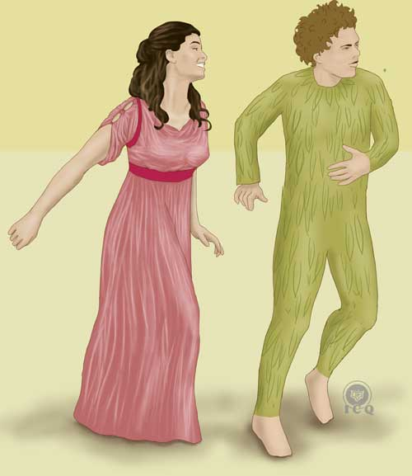
We must learn to be patient and work upon ourselves, while in the meantime we help others, so the Law will allow for our spouse to show.

A cosmic law also states “the level of being attracts the level of being” and we must keep this in mind; if we are devils, then we certainly cannot expect an angel from heaven! And if you are single longing for someone who is spiritual, then there is no other option than to achieve that internal spirituality first!

This is the message that Pamina conveys to Papageno

Patience friend! Heaven will also take care of you...
(Mozart & Schikaneder, 1791)

Her words affirm how Divine Law has a special person reserved for everyone, thus he must not despair but rather work with intensity upon himself.

In those instances where the actions of our previous lives result in the decree of the Law of Karma (the cosmic Law of Cause and Effect) depriving us of a spouse, desperate action is not our best solution. The best possible way for to change our conditions is by performing actions that can tilt the scale of justice in our favor; for example exercising good deeds in favor of others, helping those in need, being serviceable, kind and compassionate, making deliberate effort to see and feel from the perspective of the other, and certainly, taking actions to help others remedy their affliction. Actions that are meant to minimize the suffering of others inevitably result in the elimination of our own suffering and thus, tilt the scale of justice back into our favor.

Love, the Threshold to Divinity
Pamina and Papageno intone ineffable verses praising the marvelous force of Love:

PAMINA
A man who can feel love
must have a good heart.

PAPAGENO
To share the sweet emotion
is woman’s foremost duty.

BOTH
Gladly we rejoice in love
and live by love alone.

PAMINA
Love sweetens every trouble;
all creatures sacrifice to her.

PAPAGENO
She seasons our daily lives
and helps Nature’s wheels go round.

BOTH
Her higher purpose is our guide,
and nothing is nobler than Wife and Man.
Man and Wife, and Wife and Man,
attain divinity.
(Mozart & Schikaneder, 1791)

They start by making it clear that for us to experience the effusion of love from our consciousness we must first have a “good heart”, and this must be understood as us not giving ourselves into negative emotions as anger, jealousy, intolerance, and pride. For as long as these defects continue to exist in us, passions, attachments and dependencies will remain prevalent, but not love.

It has been written that if all human beings, regardless of differences in race, sex, chaste or color, were to abandon even for a minute, all of their resentments, their vengeance, wars, hatred, and were to love each other, even the venom of vipers would disappear. That is because the force of love is a cosmic force; one that emerges from the vortex of every atomic nucleus, off every solar system, and off the center of every galaxy. When adequately utilized, it is an extraordinary force that can manifest prodigies just as those performed by the divine rabbi of Galilee; such is love.
(Samael Aun Weor, 1999)

The special work that we must undergo to express love has its foundation on the deep understanding of our psychological aggregates; it is comprehension what enables their elimination. Only through the observation, comprehension and elimination of our defects we will reach the point of having “a good heart”.

Love is a feminine attribute because it is a gift of the Divine Mother, whose exponent is every woman. It is set as the first manifestation, because it is also the force capable of realizing any transformation.

God does not have any form. God is co-essential to the abstract absolute space. God is that... that... that. God has two aspects, wisdom and love. As wisdom, God is the Father; as love, God is the Mother.
(Samael Aun Weor, 1959)

The woman is the living representation of the cosmic mother. The divine forces of the Eternal Feminine can flow and express through every woman who works upon herself developing virtues as comprehension, kindness, compassion, and love.

Love emanates from the superior realms of consciousness and we must make ourselves ready in order to manifest love; we must strive to become a perfect vehicle to enable the forces of love to penetrate us, but this is only possible when we tirelessly destroy the very elements that confine and suppress love, namely feelings of hatred, vengeance, anger, resentment, and many others.

Let us remember that love starts with a spark of sympathy, it substantializes with the force of affection and synthesizes into adoration.
(Samael Aun Weor, 1971)

Each defect traps within itself a fraction of our consciousness, which is a manifestation of love, thus when we destroy the defect, love can then manifest in ways that are both spontaneous and natural. Love transforms the way we see the world; things that seem impossible become possible the moment we learn how to love.

“If all human beings… were to love each other, even the venom of the vipers would disappear…”

Nothing can withstand the power and the majesty of love. The supreme key to any magical power is found within the husband and wife who truly love each other. Learning to combine the masculine magnetic forces with the feminine magnetic forces allows for the formation of the cross, and it is from that cross itself from where everything that is, has been and will be, emerges.

Love is the only path to salvation.
(Samael Aun Weor, 1950)

The one door that can grant us access to the sphere of divinity is found in the love that can be developed between a man and a woman. There is nothing greater in this world than true love.

A Perfect Matrimony is the union of two beings: one who loves more and another who loves better. Love is the best obtainable religion of the human genre.
(Samael Aun Weor, 1950)

Chapter Three – The Three Temples
Act One, Scene 3

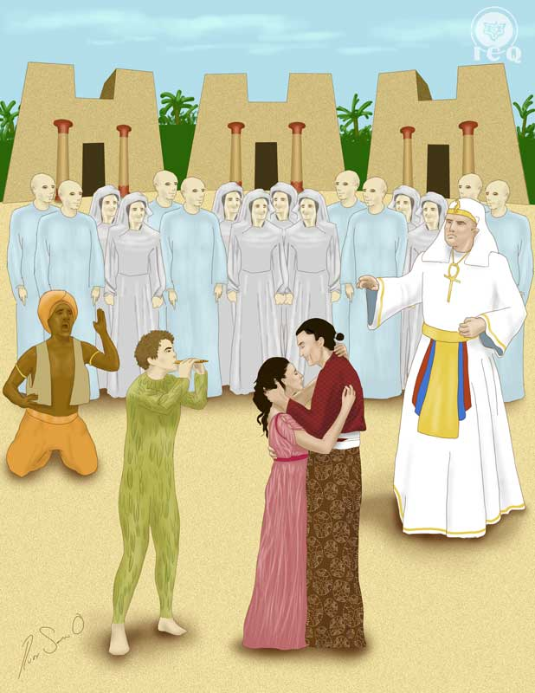

Three temples are found in a pleasant forest; the temple to the right is the temple of reason, the one of the left is the temple of nature and at the center, the temple of wisdom. The Three Boys lead Prince Tamino to the temples and tell the Prince:

This path will lead you to your goal,
but, youth, you must strive like a man.
So give heed to our teaching:
be steadfast, patient and discreet! –
(Mozart & Schikaneder, 1791)

The Relationship between Spiritual Maturity and the Three Virtues
The play suggests there is a need to develop a level of spiritual maturity in this wisdom, which is what is represented by the Three Boys and by the guidance they provide Tamino. A typical human being will have around three percent (3%) of free consciousness, not trapped within the many psychological defects we carry within, yet this 3% is seldom used. To set this free consciousness into activity we need to set ourselves into a state known as the “remembrance of self”, commonly known as the state of “living every moment”; which implies a constant state of attention to our thoughts and sentiments, to be present in everything we do and wherever we may be.

Whenever we make an effort to live life in a state of alert novelty and alert perception, the effort result in the “call of the consciousness” (the Three Boys), indicating the direction we must follow as we navigate this sea of troubled waters that is life.

Citing Apostle Paul:

“I gave you milk to drink, and not meat: for ye were not yet able to bear it, neither yet now are ye able.”
(Geneva Bible, 1599)

Paul encourages us to act as adults and show maturity in our spiritual development. It is lamentable to see many aspirants of the light grasping with their hands the precious treasure of gnosis while flirting with other teachings; which is a demonstration of a lack of spiritual maturity. The call of the consciousness is asking of us to stop being superficial, to go beyond “the milk” (the incipient teaching) and move into “the meat” (the teaching with “more substance” that is Gnosis).

Three Boys offer this guidance and there are also three temples, suggesting three virtues that we must strive to develop

- Steadfastness
- Patience
- Silence

We must develop the steadfastness that comes from practicing the teachings so we do not falter before the adversities of life. It is common to see many who join these studies but who are unable to remain firm, and the moment they start facing difficulties, they disappear.

Steadfastness comes from living the teaching and striving to acquire the wisdom through experiential knowledge, not just remaining in the space of theorizing and intellectualizing it. We must work the practical aspect of Gnosis because every moment is born out of Gnosis thus, it becomes imperative that we strive to live every moment with intensity.

Patience implies that spiritual development does not take place overnight and much less, appears by “magic”. We live in a very poor psychological state; we have already lived decades enjoying the vane pleasures of vice and degeneration, yet what we would like to see is that our internal condition becomes transformed instantaneously, magically, as in “the flick of a switch”. Learn this: Nature does not take leaps. For us to enjoy the fruit of any tree, we must first till the land, plant the seed, irrigate it and care for it, in a process that lasts for years. It requires of patience and patience is what helps yield the fruit.

The path of spiritual development requires of sincere effort working upon our own selves disintegrating the thousands of psychological defects we have developed with the passage of time. This work is of years in the making and it requires of dedication, willpower, self-discovery and comprehension.

The third virtue is silence, because there are many factors that invite us to speak of things that are better kept quiet. Some students of Gnosis do not understand the meaning of receiving teachings “from lip to ear”. There are many who have their first set of conscious experiences in the Astral Plane and find themselves speaking of them publicly. They fail to realize that it is pride and vanity what invites them to speak of these experiences, and this carries consequences to the internal work.

The initial experiences the student has are a gift from the superior planes of consciousness; in many instances a gift that is given even when the student is not truly worthy of receiving, but offered as a means to help them propel and gain momentum in their practice, to give them an extra motivation. Yet many students respond to this by sharing and speaking about their experiences thinking of themselves as “wise” and “important”. When they do this, the experiences cease.

Prince Tamino asked the Boys if we was capable of rescuing Pamina and they choose to not answer but rather insist in his steadfastness, his patience and his quietness; asking of him spiritual maturity.

Achieving steadfastness, patience and quietness are steps at the very beginning of the work as these virtues suggest the defects that must be eliminated; to be firm and consistent in the work, it becomes necessary to eliminate the aggregates of laziness. To be patient we must work to eliminate our desires for immediate gratification and to be silent, we must disintegrate from our nature all those defects of pride and vanity.

Prince Tamino receives this teaching:

May the wise teaching of these boys be engraved forever upon my heart.
(Mozart & Schikaneder, 1791)

Tamino’s words area an invitation to carry this teaching deep into our consciousness, beyond our mere intellectualism.

It is indispensable to make a sincere effort to receive these teachings consciously, in plenitude and in a way that is both natural and spontaneous, without the intervention of the mind that seeks to translate and compare. It is also indispensable to feel a deep love for the Gnostic teaching; these must be meditated with our body relaxed and with our minds in silence. Doing so results in the teaching reaching the consciousness and as Tamino says “engraved forever upon [our] heart”, so they can become part of our being, our thoughts and our emotions, and manifest whenever the need arises.

The Three Paths

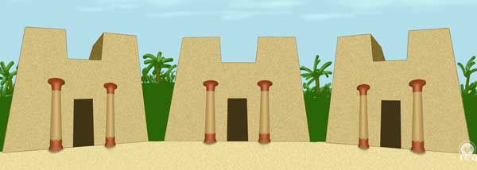

Tamino takes his time observing the three temples and becomes perplexed with the beauty of the sculpted columns and the engraved doors, a beauty that leads him to feel he stands before the realm of the gods. His reaction brings the acknowledgement that when we set ourselves into the superior activity of the sincere aspirant who seeks, “action rules and idleness is banned”.

He faces the Temple of Reason, to the right, and exclaims:

I will pass boldly through that portal;
my task is noble, straightforward and pure.
Tremble, cowardly villain!
My duty is to save Pamina!
(Mozart & Schikaneder, 1791)

And an occult voice stops him responding “Go back!” The path of reason is a very noble path, yet it is not the way. Reason is very useful for reasoning by itself, but useless to achieve our purpose and mission on our life; reason will help us memorize important events but it cannot transform us. It lacks the capacity of eliminating our mistakes and to understand this, all it takes is a bit of observation: our world is filled with intellectuals and yet the grave problems of humanity are yet to be resolved and do not subside.

The occult voice prompts Tamino to “go back”; to us that means we must stop believing that memorizing books and quotes results in some kind of spiritual transformation. There is nothing incorrect with studying, but there is plenty of wrong in stuffing our intellect with senseless theories and being proud of it, more so when such efforts do not result in us achieving a condition of internal joy and happiness.

Tamino then shifts towards the door on the left, the Temple of Nature, and again the occult voice commands “Go Back!” This temple of nature is not related to our Divine Mother Nature, but to our mechanical nature, which is a machine whose axle enables the flow of the laws of evolution and devolution.

Many tend to believe that perfection comes with time; that subsequent lives will result in higher levels of perfection and that eventually evolution will result in us becoming angels. This is an absurdity. If this were true, our current day humanity would be more humane than our ancestors and all facts indicate the contrary: every generation is worse. It is not difficult to see how every day we can witness more aggressive ways of disrespect, less veneration, less sincerity and less comprehension; wars become ever more dreadful, and we continue surrounded by hunger and desolation.

The path on the right (reason) shows materialism and skepticism and the one on the left (mechanicity), fanaticism. Neither is the correct path as each will take us into a labyrinth that exits into the desert.

This moves Tamino to seek the path of the center towards the Temple of Wisdom. This is the path of balance and equilibrium, the path of Tao of the ancient Chinese which is an allusion to Gnosis, and just as in the ancient schools of mysteries, a priest walks out of the temple to greet him:

SPEAKER
Where would you enter, bold stranger?
What do you seek in this holy place? –

TAMINO
Whatever belongs to Love and Virtue.
(Mozart & Schikaneder, 1791)

There is a marked difference between the things we think and say and the emotions that we experience in our hearts. Tamino reached the Temple of Wisdom filled with negative emotions; he had been fooled by the Queen of the Night (symbol of fanaticism and the mechanical ideas of our current humanity) – just as we allow ourselves to be fooled by gossip, the judgments and the cynicism of others. The Priest recognizes Tamino’s inferior level of being and leads him to recognize that what he seeks is not wisdom, but that he is there for vengeance.

Many of the people who seek the superior studies of Gnosis are similar to Tamino, they say they are seeking for happiness and virtues, but arrive filled with resentments, hatreds, psychological traumas, jealousies, rancor, and many other sufferings. Such an inferior internal condition makes it difficult to have an opportunity to apprehend the true gnostic teaching.

At the same time it is also very difficult the acknowledgement of our lamentable condition, because we tend to thing we are “really good people”; and this is what we see in the conversation between the Priest and Tamino. Politely, the Priest makes an effort for him to see that he has been led astray and that he holds beliefs for which he has no evidence (experience) for his claims… and he is thus unable to enter the Temple of Wisdom. For as long as we continue to carry our negative emotions we will be unable of integrating the wisdom of the gnostic mysteries.

Tamino thinks Sarastro (the Solar Priest) has kidnapped Pamina for a sacrifice or perhaps for some other nefarious purpose and his antithetical thinking is a representation of our minds; embracing the fallacies of a devolutionary society, dwelling in the constant dramas induced by corrupted media, just as fanaticizing with a “science” that promotes crime and fosters degeneration – all of which are attributes of the Queen of the Night. And before this conundrum, the Priest retreats and walks away…

The Eternal Night
Prince Tamino, finding himself alone:

O endless night! When will you vanish?
When shall my eyes see light? –
(Mozart & Schikaneder, 1791)

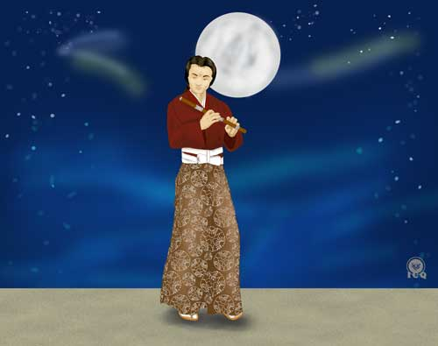
This is the “Spiritual Night” the sincere student of Gnosis gets to experience. This is a time when life feels like things start going wrong and the student experiences the effect of materialism and density; it is the absence of the Light of Wisdom and only a very few are capable of successfully overcoming this condition. This is the time the student feels they are not making any spiritual progress, with no astral experiences, no appreciable progress out of the efforts of meditation; they are unable to hear their internal voice (the voice of the Innermost) and everything becomes dense. The key to emerge victorious out of this condition is only through profound internal meditation and by sacrificing self for others.

“…well they want immediate results and things are what they are, not what the mind wants them to be. These results are not immediate, there is an effort that must be invested. And any results will go unnoticed until the consciousness has been awakened. It is only through the awakening of the consciousness that you start recognizing these results. This work is for life and none of this happens overnight. There are times of terrible loneliness; many of the best Initiates have spoken about this condition.

“The ‘spiritual night’ of each: Beethoven, Mozart, Jesus of Nazareth, Hermes Trismegistus; epochs where they saw themselves in terrible loneliness, separated from all things spiritual. They were not welcome above because they still did not deserve it and neither welcomed below because they had become enemies of the psychological self. Masters walking as if they were misfortunate ones trapped on the mud of this Earth. Most fail this ‘spiritual night’. The very few who resist emerge triumphant. Yet again, only very few are able to resist such a difficult test.”
(Samael Aun Weor, The Wisdom of the Being)

Voices reply to Tamino from within the temple by echoing “Soon, youth, or never!” and this statement is an indication that the responsibility of escaping the condition of the spiritual night relies exclusively upon ourselves. This condition can last months, perhaps years, and it is only by intensifying the work upon oneself (i.e. “soon”) what leads to the emergence of the light.

These voices from heaven are the superior help that is provided to the practitioner and they manifest at the time the disciple becomes capable of reaching, through profound meditation, the state of a silent mind. Tamino asked the voices of the gods if Pamina was still alive and their affirmation becomes enough to bring joy into the heart of the Prince.

The Sounds of the Golden Flute and the Silver Carillon
In gratitude for the news, Tamino feels moved to play his golden flute and his playing causes a miracle similar to that of Orpheus playing the harp; marveled by the harmonies of the flute, the animals and beasts of the forest approached him seeking delight in the music.

The golden flute is an alchemical symbol and is associated to the Sun, it represents the Innermost, truth, wisdom, and gnosis. The joy expressed by the beasts and the animals of the forest shows how the wisdom of gnosis enables the transformation of our grotesque aspects into subtle ones, as for example transforming our states of anger into states of tranquility. But this is only possible when we apply to our daily lives the doctrine of gnosis; such application symbolized by the skillful playing of the flute.

But Pamina is missing and because she complements him, meaning she is his “other half”, he calls upon her with the music of the flute and this “calling” could be interpreted in various ways. For one, it is similar to the internal condition of the devotees who actively wait for their future spouse; the active practicing of the teaching (the playing of the flute) becomes the “music” that brings the loved one. For those who are married, who because of time and lack of kindness tend to drift apart from each other, the intense work in gnosis leads them to rediscover each other. And yet another interpretation comes from the perspective of the role of Pamina – as a symbol of the Spiritual Soul – which is what the practitioner finds as they truly seek and embrace the wisdom. The only way to find our Spiritual Soul is through the intense work gnosis demands that we practice upon our own selves.

Papageno is able to hear the gentle music of the golden flute, he replies with his pan flute and all three, Papageno, Pamina and Tamino become joyful even before they can see each other; but as their joy grows Monostatos makes an appearance and tries to chain Pamina and Papageno. This interference of our desires and passions (Monostatos) with the bliss of the soul (Pamina) is a suppression similar to what happens in our daily lives. Many a time our happiness is interrupted by our very own animal passions such as adulteries and lust. Just like in the play, our inferior actions binds us to suffering.

Thus in the face of this adversity, Papageno chooses to play his Silver Carillon. “Silver” is a symbol of love, comprehension and kindness; and also a symbol of our individual and particular Divine Mother. Just as the music from the Golden Flute transformed the animals and beasts of the forest, the music of the Silver Carillon transforms Monostatos and his minions, leading them to sing and dance. When it comes to our internal work, this means that when we make an effort to comprehend our psychological defects (as represented by Monostatos and his slaves) and we are empathic to the needs of others, we can tame (and eliminate) our internal enemies.

Love and Wisdom are the two columns of the White Brotherhood; wisdom is represented by the music of the golden flute, love and comprehension by the music of the silver carillon.

Sarastro Arrives
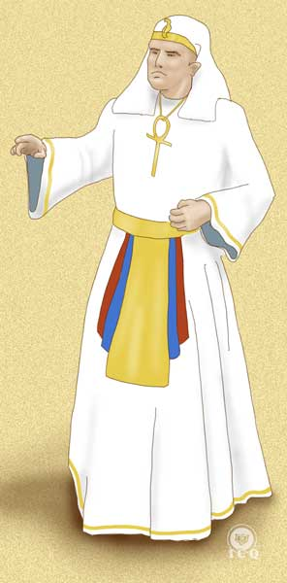
Trumpets announce the arrival of Sarastro (the Solar Priest) on a chariot pulled by six lions. The lions represent the sacred fire and also the Law of Karma (law of action and consequence) that brings balance throughout creation. They are six because the sixth Arcanum is the supreme negation of the Ego and the supreme affirmation of the Inner Christ; and the addition of Sarastro to the chariot also reflects Arcanum 7 of the Egyptian Tarot. The chariot of war, pulled by lions (or sphinxes) is a symbol of one whose inner being shows dominion over the forces of nature.

Papageno (symbol of us mortals) attempts to run away in fear, but finding nowhere to hide he becomes overwhelmed with negative emotions and worried because both him and Pamina were trying to escape, asks her: “what will we tell Sarastro?” to which she replies: “The truth…”

PAPAGENO
If only I were a mouse,
how I’d hide myself –
if only I were tiny as a snail,
I’d creep into my house! –
My child, what shall we say? –

PAMINA
The truth – the truth, even though it be a crime! –
(Mozart & Schikaneder, 1791)

Pamina addresses Sarastro and acknowledges she is guilty for trying to escape, but only because she was threatened by Monostatos who wanted to abuse of her, and Sarastro, in his wisdom and in knowing she is in love with Tamino, comprehends the dilemma and still keeps her in captivity, anticipating the potential failure that could be brought by the fanaticism of her mother, the Queen of the Night.

Pamina insists that she wants to rejoin her mother while Sarastro tries to make her to see how the pride of her mother affects her, throwing her out of internal balance and harmony.

This scene shows us many of the difficult dilemmas we face in life; here is where the devotee needs to overcome situations that appear to be noble but that behind appearances, there are conditions that would inevitably take us to illness, destruction and failure. These are those events in life where our sentiments intervene, making us feel sensations of “love” when in reality, we are reacting to conditions influenced by lies, pride, fanaticism, ignorance, and error.

Yet the scene also speaks of the power of the woman and how the woman can lead a man into a superior condition through her love, kindness and compassion; just as the man can also help lead a woman into a superior conditions through wisdom and severity, etc. Because man and woman are complements of each other, neither one is better than the other nor is one meant to achieve more than the other. It is clear man and woman are different, yet they must lead and guide each other in what corresponds to each one of them (wisdom and love). When we make the mistake of underestimating the capabilities of the opposite sex, the downplaying of their potential leads us into error.

Pamina and Tamino
Monostatos takes Tamino before Sarastro; this is the first time Tamino and Pamina stand face to face before each other, contemplating each other in ecstasy and reminding us of the transcendental axiom:

“Of hearings I had heard of you, but now my eyes see you and my heart, feels you.”

To the amazement of all and fearing no consequences, they fuse in a deep embrace.

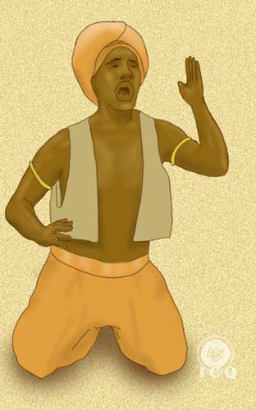
This triggers a reaction in Monostatos, who in anger proceeds to separate them and then kneel before Sarastro to beg him to punish them both; he calls himself faithful and boasts of his efforts, stating that it is thanks to himself that Papageno and Tamino have been unable to abduct Pamina. But in his wisdom Sarastro perceives the deceit of Monostatos and commands a punishment for him, by receiving seventy-seven lashings to the soles of his feet.

The gnostic gospel of Phillip states: “Acknowledge that which lies before your eyes and that which is occult will manifest, as there is nothing hidden that will not come to be.” Everything shows up at its right time, regardless of our attempts to deliberately hide things or even cloud situations with our lies; the law always allows for all things to manifest. In this scene Sarastro is a representation of the Law of Karma in action and he comes to settle all things to equilibrium.

Monostatos is punished by lashing on the soles of his feet because “the feet” by themselves are very significant. It is on the lines inscribed on the soles of our feet that our karma is written; and the number “seventy-seven” appears in the Pistis Sophia (the book where the Great Master Jesus leaves his teachings to the remaining apostles eleven years after his resurrection):

For this cause, therefore, when ye questioned me aforetime, saying: 'If our brother sin against us, desirest thou that we forgive him unto seven times?' – I answered and spake unto you in a similitude, saying: 'Not only unto seven times, but unto seventy times seven.'

Now, therefore, forgive him many times and every time give him the mysteries which are in the first space which is from without. Perchance ye win the soul of that brother and he inheriteth the Light-kingdom.
(Samael Aun Weor, 1983)

Sarastro’s action is a clear allegory to the Mercy of the Divine Law and it also reminds us that in par with Divine Mercy is Divine Justice. The violation of the law always generates a consequence.

From a kabalistic perspective, in the “seventy-seven” (“7” and “7”) we find the seven realms: Physical, Vital, Astral, Mental, Causal, Intuitional, and the Realm of the Being; and also the forty-nine (7x7) levels of our sub-consciousness upon which we must knock, discover and study, as the depth of our Subconsciousness is the very den of our Ego.

The Tests Begin
Sarastro commands for Tamino and Papageno to be taken to the Temple of Trials to receive their tests for which their heads are then covered with bags; these are a representation of the blindness of the ignorance we experience before we reach any kind of initiation. The tests they are about to face are the means through which we become purified – a purification that will render us worthy of the sacred mysteries.

As two of the priests cover Tamino and Papageno’s heads, a choir is heard:

If virtue and righteousness
pave the Great Path with honour,
then earth will be a paradise
and mortals resemble gods.
(Mozart & Schikaneder, 1791)

End of Act One

Chapter 4 – Osiris and Isis
Act Two – Scene 1

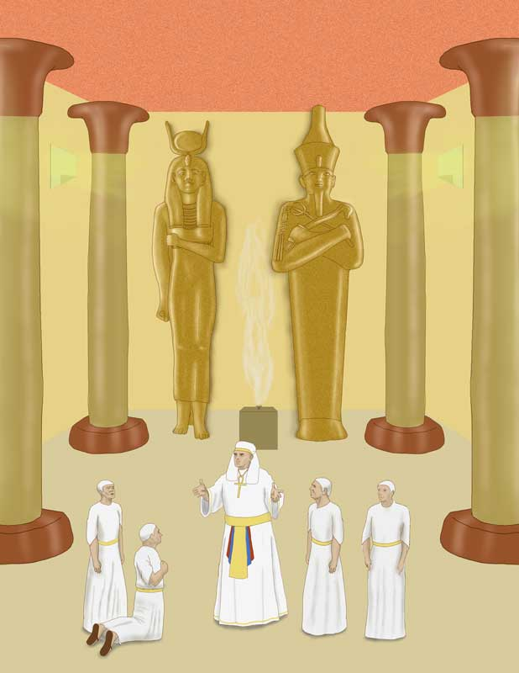

Surrounded by a forest of palm trees, Sarastro and the priests consecrated to Isis and Osiris solemnly walk in procession into the inside of the temple. Osiris is “the Father who is in Secret” and Isis is our internal Divine Mother. To be a priest (or priestess) of Osiris and Isis means that we have consecrated ourselves internally to our internal fathers and that our actions are a reflection of their will, love and wisdom.

The Lord’s Prayer, gift of the Great Master Jesus, invites us to know about these divine forces that are constantly watching over us and it does so through its first petition: “Our Father who art in heaven”. Such “heavens” are the superior dimensions of nature and when we say “Our”, this undoubtedly means that each one of us has his own individual and particular Father.

Osiris is this Father who is in Secret and his unfoldment is our Divine Mother Isis. These are divine principles we must learn to respect and venerate as they are a part of our Being and they exist within us, here and now; their sole objective is to guide us from the darkness of our existence into the realm of the light.

151. It is indispensable that our disciples cultivate the beautiful quality of veneration.
152. We must profoundly venerate all sacred and divine things.
153. We must profoundly venerate all the works of the Creator.
154. We must profoundly venerate the venerable masters of the Universal White Fraternity.
(Samael Aun Weor, 1953)

The Triumph of the Being
The palm trees that adorn the scenery are symbol of the Victory of the Being over the passions of the Ego, they represent a triumphant Being in dominion over the dense matter.

Yet again at this stage, the musical aspect of this play generates nine sacred sounds split in three groups of three, inviting us to penetrate into the mysteries of initiation; and then Sarastro speaks to the initiates:

SARASTRO
O Isis and Osiris, grant the spirit of
wisdom to the new-formed couple!
Direct the Wanderer’s steps to them,
strengthen them with patience when in peril.

PRIESTS
Strengthen them with patience when in peril.

SARASTRO
Let them see the benefits of their trial;
but if they should succumb,
reward their courageous course
and admit them to thy dwelling!
(Mozart & Schikaneder, 1791)

Tamino is a prototype of every Essence (whether in a man or a woman) that longs to step out of ignorance and bring an end to the fanaticism that binds us to misfortune and suffering. Anyone who makes the decision to become an aspirant of the light, is guarded and protected by the Divine Law, in this case represented by Sarastro, and by the White Lodge – the great masters who watch over the humanities of the world.

The Three Factors of the Revolution of the Consciousness
Achieving self-realization is nothing but impossible without the three factors of the revolution of the consciousness; these are described in the narrative of Sarastro and the Priests as they find out if Tamino is worthy of receiving the mysteries.

The first priest asks Sarastro if Tamino is virtuous, in reference to the mystical death as the second factor of the revolution of the consciousness. This is the death associated to the elimination of the psychological aggregates; a defect that is eliminated allows for the manifestation of a virtue, thus the first priest will ask, as it is impossible to reach initiation if we do not eliminate the Ego. No death of the ego means no virtues.

The second priest asks if Tamino is discrete, showing us the importance of the correct use of the spoken word. It is clear that when we are not cautious with the use of our words, problems arise.

The third priest asks if Tamino practices good deeds in reference to the factor associated with the sacrifice for humanity. This is the act of helping others heal from their suffering by sharing with them the light (gnosis) that has the power to heal their afflicted hearts. Sacrifice for humanity must be demonstrated through our actions, so others can directly experience the discipline that can help them eliminate their sufferings. Then all priests give their consent for Tamino to be tested in the Tempe of Trials.

Sarastro then speaks:

(Sarastro and his Priests enter in stately procession, carrying palm fronds; when they have taken their positions they sound three blasts on their trumpets. Sarastro announces that he has sponsored the initiation of Tamino into their order to strengthen it against the wicked ambitions of the Queen of the Night.

“Pamina, joyous and sweet child, has been destined by the gods to Tamino, which is why I have taken her away from her Mother.”

The Prince’s virtue will be rewarded with the hand of the Queen’s own daughter, whom Sarastro has taken captive.)
(Mozart & Schikaneder, 1791)

With his words Sarastro speaks to the last factor of the revolution of the consciousness, or birth. It is by the work of the married couple in the super-dynamics of love through which they can effectively transmute their creative energies and create the superior existential bodies of the Being. These bodies become the “house of the Inner Father” and through them, our Father can then manifest freely.

Sarastro’s words: “[she} has been destined by the gods to Tamino” confirms each human being has a designated twosome, but we must learn to be patient because their timing of arrival into our lives depends on the Level of Being we have created by virtue of the work we have realized upon ourselves; impatience and lust will always be obstacles.

The Deceit of Society
We live in times of social devolution and moral decay where humanity has discarded superior spiritual values and for the most part, these have already been lost. Nowadays people do not seem interested in being faithful and loyal to their twosome, such attributes are considered antiquated and even in our newly-found degenerated behaviors we continue to suffer, while we also continue to think we are doing things right and doing well in life.

The Queen of the Night is a representation of all of these fallacies that keep us fooled, thus Sarastro’s words to the priests:

“That woman believes herself to be powerful and holds to the hopes of upsetting others with her delusions and superstitions and to destroy the sordid foundation of our temple. Yet she will not achieve this! Tamino will strengthen it, with us!

This is why the efforts on self-discovery are so important; to know of our thoughts and of our sentiments is crucial as that is the way we can acknowledge how mistaken we can be. It is only though the efforts of self-knowledge that we can truly see all the falseness that exists within our own selves; and this requires of arduous self-vigilance at every instant of our lives.

Tests We Receive in Life
The tests and tribulations Tamino will face in the temple are the very same tests we receive throughout our daily lives. Though these are tests that can take place on a daily basis, there are only a few who are capable of overcoming them. What is common is for people to fail and thus, the words of the priest doubting Tamino:

SPEAKER
Great Sarastro, will Tamino also withstand the harsh trials? Remember: he is a prince.

SARASTRO
He is a human being!

PRIESTS
“We venerate and recognize your wisdom”
(Mozart & Schikaneder, 2011-2016)

This brief dialogue is a reminder that regardless of our social, economic or moral status, we all have the opportunity and the possibility to reach initiation.

The various tests that come to us as challenging and difficult times in our lives are administered to us only when we are ready to receive them; they come to us only with the authorization of the Divine Law, but it is common for us to fail them, because of our fears.

“There hath no temptation taken you, but such as appertaineth to man: and God is faithful, which will not suffer you to be tempted above that you be able, but will even give the issue with the temptation, that ye may be able to bear it.”
(Geneva Bible, 1599)

The words of the Apostle Paul resonate with the command of Sarastro as he ordains “Take Tamino and his friend to the atrium of the temple”. Every challenge and tribulation that happens in our lives happens because we already carry within the potential to transcend them.

The Guru or Spiritual Guide
As a priest kneels before Sarastro, he commands:

“Lead Tamino and his companion into the forecourt of the temple.
[And addressing the priests]
And teach them to recognize the power of the gods!”
(Mozart & Schikaneder, 2011-2016)

In Fulcanelli’s words, the French alchemist says: “the teacher shows up when the student is ready”, Sarastro’s action is representative of the readiness of Tamino’s consciousness to receive its tests.

For us in our modern times, the millenary wisdom of Gnosis becomes the “guru” or “Spiritual Guide” present to show us the power of the divine intelligences and the means on how to transcend the harsh circumstances of life; Gnosis teaches us to live life intelligently and shows us the way to walk away from pain.

Isis and Osiris
We all have an internal Father and an internal Mother; Isis is the Egyptian name of our Divine Mother and she is an unfoldment of Osiris, our Father who is in Secret. Osiris and Isis are our internal divine parents. Deep within us exists a spark that emanated from divinity and that is our Real Being.

Our Father gives us the wisdom and our Mother gives us love and both being a part of us, they are well aware of the challenges and difficulties we face however, our varying attitudes towards life and its challenges are what drift us apart from them. Our internal parents make a constant effort to guide us, heal us and orient us into a life of right action, right thought and right feeling and it is exclusively to them, that this prayer from Sarastro is made:

“SARASTRO
O Isis and Osiris, bestow
the spirit of wisdom on this young couple!
You who guide the wanderers' steps,
strengthen them with patience in danger.

CHORUS
Strengthen them with patience in danger.

SARASTRO
Let them see the fruits of trial;
yet if they should go to their deaths,
then reward the bold course of virtue:
receive them into your abode.”
(Mozart & Schikaneder, 2011-2016)

The best time for us to make contact with our internal Father-Mother is when our mind has achieved a state of silence and thus, meditation is the best means for us to implore of their help. They give us wisdom through what we experience as hunches, which is the Voice of the Silence (also knows by Immanuel Kant as “intuits”) that is only manifest in the presence of a quiet mind.

Thus it becomes very useful for the practitioner to concentrate in their internal Father-Mother and to ask of them wisdom in this path of life; they will guide the steps of the pilgrim as they walk the internal path of perfection and they will guide their children through safe pathways. Nevertheless, we must always follow their higher will as they know the best and most convenient path for us to follow.

This matter of their superior will is something that we should make an effort to not overlook because it is common, in our prayers, for us to ask for “things” based on our own will and not the superior will of our Being. This is all rooted in our self-considerations and self-sufficiency and being a mistake of our ignorance, it is an attitude we must change. Even the Great Master Jesus the Christ says in the Pater Noster prayer:

“Thy will be done on Earth as it is in heaven.”

Our internal Father-Mother can aid us and strengthen us in times of danger, but for us to receive of their help we must remain in a state of “remembrance of self”; this is a state of alert-novelty and alert-perception, where we are in a state of self-observation, vigilant of our thoughts and our sentiments.

We can make ourselves able to receive the help our Father-Mother is constantly offering us and to do so, we must reach a state of intensified consciousness; the problem is that our attitudes and our behaviors are contrary to alert-novelty and alert-perception and in general, we are not vigilant of our words, actions and emotions. This results in us creating for ourselves a condition that is contrary to the fundamental Buddhist teachings; instead of us holding our “cup of wisdom” upright to receive their knowledge, we allow our negative emotions to turn that cup upside down.

Living life as a path to initiation is not an easy feat, but the right efforts invested at the time of meditating can result in a state of mental quietude that can result in the experience of the Illuminating Void where if even for an instant, we can experience THE TRUTH.

Those who make super-efforts and who live their internal life in the heroic actions that result in the death and elimination of their psychological aggregates, will have the opportunity of living in the dwelling of their internal Father-Mother, Osiris and Isis.

Chapter 5 – The Test of Silence
Act Two, Scene 2

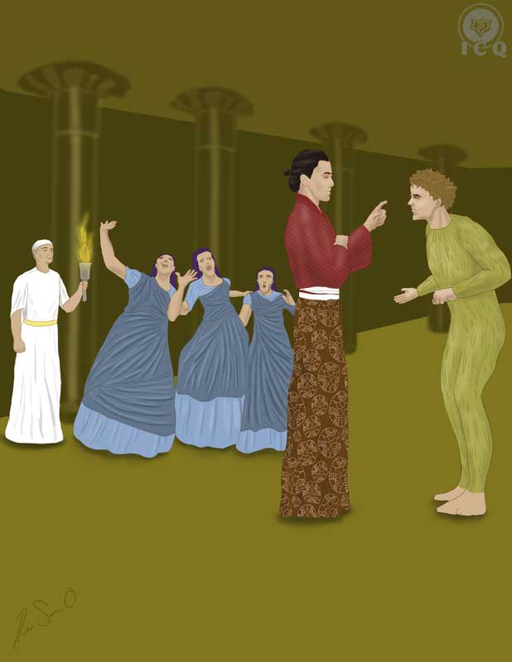

Tamino and Papageno are brought into the temple, in the darkness of the night, by three priests and once inside, the sacks are removed off their heads.

Know all of our tests are administered at “night”, yet distinguish the various meanings of this symbol; one is a symbol of our defects and our ignorance, the other, the august night of the wise ones, which stands for “the silence of the mind”. This particular scene associates the night as a symbol of quietness, peace and wisdom; which happens to be the primordial internal state we must achieve to overcome our tests triumphantly.

Sacks off, Tamino and Papageno do not know where they are; the darkness is meant to take them into a state of reflection and introspection.

Papageno becomes afraid as he faces the darkness and the rumble of thunder; and this is the case of people who are superficial, they become afraid any time they have to confront their own mistakes, the dread the moment they have to face their wrongdoings, and they are afraid of performing an introspection to know themselves. They prefer to “be as they are”, to live life with no changes, living in self-deceit and fascinated with all those things upon which they have incorrectly assigned some value.

Once their period of reflection is complete, the priests walk in carrying torches to observe the internal state of the aspirants and they probe them with questions; the objective of the priests is to know if they are determined to walk the inner path.

Our Mission in Life
Thousands, perhaps millions of years ago we emanated from an ALL which has no name and no end, with the sole purpose of returning into The ALL self-realized; we emerged as simple innocent sparks and our duty is to return as a flame of wisdom, but we have become lost. We veered off the path and the path to return is taking life as an initiation itself.

For many lives we have roamed to and fro living with no sense at all and yet, here we are holding the wisdom of Gnosis on our hands. It is possible for us to return to that path from which we have veered off, with the caveat that we must define ourselves to walk it. This is why Tamino and Papageno are asked:

“SECOND PRIEST
You strangers. What do you seek, what impels you to penetrate our walls?

TAMINO
Friendship and love.

SPEAKER
Are you ready to risk your life fighting for them?

TAMINO
Yes!

SPEAKER
You will submit to every trial?

TAMINO
Every one!

SPEAKER
Give me your hand!
[They clasp hands.]
So be it! “
(Mozart & Schikaneder, 2011-2016)

For us, Tamino is an example of the superior attributes we must put into play; our determination must be firm, we must be willing to face any adversity just as it is stated in the transcendent axiom of Arcanum 19:

“TAKE THE SHIELD OF YOUR FAITH AND ADVANCE WITH [A] DECISIVE STEP, BE IT IN FAVOR OF THE WIND OR AGAINST ALL WINDS.”

But we are something very different from that. We are in a constant state of indecision, thus we are not Tamino, but Papageno.

The Internal Silence
The priests walk in, torches on hand, and they ask Papageno if he is willing to fight to conquer wisdom and love, but he is not interested; he is contempt having food and shelter, yet he longs to find a woman.

To understand the meaning of “woman” in this context, we must first explain there are four types of women:

Eve-Venus
Eve-Venus is the alcoholic woman, the one who partakes of the use of drugs, the one who lies, prostitutes herself, adulterates.

Venus-Eve
Venus-Eve is the woman, whether professional or stay-at-home, who seeks to create a well-formed home, who seeks to educate her children, who seeks love, financial stability, etc. She is the woman who will not hurt others but who has no spiritual longings or aspirations.

Venus-Urania
Venus-Urania, beyond being a good housekeeper, is an exemplary mother and she complies with all the responsibilities of being a woman such as being a daughter, a wife, a professional, etc. She works in her individual and particular spiritual revolution, seeks the destruction of her psychological aggregates, makes an effort to sacrifice herself for humanity, and transmutes her creative power. She is the ideal prototype of a woman who is a student of Gnosis.

Urania-Venus
Urania-Venus is the self-realized woman. She has already achieved her mission in life and has become a beacon of light for humanity. Women of this caliber are women in the likes of Helena Petrovna Blavatsky and Joan of Arc.

Papageno is a symbol of both the man and the woman who is satisfied with food, drink and sleep; and there is nothing wrong with that. Divinity is not against that. Simply stated, they are not interested in any internal work, they do not seek an internal revolution and they are not heeding the call of the secret path of life as the path to initiation. However, this does not mean they are exempt from the tests and tribulations of life.

It becomes necessary to live life at a certain level of morality (i.e. Level of Being) to achieve a certain level of stability and this requires of the ability to overcome certain tests; these tests are not as elevated or superior as the ones that will be experienced in the internal secret path, but they will be severe enough to allow receiving the joy of the simple life at home.

Wisdom and love are the two columns of the White Lodge and they are also the two pillars that make every good home and the foundation of any successful enterprise. This is why the priests ask Papageno to make himself willing to follow the rules of the temple because Sarastro, the Solar Priest, has in store for him a woman: Papagena, who happens to be dressed just like him. They ask him to be willing to die, if necessary, but of course this is not associated with the death of the physical body, but the death of the inferior aspects of the human being: to not steal, not lie, to not adulterate, etc.

Papageno must remain silent just as Tamino must remain silent before Pamina. This is the Test of Silence and there are many levels at which this test is applied in life. It is not only related to remaining silent as in “to avoid speaking calumnies, cursing, foul language, intrigue, or foolish speech”; it goes beyond that. It becomes important to learn to not let loose our internal [silent] words against the various dramas we live in life, we must also learn to not judge others whether verbally or silently.

The Internal Silence that we want to exercise is related with something that is already in our mind: a person, an event, our business or another one’s business, what we were told, what such a fellow did, etc.; [we seek to be] without our interior tongue commenting about these things, without internal discourse...

To learn how to remain silent not only verbally, but also with the secret, internal word, is something extraordinary and marvelous.

Many remain quiet externally; however, with their internal tongue they skin their fellow men alive. The internal, poisonous and malevolent chatter produces inner confusion.
(Samael Aun Weor, 1975)

This “Test of Silence” is meant to take place every day of our lives. We need to learn to be less selfish and start thinking more in benefit of others.

Temptation
The elimination of the psychological aggregates that invite the misuse of the power of the word is by itself a Herculean activity that requires courage, diligence, tenacity, and heroic action. But that is not all.

All of the initiatic traditions make it a clear expectation for the practitioner to develop the ability to overcome and transcend temptation; this is clear in the gospel of Buddha, when the demon MARA sends his three beautiful daughters to seduce the Great Initiate with their enchantments, at the time he meditated under the Bodhi Tree (the “Tree of Illumination”). This event itself gives the test of silence a whole new dimension in Mozart’s work, as we can see from the warning issued by the priests to both Tamino and Papageno:

“Beware of womanly wiles:
this is the brotherhood's first duty!
Many a wise man has been beguiled,
has erred and not realized it.
He has found himself abandoned in the end,
his faithfulness repaid with scorn!
In vain he has wrung his hands,
death and despair were his reward.”
(Mozart & Schikaneder, 2011-2016)

Without a doubt, this warning is related to the temptations that are of a sexual nature, as these always end up bringing disaster in the life of those who succumb to them. Temptations are fire but those who become capable of transcending them, receive the light.

The priests offer their warning and leave behind Tamino and Papageno in the temple and soon after, the Three Ladies of the Night make an appearance, tempting them to make them fail. This very same drama is presented in Richard Wagner’s Parsifal, where the women of flowers attempted to seduce the Knights of the Holy Grail; just as it was also seen in the rituals of initiation of the Persian temples, when the priestesses of temptation tried to seduce the candidate to initiation.

The prior seduction of the Flower-Women of KLINGSOR, the Black Magician, is a tradition amongst the Asians. There is no sacred hero who has not gone through the test.
(Samael Aun Weor, 1970)

The Three Ladies make every possible effort for them to break their silence – meaning “every effort for them to fall into temptation”. The three women are a symbol of seduction, similar to that of Eve in the book of Genesis, but though women, they are not specifically pointing at women as the source of temptation, they are simply a personification of temptation for everyone, whether man or woman.

Tamino the Prince, is completely capable of remaining silent before the women, but Papageno is weak and needed of the help of Tamino to pass the test.

As the priests walk in they notice the presence of the women and see how they profane the temple with their efforts to seduce and tempt the men; the priests conjure them and they submerge into the darkness.

As the priests appear, nine sacred sounds (in three groups in three) are also uttered to show the beginning of the work. These nine sounds are an indication of the ninth door of mysteries, the Arcanum of the Hermit in the Egyptian Tarot, a symbol of initiation and intense work with the transmutation of the sexual energy.

One of the priests approaches Tamino to praise him for overcoming the test; in this case the student has overcome obvious sexual temptations that are easy to identify, and yet that so many fail to overcome. Because there are still additional, more severe tests, the priest says:

SPEAKER
Tamino! Your steadfastness has triumphed. But you will have many a hard and dangerous path to tread! - Come then!
(Mozart & Schikaneder, 2011-2016)

Meanwhile Papageno (people with no spiritual aspirations) makes pretend he has passed out. He does not understand why it is that he must endure so many dangers to receive his Papagena.

Obviously, regardless of people wanting or wanting not know about life as a path to initiation, we all must earn our twosome; we must at least pass through the most basic of tests to show we are loyal, that we are not adulterous and that at a minimum, that we live in right conduct.

Chapter 6 – Vengeance and Forgiveness
Act Two, Scene 3

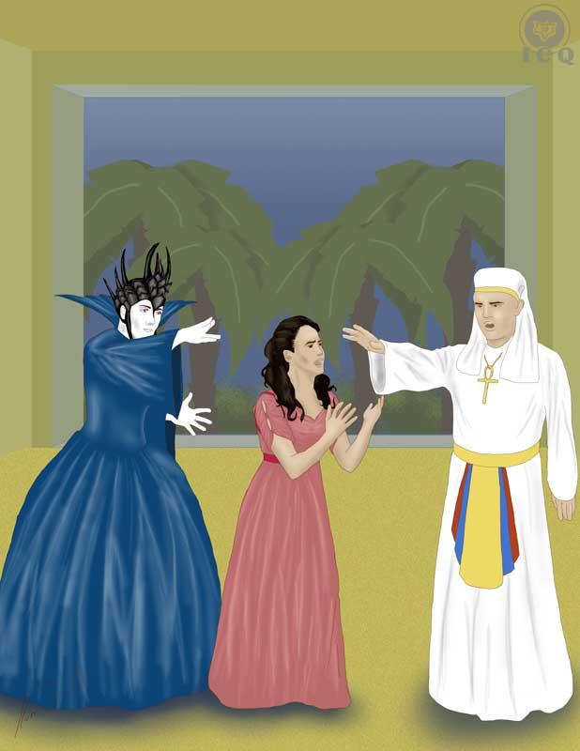

Pamina appears sleeping, a garden in the backstage; moonlight illuminates her face and Monostatos walks in, spellbound before her.

Monostatos is the unfaithful servant that symbolizes us every time we are under the spell of our animal desires. Under those circumstances we are void of understanding, we lack the ability to reason, and we are willing to commit the worst crimes while still believing we are doing the “right thing”. Our ways of thinking are described with his voice:

“MONOSTATOS
Everyone feels the joys of love,
billing and cooing, hugging and kissing;
but I am to forswear love
because a black man is ugly.
Do I not then have a heart?
Am I not flesh and blood?
To live forever without a wife
would truly be hell-fire.

So, because I am alive, I want
to bill and coo and be amorous!
Dear good moon, forgive me;
a white woman has taken my fancy.
White is beautiful! I must kiss her!
Moon, hide your face from this!
If it should offend you too much,
then close your eyes!”
(Mozart & Schikaneder, 2011-2016)

This is the same way that Pontius Pilate condemns the Christ to death and then washes his hands. Just like that we justify our most perverse desires.

One of the most used means of seduction from those who think of themselves as astute, is the pretext of helping a young woman make progress in the internal work by “working” with her to transmute her creative energies. We find this level of justification and thinking everywhere and this requires of all young women to be extremely vigilant, not only to avoid becoming victims, but to also avoid becoming the astute ones who fool others into becoming victims themselves.

The Astral Light
The light of the moon illuminating the face of Pamina is a symbol of the Astral Light; this is a particular magnetism that impregnates a flower as much as a person and it is enchanting, hypnotic and leaves us under the spell of our psychological aggregates, depriving us from perceiving reality but rather perceiving an illusion. Its effect is strong enough to blind us.

When the Astral Light is coagulated in a flower, we fall in love with the flower. If the Astral Light is accumulated within a woman, then men fall in love with this woman.

The man who lives bewitched by many women does not stop being a weak little bird fulminated by the bewitching eyes of she, the temptress of the Astral Light.
(Samael Aun Weor, 1978)

Monostatos quietly and slowly makes his way towards Pamina and at that moment, the Queen of the Night appears between the rumblings of thunder. This awakens Pamina and Monostatos, realizing it is the Queen of the Night, retreats and hides to eavesdrop in their conversation.

Vengeance
The Queen of the Night reacts in anger after inquiring about Pamina’s savior and hearing he has dedicated himself to the initiation. Angry, the Queen retrieves from her garments a dagger and placing it in Pamina’s hands, orders her to kill Sarastro.

The Queen proceeds then to sing perhaps the most beautiful aria of Mozart’s work; the Aria of Vengeance is so powerful and impacting that all who listen to it experience a particular ecstasy. And yet, why would Mozart create such beautiful melodies to emphasize something as terrible as vengeance?

QUEEN OF THE NIGHT
My heart is seething with hellish vengeance,
death and despair are blazing around me!
Unless Sarastro feels the pangs of death at your hands
you are no longer my daughter.
Forever disowned, forever abandoned,
forever destroyed may all ties of nature be,
unless Sarastro dies at your hands!
Hear! Gods of vengeance! Hear a mother's vow!
(Mozart & Schikaneder, 2011-2016)

The Queen of the Night orders her daughter to kill Sarastro and tells her that unless she does this, she will be rejected, repudiated, and that all bonds with her will be broken; she does this swearing before the gods of vengeance. Harsh emotions and cruel words all within the envelope of not only beautiful music, but perfect harmonies.

Without a doubt this blend of harmony and disharmony is a crude reality in our daily lives – which is precisely what Mozart wants us to realize. An example of this dichotomy is the justification of abortion in our modern humanity. Abortion is murder. The essence or soul is bound to the fecundated egg the moment the zoosperm penetrates the egg and from that moment, a life is being set. But our justifications are always beautiful – perhaps similar to the singing of these melodies – and we strive to justify that which is unjustifiable.

But we are unable to see the many mistakes we make because we are submerged in an ocean of beautiful theories that justify our wrongdoings, our ignorance, our fanaticism, and our mistakes. It becomes easy for us to see and call out the mistakes in others, but when it comes to seeing those very same mistakes within ourselves, that becomes too difficult.

The Queen of the Night places the dagger in Pamina’s hands and disappears. On one hand she cannot come to terms with the idea of committing murder and on the other, she suffers the internal conflict of breaking her family ties. As she struggles, Monostatos comes out of hiding and bribes her by telling her he has heard everything and her only way out, to save herself and her mother, is by loving him. Pamina rejects this and in anger, Monostatos tries to kill her.

But Sarastro walks in and stops Monostatos’ action; he flees and as Pamina realizes all this drama has come to light, she begs for forgiveness for her mother.

Forgiveness
Because the divine law is a perfect balance between severity and kindness and justice and mercy, with infinite compassion Sarastro tells Pamina how it is that he will exercise “vengeance” against her mother, and emphasizes that vengeance by itself, it not part of his plans:

SARASTRO
Within these sacred portals
revenge is unknown,
and if a man has fallen,
love guides him to his duty.
Then, with a friend's hand, he walks,
glad and joyful, into a better land.

Within these sacred walls,
where man loves fellow man,
no traitor can lurk,
because enemies are forgiven.
He who is not gladdened by such teachings
does not deserve to be a man.
(Mozart & Schikaneder, 2011-2016)

The inability to forgive has darkened our homes. We create our own individual inferno whenever we start living taking note of all the wrongdoings of others and seeking revenge. This is nothing more than selfish love, but let’s understand that this is an aspect of our Pride; this similar to us thinking we are the center of the universe and that others should acknowledge our greatness.

Many marriages—that could be truly happy—are disgracefully unhappy, due to old resentments accumulated within memory.

If spouses had generosity, they would forget their painful past and would live in plenitude, filled with true happiness.

The mind kills love, destroys it. As well, experiences, old discussions, past jealousy, all of these accumulations of memory destroy love.

Many resentful wives could be happy if they had enough generosity to forget the past and to live in the present adoring their husbands.

Many husbands could be truly happy with their wives if they had enough generosity in order to forgive old errors and forget the quarrels and unhappy situations that have accumulated in their memories.

It is necessary and essential for married couples to comprehend the profound significance of any given moment.

Husbands and wives must always feel as if they were recently married, forgetting the past, and living happily in the present.

Love and resentments are incompatible atomic substances. Thus, resentments of any kind cannot exist within love. Love is eternal forgiveness.
(Samael Aun Weor, 1970)

Mercy is a pillar of the divine justice and thus, it should also be a pillar in our lives. We must learn to forgive, but beyond simply saying “I forgive you”. We must learn to forgive others but as a result of our ability to “walk in their shoes”, of seeing things from their perspective and feeling what they feel.

In reality, we cannot be referred-to as true human beings if we cannot integrate these sacred teachings; we must learn to truly forgive, learn how to sincerely express love for one another, and to demonstrate this with our actions.

The very same key offered in the Magical Flute is given to us by the Great Master Jesus in the Our Father prayer when we say: “Forgive us our trespasses, just as we forgive those who trespass against us”; if we are willing to ask for mercy, we must first learn how to forgive. This implies the internal work of the elimination of those psychological aggregates of vengeance, resentment, and even those aspects of us that tend to tally and take note of the wrongdoings of others.

But fact is that our behavior shows we are far from expressing those superior virtues. We are the true representation of Monostatos or perhaps the Queen of the Night. That is why the human race is referred-to as a collective of “intellectual animals”; there is much to be learned before we can earn the title of “Man”.

We have the opportunity and we must make an effort to liberate ourselves from the inferior laws that cause us so much suffering; yet we tend to hold on to them with our desire for revenge and our impulse to take justice in our own hands. We need to make an internal change so that we can shift onto living a life that is based on superior laws, all of those that manifest when we become capable of forgiving and expressing both, kindness and compassion.

For as long as we continue identified with our own concept of self, it becomes impossible to forgive. It hurts when someone insults you, it hurts when someone humiliates you, it hurts to be felt disregarded. Why is that? Simply because we carry the “I” of pride; we have this strong conviction of self-love and for as long as that exists, any time your self-love becomes hurt, you suffer. Thus if we do not identify with it, then it becomes easy to forgive others, and I will say something else: it will become easier to cancel the debts of others, and that is the best.”
(Samael Aun Weor, 1999)

Our duty as human beings is that of sincerely helping and serving others, with no expectations of any rewards and renouncing of any retributions; our duty is to help others for the sake of alleviating the suffering of others, because serving them becomes an impulse that emanates from our hearts and because we can acknowledge that the suffering of others is our suffering as well.

All the social disasters we evidence around us result from the harm we cause others and our indifference to that suffering is a source of our own karma.

Karma is paid not only for the evil that is done, but also for the good that could be done, yet is left undone.
(Samael Aun Weor, 1978)

Chapter 7 – Temptation is Fire
Act Two; Scene 4

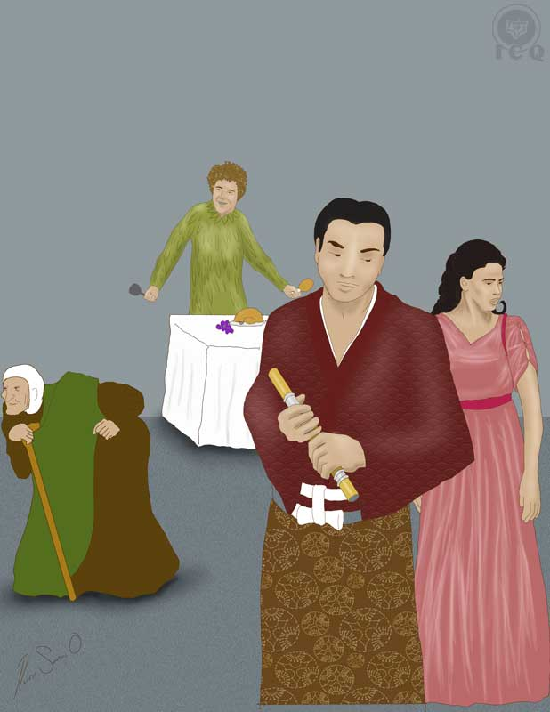

The priests lead the aspirants to initiation into a hall and before leaving them, warn them of the silence they must keep the moment women stand before them. Without a doubt this is an allegory to test their ability to overcome temptations of a sexual nature, which are present in the lives of all humans whether candidates to initiation or not, whether men or women, young or old. The role of the woman on this scene is that of representing temptation and the ability to abstain from talking to them represents the ability to resist it.

Papagena
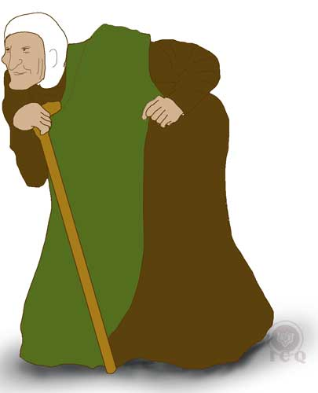
Papageno is unable to hold silence and after a brief moment, starts uttering senselessness. The Prince tries to help him remain silent, but he disregards him. Into the scene walks an old, decrepit woman holding a cup of water and in a gesture, she approaches Papageno and offers it to him. Soon enough it is revealed this is a young woman in an old woman’s costume; the wife Sarastro has set in Papageno’s destiny.

Papagena is eighteen-and-two-minutes years of age and Papageno is ten years older than; a key condition for their relationship. This is so because to partake of marriage our physical bodies must have reached a state of maturity; in the case of the woman, this maturity arrives at eighteen years of age. Any intimate contact before the age of eighteen is thus a violence against nature, hence her age set at “eighteen-and-two-minutes”, as an indication that her body is ready and “at the right time”. For the man, the age of maturity is the age of twenty one.

The difference of ten years between them can be interpreted according to the kabbalah; “ten” is the number of the Wheel of Samsara, the wheel of recurrent births and deaths. In this context, the union of Papageno and Papagena, with her being “sent by divinity” [Sarastro], and the number “ten”, states that we must indeed be patient and not despair; there is that “special someone” for each one of us and they will show up, according to the decrees of the divine law, at their right time.

Meanwhile Papageno’s cluelessness about who the old, decrepit woman offering him a drink may be is a reflection of the level of distraction or the deep state of sleep of our consciousness, a condition which affects us on a daily basis; we are in fact distracted by appearances and the illusion of things, we fascinate with the appearance of things while we are unable to see “the thing itself”; we are blind to the many realities that surround us and perhaps within our blindness, we live life unaware and not realizing our future spouse may be walking next to us all along.

Thus Mozart issues the recommendation to all to not be impatient like Papageno, but rather to make the necessary effort to “pass the tests of life”, or as in this case, to remain silent, as passing these tests will effectively result in internal changes that will shift us into a superior level of morality and with that transition, the law of universal magnetism will bring us together with that person who has been “there”, all along.

When Papageno asks the old woman her name, a loud thunder interrupts, muffling her voice and forcing her to leave. This happens because Papageno’s senseless chatter is a demonstration that he is not ready yet, that he is still identified with mundane passions; he is in a condition where he is not serious about causing any internal transformation, fascinated by the desire of wandering to and fro in life, with no restraints.

The Bread of Substance
The Three Boys appear and return to both Papageno and Tamino their magical instruments; they also provide them with a table full of delicacies as a reward for their efforts.

THE BOYS
Welcome for the second time,
you mortals, in Sarastro’s realm! –
He sends you what was taken from you,
your flute and your chime of bells.
(A table with food and drink rises from the ground.)
If you do not scorn food,
then eat and drink of it with pleasure! –
When we meet for the third time,
joy will reward your courage!
Tamino, take heart! – Your goal is near!
You, Papageno, keep quiet! –
(Mozart & Schikaneder, 1791)

The ability to listen to the call of the consciousness is a faculty that each one of us must develop because through it we receive indications if what we are doing is correct or incorrect; it is the voice of the internal judge and feeling remorse for our actions is one of its functions. The Three Boys are a symbol of that voice and like Tamino and Papageno, it is our duty to pay attention to the call of the consciousness.

The Three Boys bring them the bread of sustenance or the same “daily bread” we ask-for when we pray the Our Father prayer; but this bread is not meant to be physical bread but rather the SHEKINAH of the Jewish theology which is the light and glory of divine presence: it is divine wisdom.

The phrase “daily bread” refers to the “bread of substance” of the Greeks, which is the same as “the bread from above”.

Gnosis gives us this bread of life in the sense of ideas and strengths necessary to disintegrate our psychological aggregates.

Each time we reduce to cosmic dust this or that “I”, with that reduction comes psychological experience, which is the same as the “bread of wisdom”; we receive new experiential knowledge.

Gnosis gives us “the bread of substance”, the “bread of wisdom” and it shows us, with utmost precision, that a new life starts within oneself, here and now.
(Samael Aun Weor, 1975)

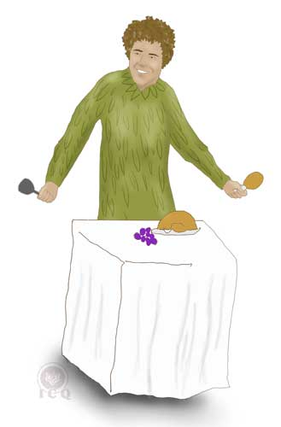
This intricate scene is an elaborate, allegorical representation of a fragment of the Invocation of the Wise Solomon where the Master prays:

HASMALIM illuminate me with the splendors of the ELOHIM and SHEKINAH!

HASMALIM is the choir of angels that rules over the realm of the Innermost and with this invocation, the Master pleads to his Father who is in secret for the light of wisdom in the name of the angels who rule over the region of CHESED (the sphere of the Christ).

ELOHIM is a word of Hebrew origin which means “gods and goddesses” and as a name is used to address the collective of self-realized masters; their “splendor” is the collective of their virtues, abilities, powers, and the light of the wisdom they offer humanity; SHEKINAH is the “bread of substance” or divine wisdom. In this very scene we see all of these aspects come together.

The Wail of Pamina
While Papageno eats of the meal brought by the Three Boys, Prince Tamino plays his flute and Pamina listens to its melody, prompting her to follow the music and finding them. But Tamino must remain truthful to his promise of holding silence which she misinterprets as rejection and thinking he no longer loves her. Because of this she woes in sorrow and sings the following:

PAMINA
Ah, I feel that the joy of love
has gone for evermore! –
Never will happiness
return to my heart!
See, Tamino, see these tears

that flow, beloved, for you alone.
If you do not feel love’s yearning –
I must seek peace in the grave!
(Mozart & Schikaneder, 1791)

The sadness expressed by Pamina is meant to move Tamino’s soul and the sentimental conflict it generates is equivalent to that of the singing of the mermaids in Homer’s literary work Odyssey; just like Ulysses’ sailors were threatened of falling before the hypnotic power of their songs, the same happens to Tamino as he faces the potential of getting “distracted” from the Great Work. The song and its melody are beautiful, yet if we allow ourselves to fall for the distraction, the act of identifying with them would take us into total failure, just like Ulysses’ sailors were precipitated unto death.
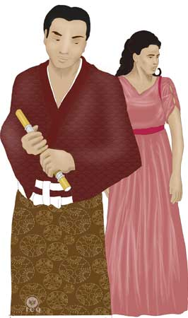
The Magical Flute presents for us in this scene a very sophisticated type of temptation where both, sentiments and the fire of passion come together. On one hand we have Pamina’s sentiments and the suffering she feels by incorrectly believing she is being rejected, on the other, her beauty as a symbol of eroticism – the force of Eros. This drama teaches us the importance of wisely combining eroticism with spirituality, which means that we must not “fall into temptation”. Just like Hercules was able to steal the golden apples from the garden of the Hesperides (the nymphs who were the daughters of Atlas), a symbol of the forbidden fruit, he did so but without eating them; such is the wail of Pamina as a temptation for Tamino.

This specific segment of Mozart’s work is profound in wisdom; it speaks of the effort required to bring an end to our passions, it teaches that for true love to manifest, there must be a willful rejection of our animal passions and it also tells us that sexuality is not void of spirituality. All of the great heroes have seen themselves facing this very same temptation, one of them being Krishna – the Great Master of India – as he faced Nysumba the magician, daughter of the king of the serpents;

As Nysumba and the seven priestesses of temptation of the Syrian Druze try to seduce the initiates, Krishna at the head of the chariot, stares through them with his fiery eyes; this constitutes the basic foundation of all esoteric studies.
(Samael Aun Weor, 1970)

Nysumba, the magician, transformed herself into a young, beautiful woman who lured Krishna by presenting herself resting seductively on a bed dressed with red sheets, wearing golden ornaments on her arms and her ankles, adorning her head with a crown of precious stones, enveloped in a cloud of perfumes that emanated from a cauldron of copper; and this is how temptation works its way with the most subtle enchantments.

Luring Krishna with temptation, Nysumba offered him all power claiming they were destined to each other; she lurched a stare off her dark eyes that shook Krishna, but the hero was able to see through this and with his fiery eyes he pierced through Nysumba, seeing in her eyes the abyss, serpents, desire, and death. Krishna rejected Nysumba and in consequence she lost her beauty, remaining aged, angry and wrinkled.

Krishna’s rejection of Nysumba, just like Parsival’s rejection of Kundry is the same rejection Tamino delivers Pamina; it is a symbol of being capable of loving with all of the power of the soul while still rejecting the animal passion.

Temptation is fire and defeating temptation creates light. Temptations are the means through which aspirants are tested and each temptation is akin to taking a test; pass the test and the reward comes as new powers, faculties, virtues and abilities however, failing the test always implies a loss of values, because everyone is tested based on the extent of their capabilities. What we have learned from the Great Master Jesus through the Our Father prayer is “lead us not into temptation, but deliver us from evil”, which is not us asking to be excluded from these tests in life, but a petition to receive and hold the necessary spiritual strength to overcome them.

Regardless of how big and overwhelming they may feel, temptations can be of much use to man, as they humiliate, purge and educate. All saints endured temptations and tribulations and they took advantage of them, yet those who chose to not suffer and endure, failed. There is no such thing as order, neither religion so deserving, nor place so secret, where adversities and temptation are not somehow present.
Thomas de Kempis – The Imitation of the Christ

It is of true heroes as Parsifal and Krishna to defeat oneself and there is where we find the true warrior; the battlefield is within our own internal universe.

Chapter 8 – Admission into the Mysteries
Act Two, Scene 5

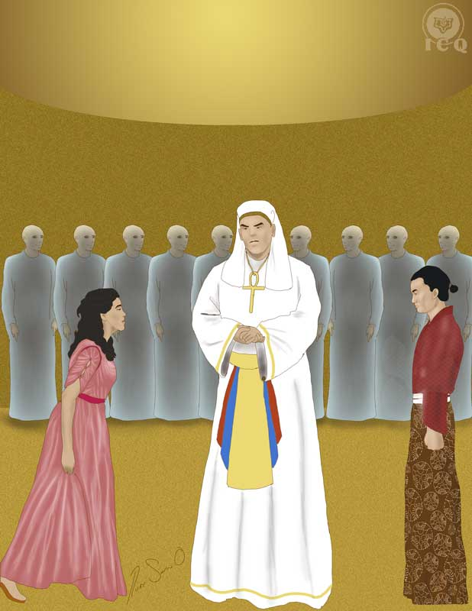

One of the greatest joys of the consciousness is to be admitted into the gnostic mysteries and to work on them, intensely, throughout existence. That is because we have not always been admitted into the teachings of this wisdom; there have been many lives where we have lost ourselves into the desert of theories, thus we must make the most of these moments when we are allowed to contemplate this light of wisdom.

However there is a significant difference between learning about the gnostic mysteries and putting them into practice; Sarastro and the priests enter into a hall and full of veneration and devotion address their internal Father-Mother:

PRIESTS
O Isis and Osiris, what bliss!
Dark night is banished by the sunlight,
soon the noble youth will feel new life;
soon he will be wholly devoted to our service.
His spirit is bold, his heart is pure,
soon he will be worthy of us.
(Mozart & Schikaneder, 1791)

Just because we know of these mysteries does not mean we have been admitted into them; we must endure in flesh our individual version of the tribulations outlined in Mozart’s Magical Flute; whether at work or at school, while tilling the land or housekeeping; it is there where we should demonstrate we can emerge triumphant from all the adversities, problems and difficulties we face in our day-to-day life.

We live in the midst of ignorance and wrongdoings, but the bright light of internal wisdom can allow us to find our way into a life that is edifying and dignifying. As is said in the Magical Flute, we must hand ourselves in totality to the work of the initiates; our life and all of its details must become the path to initiation.

This is why when praying the Our Father prayer, Jesus says: “Thy kingdom come”; we must ask with all of the strength of or soul to see the manifestation of our Father who is in secret (OSIRIS) and our Divine Mother (ISIS).

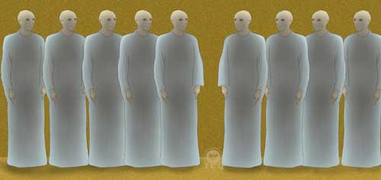

We must live our lives with a courageous spirit and willing to take heroic action before the adverse circumstances of life. Master Samael Aun Weor states: “Heaven must be taken by assault and it is the courageous ones who have succeeded”, an indication that the work demands of plenty of spiritual strength, but courage is not all that is needed. We must also present ourselves with a noble and pure heart, which means that throughout life, we must succeed the temptation of falling into negative emotions as jealousy, envy, anger, etc.

As we live life in this way we start gaining these faculties and we start becoming proficient applying these superior values in our daily doings; it is then that we become ready for initiation.

People in general have incorrect considerations and ideas of what this “initiation” actually is; some think there will be a shaman or a witch doctor that will dance around while they are being covered in smoke, hearing unintelligible words and that will make them “initiates”, but the initiation is not that. To be an initiate we must incarnate the virtues, faculties, powers, laws, and abilities of the Being; we need to transform ourselves by living a life of right action, right thought and right sentiment. There is nothing spectacular about initiation.

The Guardian of the Threshold
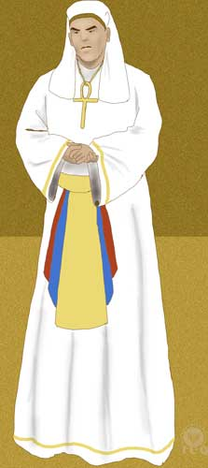
The initiations that are practiced here on Earth are symbolic in nature and they are a teaching to the consciousness of what must be lived in the internal realms. All the drama lived by Tamino in the Magical Flute must be lived by each one of us.

Once the chant to OSIRIS-ISIS is offered, one of the priests takes Tamino into the main hall:

SARASTRO
Tamino, your behaviour so far has been steadfast and manly. Now you have two more dangerous paths to travel. - Let Pamina be brought in, blindfold!
(Mozart & Schikaneder, 1791)

This marks the very beginning of the work. In Gnosis these are known as the tests of the Guardian of the Threshold; where the aspirant faces himself, discovers what he actually is, confronts the misery of his internal condition in the realms of desires (the Astral Plane), his thoughts (the Mental Plane) and his willpower (the Causal Plane).

These tests require of much courage because the aspirant must be capable of confronting himself “as-is” and with no filters, and just a few are capable of such confrontations. This work requires of plenty of self-observation; of learning to wisely route our attention to what we are, to the sentiments and the thoughts we express in our daily doings; and just as important, to make the most of those circumstances where we easily get angry or believe we are superior to others.

Here is an excerpt from the ceremonies practiced among the ancient Aztecs, specifically on those who strived to become Eagle-Knights in ancient Mexico:

Among the chambers in this temple of mysteries was the Tzinacalli (the house of the bat), an expansive room akin to a somber cavern where the rituals of initiation to reach the high degrees of a Tiger-Knight (Ocelotl) and Eagle-Knight (Cuauhcoatl) were ordered. Above the lintel of a small door at the far-end of the cavern, which led into the temple, hung an obsidian mirror and before the threshold, a bonfire made with branches of pine trees.

The candidate to initiation was taken into the Tzinacalli where he was left alone at the late hours of the night. His instructions were to walk within the darkness towards the bonfire and to stand before it, invoking the guardian of the threshold by saying:

“I am a child of the Great Light, darkness, shed away from me”

Bats would start revolting and squirming over the head of the candidate. As the bonfire burned out, the fire of the remaining embers reflected itself in the mirror. Suddenly, with a loud beating of wings, a terrifying screech and a human silhouette with the wings of a bat and a maxtlatl wrapped around the waist, this form charged against the candidate propelling itself from the darkness and threatening to decapitate the intruder with his sword.

Woe of the candidate who retreated in fear! To those a door, till then concealed within the rocks of the cavern, would silently open and a strange figure would become visible, pointing the way to the path leading to the world of the profane, from where the candidate had come.

But those who had the necessary strength of character and who were capable of withstanding the threat brought up by Camazotz (the Bat god), would witness a door, hidden before them, open and a Master walking towards him to uncover and burn a hidden effigy of the candidate that had been previously made with amate paper; meanwhile other Masters would greet and welcome the candidate, inviting him to walk into the temple. This ritual symbolized the death of the passions of the personality of the initiate as he walked from the darkness and into the light.

The candidates were subjected through different tests in the schools of mysteries of the ancient Nahua and their animal soul used to be portrayed as a bat because, like the bat, their soul was blind and void of power, as it lacked the spiritual light of the Sun.
(Samael Aun Weor, 1973)

As we can see, there is no fundamental difference between the wisdom of ancient Mexico and the chanting of the priests of OSIRIS-ISIS; spiritual light can illuminate us but for that to happen, it is necessary that we become capable of recognizing our own defects with no justifications of any kind.

Initiation has nothing to do with theories, or with the reading of hundreds of books, just like it is neither having dreams of beautiful temples, nor dreaming of angels or “beings of light”; initiation is a matter of things of substance and learning how to live. It is not uncommon to find way closer to an initiation the humble farmer who irrigates the land with the sweat of his efforts, or the factory worker who attends to his job with happiness, gratitude and gratefulness, than one of us who believes is the reincarnation of this or that great ruler or who call themselves with fancy “illuminated” names.

Initiation is the exact opposite of the pride felt by one referring to oneself as “Illuminated” an “old” or “very developed” soul; the first step in the path of initiation is the recognition of our nothingness, acknowledging we are a legion of psychological defects, and to make oneself conscious that our person is controlled by many different “I’s” that make our life miserable.

Those who are capable of this can (consciously and in the Astral Plane) ask their Real Being (or Spirit) to grant them the opportunity to receive the test of the Guardian of the Threshold.

The first test the disciple must endure is that of the Guardian of the Threshold. This is certainly a horrendous test and those who are not ready for it become terrified before the larva of the threshold. The Guardian of the Threshold is the very root of our animal self, and its mantric name is Satan. It is – we should perhaps say – the depth of our “Satan”. It is the personification of our past with all of its horrendous defects.

We carry within ourselves this aspect of the threshold and within the internal planes the disciple sees everything through the eyes of that animal self; he sees everything tainted with the colors of his own personality and thus fails to see things as they truly are. Yet once the disciple is capable of consciously unfolding in his Astral Body, can and must invoke the spectre of the threshold and then, that which exists within the disciple is projected outside, presenting itself and threatening him. This event is preceded by winds of death; the disciple courageously confronts the specter of the threshold and defeats him with his valor and force of love, causing him to flee.

From there on, the disciple remains alone, illuminating himself with his own light, because the light that showed him the path at first is now gone and now he must illuminate himself with his own spiritual oil. He was illuminated before by the spirit of his race, family and nation; now these spirits have abandoned him and the disciple becomes responsible for himself, as he has acquired more responsibility before the laws of the cosmos.
(Samael Aun Weor, 1950)

The test of the Guardian of the Threshold must be passed three times, once in the Astral Plane confronting the reflection of all of our desires; a significant challenge to the aspirant as he will be confronting an entity where all of our desires – of lust, of greed, of envy, of anger, etc. – are personified.

Later on we will face the Guardian of the Mental Threshold, which is a reflection of what we are in the realm of the mind; our murderous egos, our depravity… all we are and do with the mind will be reflected in this entity. If we are lustful this guardian will present itself as a monstrous canine, because that is what we are on a mental level and the test is in fact, the discovery in the realm of the mind of the reflection of what we are capable-of while being in the physical plane.

The third test is that of confronting the reflection of all of the hundreds of defects associated to our ill will; all of those ill desires we project unto others, all of our criticisms, our negligence with our internal practices, our negligence helping others, etc.; this all reflected as a single entity, a reflection of what we are within the realm of causality.

However this is just the beginning of the work and we see in the Magical Flute the many virtues that we must develop ourselves. Soon after this event in the halls of the temple of OSIRIS-ISIS, the candidate must put to the test his morality and that is why the priest warns Tamino that he faces two additional paths…

The Suffering that Comes from Impermance
Pamina is brought in darkness into the chamber and once inside, Sarastro removes her blindfold. She immediately seeks of Tamino and asks for him, and their reply to her is that he makes himself ready to say his goodbyes, as he prepares to face harsher tests.

PAMINA
Am I to see you no more, my dear one?

SARASTRO
You will see each other again with gladness.

PAMINA
Mortal dangers await you!

TAMINO
May the gods preserve me!

SARASTRO
May the gods preserve him!

PAMINA
You will not escape death;
a premonition suggests this to me.

TAMINO, SARASTRO
The will of the gods be done;
their beckoning shall be my/his rule.

PAMINA
Oh, if you loved as I love you,
you would not be so calm.

SARASTRO
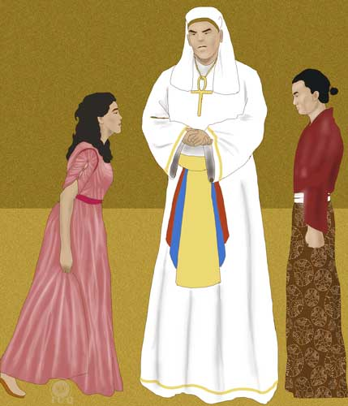
Believe me, he shares the same feelings,
and will be faithful to you forever.

TAMINO
Believe me, I share the same feelings,
and shall be faithful to you forever.

SARASTRO
The hour has struck, now you must part.

TAMINO, PAMINA
How bitter are the sorrows of separation!

SARASTRO
Now Tamino must depart again.
The hour has struck, now you must part.

TAMINO
Pamina, I really must depart!
How bitter are the sorrows of separation!

PAMINA
Now Tamino really must depart!
Tamino!

SARASTRO
Now he must depart!

TAMINO
Now I must depart!

PAMINA
You must depart then!

TAMINO
Pamina, farewell!

PAMINA
Tamino, farewell!

SARASTRO
Now make haste.
Your oath calls you.
The hour has struck; we shall meet again.

TAMINO, PAMINA
Oh, golden repose, return!
Farewell, farewell!
(Mozart & Schikaneder, 1791)

We once again notice the difficult reconciliation of three factors: love (between Tamino and Pamina), separation (necessary to endure the tests of initiation) and death (the dangers faced by Tamino in his tests).

Though these factors appear to contradict each other, the mysteries of supra-sexuality conciliate them. These mysteries of the super-dynamics of love were studied in all of the ancient schools of mysteries, whether Aztec, Maya, Egyptian, Inca, Hindi, Buddhist, etc.

These mysteries speak of the power of sexuality when it is adequately combined with spirituality. This power has the ability to give form to the GENIUS LUCIS – the Genie of the Light – capable of realizing the most powerful magic however, for this Genie to materialize there must exist love, spirituality, and the capability of separation from our animal desires at the time of the intimate contact of love, just as St. Augustine stated: “the sexual act is another form of prayer”.

The Alchemists of the middle ages referred to this act of love as the laboratorium oratorium, because in the combination of these three factors (love, death and separation) combined with the application of mysticism (oratorium), results in energies that are transmuted (laboratorium).

The reference to Tamino’s facing of “mortal dangers” is associated to the work in this laboratorium oratorium, as it is at the moment of the intimate union that the couple develops a superior electrical power capable of disintegrating their psychological aggregates; it is precisely at that instant of loving bliss when the couple is capable of directing that sacred fire to destroy the defect that has been previously observed and comprehended through meditation.

Raise high your cups in this feast of love and be watchful, safeguard thyselves from spilling not even a drop of the precious wine…
(Samael Aun Weor, 1970)

The mysteries of transcendental sexuality are a profound, ancient science; a wisdom impossible to be delivered in single discourse and accessible only to those who sincerely seek of the light. This is a teaching that is delivered in the didactics of advanced level studies in Gnosis.

Chapter 9 – Free Will
Act Two, Scene 6

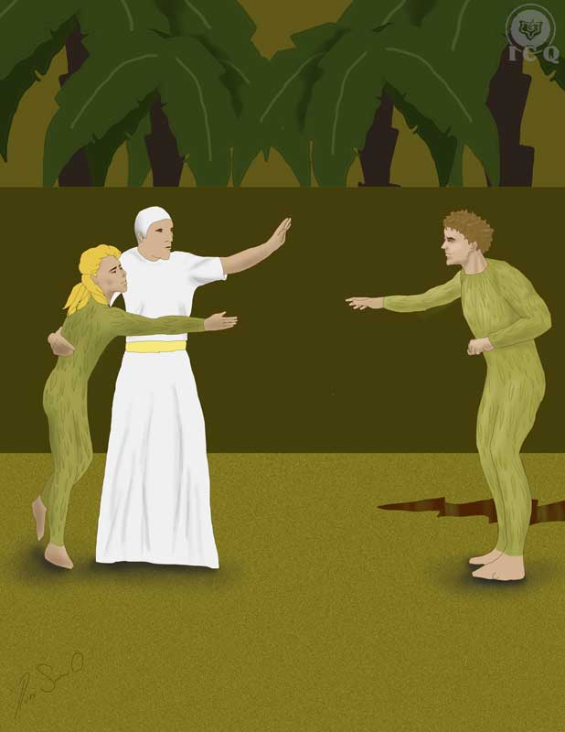

Free Will is an unbreakable law; each one of us is free to choose taking the path of initiation or not. What people generically call “God” cannot be a tyrant, demanding attention and praise, thus we are free to make of our lives what we want however, we must keep present there are consequences for all our decisions and actions, both from our good ones and our bad ones.

We will be safe from earning karma for as long as we do not hurt or harm others. We earn karma any time we steal, kill, adulterate, lie, or for example, exploit others, so it is incorrect to think that if we are enjoying today of the fruit of Gnosis, that tomorrow we will be punished for moving on and leaving the train of Gnosis behind; that is false. Each one of us is free to do as they please and if for one reason or another you choose to leave behind the path to initiation, then that is acceptable, as that action is of your own choosing.

This is the symbol embodied by Papageno; he is a reflection of those who are not interested on living life as the path to initiation and who are happy with living their lives enjoying three meals a day, having a home, and having children; there is no crime in that.

In his effort to follow Tamino, Papageno gets lost and disoriented; he tries to walk through the same door Tamino has entered, but a thunderous voice remarks “Retreat!” As he tries to backtrack his steps, the same voice commands the same, causing him to cry not knowing what to do.

A priest notices he has failed the tests and that as a consequence he will neither enjoy of the joy and bliss of the initiates, nor have access to the superior planes of consciousness or the sacred mysteries and divine wisdom.

But Papageno is unmoved and shows his lack of caring by justifying there are many more people like him; so for him a glass of wine brings enough satisfaction and as such, a cup of wine emerges from the earth. The wine is exquisite and as he drinks it, he feels the need to be next to a woman.

PAPAGENO
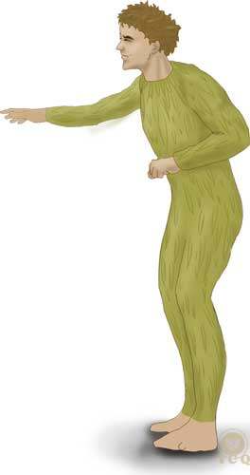
A sweet heart or a wife
is what Papageno wants!
Oh, a soft little dove
would be bliss!
Then food and drink would be pleasant,
and I could match wits with a prince,
enjoy life as much as a sage
and think myself in Heaven!
A sweetheart, etc.
Ah, can I not please even one
of all the charming girls in the world?
One must come to my aid,
or else I shall surely die of grief.
A sweetheart, etc.

If none will offer to love me,
the flames of desire will consume me;
but if I am kissed by a woman –
I shall be happy once more.
(Mozart & Schikaneder, 1791)

Living life as the path to initiation is not for everyone, and for Papageno, the decision to live life beside a woman is no crime.

Samael Aun Weor shares in his book The Mystery of the Golden Blossom, an experience from his Astral travels where he met Goethe, author of the Faust, and they held a conversation about precisely this topic:

The splendor of the stars on the infinite heavens and below, the sound of the waves as they crashed on the sands of the beach.

He and I were having a conversation while at the edge of the cliff and while exchanging ideas, I decided to ask some point-blank questions:

- Do you now have a physical body? To which he answered in the affirmative.
- Is your body masculine or feminine? And he answered “my actual body is feminine”.
- Where have you incarnated? “In Holland” he said.
- Are you in love with someone? “Yes” and continued by saying: “a Prince from Holland and I am thinking about marrying him at some defined date” (May the reader excuse the date is not shared).
- I thought your love would be strictly universal; love the rocks (I said), the mountains, the rivers, the seas, the bird that soars and the fish that swims within the deep waters. “Isn’t human love a spark of divine love?” he replied.

This answer stated by Goethe as a question left me dumbfounded, amazed. Undoubtedly, the great poet had stated an irrefutable, incontrovertible, exact truth.
(Samael Aun Weor, 1971)

To long for a home and live in marriage is a human right; if someone is not ready to walk into the path of initiation, they should at least gather what is necessary to live a good life in a way that is deserving of love; which means that it is indispensable to not be adulterous, or a thief, or a murderer. The person must at least reach the level of being of “a good housekeeper”.

Papageno fails before the most elemental tests of the initiation, but failing does not mean the Divine Law will disregard and “forget” about that essence, as that would be a similar cruelty as discarding a delicate flower that is still not spiritually mature however, Papageno must meet the basic human requirements to find its twosome.

Lamentably today, our degenerated society dictates the most absurd norms and habits, so people look for a spouse as if they were looking for furniture in a catalogue; today all that matters are appearances, superficiality and all things illusory. Today it is enough for many to find someone who has a healthy bank account, who is tall or short, with skin that is dark or not, blonde or brunette, with or without a degree – all things which are meaningless when what seeking for the creation of a home ruled by comprehension, kindness and harmony.

With the intent of showing that love exists beyond appearances, Mozart introduces Papagena as a woman that though old and decrepit, enters the scene at the moment she is invoked dancing, though aided by a staff.

Papagena speaks of the need to see beyond the façade created by societal norms and of the need to focus on the values of the soul. The old woman suggests Papageno that he should commit to her and that he should be faithful for the rest of eternity and in turn, she will love him without limit.

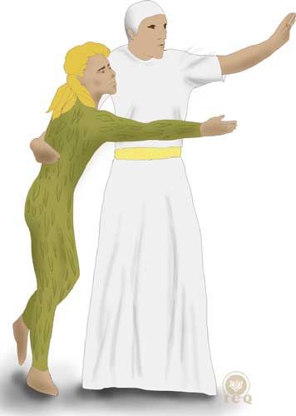
It is absurd for humanity to continue to seek happiness where it is impossible to find it; modern day humans want love, but they are unwilling to abandon what opposes love, for example adultery. We must commit to be faithful for all of eternity – that is the sign we should look for. Lamentably for us, adultery has many faces and many forms of manifestation.

The Ego is mixed, corrupted, populated with vice, false, and it delights itself in justifying adultery by subestimation, by assigning to it ineffable and subtle hues; and the mind gives itself the luxury of covering and hiding it from itself and others. Adultery is decorated and adorned with legitimate norms and divorce decrees, to then be legalized with a new marriage ceremony. He who desires of another woman is an adulterer even if he never copulates with her; I truly say unto you that there is adultery in the subconscious backstage of even the chastest ones.
(Samael Aun Weor, 1970)

Papageno is led to see that he must not hesitate and that he must be decisive and committed, as the alternative is to live in suffering. The moment Papageno makes the decision, the old lady is transformed into a young and beautiful woman; she is dressed as he is, showing us there is affinity between them and that our level of morality, will always bring forth to us someone with a similar Level of Being.

As the scene unfolds, Papageno reaches out to Papagena and a Priest appears asking of her to leave – because Papageno is still not deserving; and as he tries to catch her, earth swallows him.

It will not be until the basic requirements of not carrying so many incorrect behaviors (as is the ego of adultery with all of its faces) that those who are single today will not find their significant others; and for those who today are married, it will not be until they meet these basic requirements that they will not find in their spouse, the tenderness and love they for so long have longed-for.

Chapter 10 – Senselessness
Act Two, Scene 7

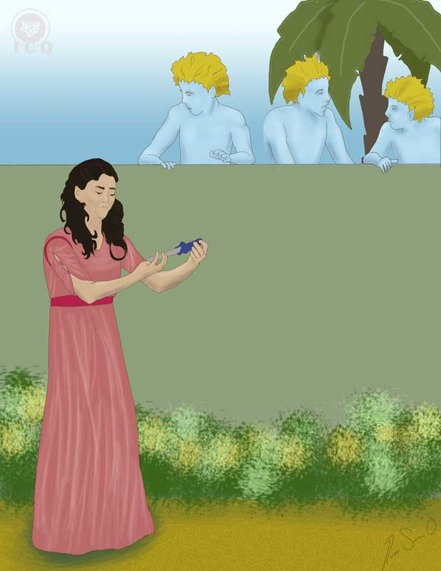

The path to illumination if full of dangers, inside and out. Sivananda refers to this as “the path of the edge of the blade”.

It is very easy to deviate from this path to find oneself lost in the desert of existence or even worse, to find oneself failed. This is why it is of such importance for the aspirant to live a life in a constant state of intense psychological self-observation. It is necessary for us to identify ourselves with ideas that are of a solar nature, to change our ways of thinking and feeling and make our thoughts, actions and sentiments one with the gnostic wisdom.

The Three Boys – the values of the consciousness – descend from the heavens showing us the way and giving us the keys to realize the internal work as they solemnly say:

THE BOYS
The sun, the splendid herald of the morn,
will soon set off upon his golden course –
soon will doubts disappear,
soon the wise man will triumph! –
O sweet contentment, descend upon us,
return to human hearts;
then earth shall be a paradise
and mortals be like Gods.
(Mozart & Schikaneder, 1791)

The “Sun” is spirit, wisdom and truth. The Being or the Spirit of every human being is an emanation of this very same divinity; our consciousness, an immortal spark of our Spirit makes every effort possible to manifest, but our poor ways of thinking are an obstacle to this. But the wise human being, those who work intensely upon themselves, comes to discover their own false ideas and becomes capable of transformation. This is how the Sun of the spirit can illuminate us.

The Silence of the Mind
The first thing that must be achieved to enable the manifestation of the Sun in its plenitude, is the silence of the mind. This means we must stop the continual battle of opposites and the duality of the mind. This is why the Three Boys call for calmness and for the spirit to descend and return into the depth of the human heart.

But today we live trapped in the confinements of a mind that is split in duality, which impedes the flow of the light of the Being.

While our mind remains agitated it will continue to be a roaring ocean where it is impossible to see the reflection of the light of the sun, as well as the plenitude of life that exists at its depths. Such a mind makes it impossible for the Being to become manifest.

In its most pure state, the mind if feminine, comprehensive, and it does not react. However today our minds react before any external and internal impression; it turns little problems into big ones just as easy as it justifies our wrongdoings and criticizes and doubts right actions.

All of the Great Masters of Zen Buddhism speak of the urgent need to develop the silence of the mind to reach a state of illumination, and we find this teaching in the Magical Flute as a sweet calmness.

Beloved, change your character through the intelligent action that is free from the battle of opposites.

When the door to fantasies is closed, the organ of intuition awakens.
Action becomes intuitive action when it is free of the battle of antithesis; this is action in plenitude and wherever there is plenitude, the Ego is absent.

Intuitive action leads us by the hand to the awakening of the consciousness.

Let’s work and rest in the joy of happiness, giving ourselves into the course of life. Let’s rid ourselves of the turbid and tainted waters of our habitual thinking and within the emptiness, Gnosis will flow and with it, the joy of living.

This intelligent action that is free from the battle of opposites raises us to a degree where something breaks; when all things start marching correctly, the false ceiling of our rigid thinking shatters and the light and power of the Innermost inundate the mind of those who have stopped dreaming.
(Samael Aun Weor, 1964)

We must not delay developing the ability to meditate to achieve the silence of the mind, we must live from instant to instant in a constant mystical search, like a warrior that fights against himself.

The elimination of the battle of antithesis results in the absolute manifestation of the Being and when united with our Spirit, even if we are still living within this plane of substance, we experience heaven on earth – because this famous idea of a “heaven” presented by all religions is nothing more than superior states of consciousness. The human being who becomes capable of manifesting the light of their individual and particular internal Sun becomes ONE with divinity.

Arcanum 21 – The Fool of the Tarot
Far from being a deck of cards for fortune-telling, the arcana of the Tarot is a precise guide for those who long to not get diverted and lost from the path of initiation. Its images are a system of measurements that every sincere practitioner must follow or else risk deviating from the path of initiation. Whosoever starts walking the path of life as that of the path to initiation but does not work intensely upon themselves, becomes the Arcanum 21 of the Tarot: The Fool.

Frankly each and every one of us could be represented by this particular Arcanum; we use the name of things that are sublime to consistently justify our most abhorrent mistakes.

We are The Fool of the tarot when we abandon our wife and children under the pretext of following a “spiritual path”. The fact of the matter is that it is at home where we find the most adequate environment to enable our spiritual path, discovering our intimate defects and profoundly knowing ourselves. In a same note it is just as absurd whenever someone abandons their job or their studies because they want to follow “the path laid by their ‘Internal Father’”. It is not by us abandoning our responsibilities that we can embark into a life of profound spirituality but to the contrary, we find our best opportunities for internal development as we embrace our daily duties and deliver to them to the best of our abilities.

I must repeat this emphatically: life is the school where we can acquire the necessary faculties for Initiation, as Initiation is life itself.
(Samael Aun Weor, 1950)

Mozart warns of this danger by showing Pamina swayed and confused by thoughts that Tamino no longer loves her; her mind lures her into a battle of opposites and as she becomes trapped in her fears, she becomes lost in duality only thinking the worst.

The Three Boys – or her consciousness – notice her struggle:

THE BOYS
The sorrow of rejected love torments her.
Let’s try to comfort the poor girl! –
Truly, her fate is close to our hearts! –
Oh, if only her young man were here! –
She’s coming; let’s hide
and see what she intends to do.
(Pamina, half out of her senses, comes in with a dagger.)
(Mozart & Schikaneder, 1791)

Pamina feels the curse of her mother and becomes desperate feeling she has lost the love of the Prince and decides to use the dagger on her hands, rather than to give death to Sarastro, to commit suicide.

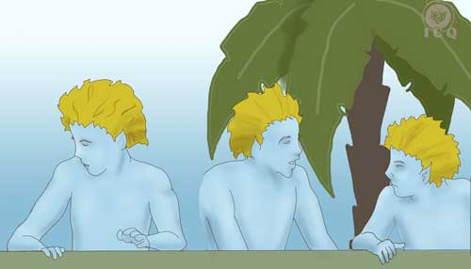
The Three Boys try to persuade her, but she cannot hear them; which is what happens to us whenever the consciousness speaks: it warns us of our senselessness, but we are deaf to the Silent Voice of the heart. Pamina has become The Fool of the Tarot and she reflects the internal state of many who succumb to their justifications as they try to walk the internal path.

The Three Boys are also a representation of superior, transcendental forces that aim to help guide our disoriented hearts, yet we are in an inferior state caught between the fascination with our sufferings and our problems, and the self-imposed lie of thinking that “everything is fine” and that “we are happy”; it is in this confusion that we fail to hear the internal Voice of the Silence. These Three Boys are the Great Masters of the White Brotherhood of the Light, divine beings, angels and devas who seek to guide us.

In the Hall of Children, the Great Masters transform themselves into children to let the disciple know that it is not until we become innocent as children that we will not be able to enter the kingdom of heaven. This is why all Ancient Initiates were referred to as ‘children’.
(Samael Aun Weor, 1950)

Pamina makes an attempt to take her own life but the Three Boys stop her, telling her Tamino profoundly loves her and he would die if he were to find she had perished. These words take Pamina out of her somber and lead her to realize the grave mistake she was about to commit.

As aspirants to enter the path to initiation, we must develop the ability to listen to the Internal Voice, which is why meditation must become a daily practice as an esoteric discipline of the mind. When we reach that divine calmness and achieve the “quietness of the mind”, we reach an internal state that enables us to listen to the voice of the consciousness.

As Pamina reacts, she questions Tamino:

PAMINA (recovering)
What? Did he return my love
yet hide his feelings from me –
and turn away his face?
Why did he not speak to me? –
(Mozart & Schikaneder, 1791)

Pamina asks questions as she seeks answers, yet we see the silence of Tamino and afterwards, the silence of the Three Boys as they keep in secret the reasons behind Tamino’s silence. This brief act of Pamina is an enactment of seeker who wants wisdom “on their own terms” and who constantly look for the “unveiling of the mystery” – the seeker questions and wants to know, yet the wisdom is kept from them. That specific mystery is the mystery of supra-sexuality that, in ancient times, was only unveiled to those who had already awakened their consciousness and who had demonstrated loyalty to the wisdom after successfully completing a number of tests.

THE BOYS
We may not tell you,
but we will show him to you,
and you will see with wonder
that his heart is wholly yours,
and that he would risk death for you!
Come, let’s go find him.

PAMINA
Lead on, for I must see him.
(Mozart & Schikaneder, 1791)

True love emerges only after working intensely in the elimination of our animal passions; this is the work that enables the emergence of extraordinary faculties, virtues and powers, as love is the very force that gave birth to the universe.

A Talisman of Protection
They all come together and intone a melody praising the great feats that are achievable only through the force of love:

ALL
Two hearts aflame with love
can never be parted by human weakness. –
Their enemies strive in vain,
for the Gods themselves protect them.
(Mozart & Schikaneder, 1791)

Wherever love is present, the forces of the darkness become incapable of creating any harm. Love is the most powerful talisman of protection before any sinister force. When there is love between a couple, as Pamina and the Three Boys sing, the very gods intercede and offer their protection; when there is love the couple is enveloped within a shroud of powerful divine forces, leading all efforts of those who wish to harm them, to failure. The key to unleash this power is in learning how to love.

Chapter 11 – The Tests of the Four Elements of Nature
Act Two, Scene 8

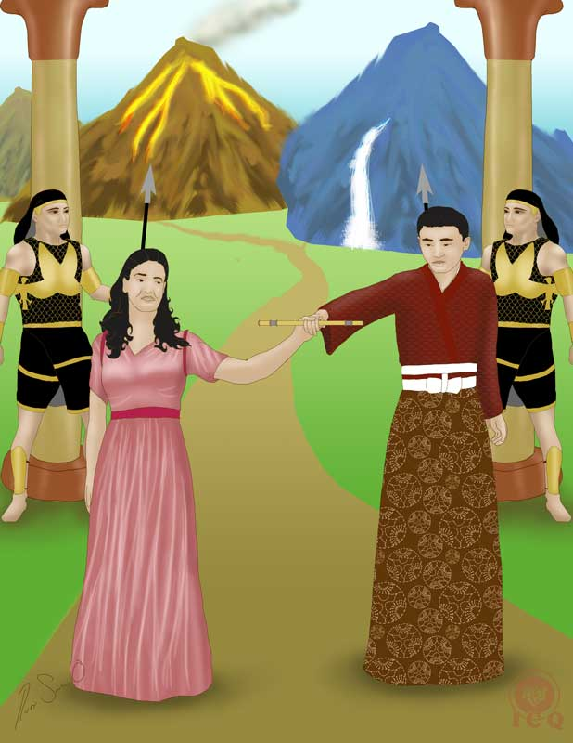

Men in battledress of black armor lead Prince Tamino before two mountains, one with a waterfall, the other spitting fire, and in their lore, their song guides us in the path that must be followed by the true aspirant of the light.

ARMED MEN
He who travels these laborious paths will be
purified by fire, water, air and earth.
If he overcomes his fear of death, he will
raise himself from earth, soar heavenwards!
in the light of this higher level he can
dedicate himself wholly to Isis’s mysteries.
(Mozart & Schikaneder, 1791)

Very elegantly, the Magical Flute tears the veil of the mystery and shows our duty, which is the work that must be eternally consecrated in the mysteries of the Divine Mother.

Overcoming the Fear of Death
The men wearing black armor battledress solemnly state that it is necessary to overcome the fear of death. One may think they refer to being courageous facing challenges, but in reality the message is much more profound.

In general, people are not willing to experience the “psychological death”; they are not willing to go through the efforts of observing, recognizing and eliminating their own psychological defects. Those who are willing to face their own mistakes are the ones who in fact overcome the fear of death. These guards refer to the first test Tamino must face, the Test of the Guardian of the Threshold, which is the same as facing oneself and be willing to “die” before all things that are illusory in nature.

The Three Tests of the Guardian of the Threshold are only a fraction of the work that must be completed; the aspirant must afterwards complete the test of the Hall of Fire (where the internal bodies are purified) and then the four tests of the elements of nature; these last four qualify the level of morality of the seeker. Up to this stage of the work, the seeker is only an aspirant of the great work, and once the practitioner has their level of morality adequately qualified through the four tests of the elements, they become a true disciple of the Great Work.

The Four Tests at the Times of Ancient Egypt
The Great Master Jesus says: “Give ye not that which is holy to dogs, neither cast ye your pearls before swine, lest they tread them under their feet, and turning again, all to rent you”, an indication that we must achieve certain degree of moral preparation to receive the sacred mysteries. Such a preparation is reached by successfully completing four tests that are given to each one as part of our lives, but that in times past, were offered to the seeker while in the physical plane, exactly as Samael narrates:

I was incarnated in the sacred land of the pharaohs at the time of the Kephren dynasty. I learned in detail all of the ancient secret mysteries of the Ancient Egypt and I verily say unto you, I have never forgotten them.

At this time come to my mind some remarkable memories.

One afternoon, it doesn’t matter which, as I walked slowly over the sands of the desert and under the ardent rays of the sun, I crossed quietly and as if sleepwalking a street bordered with sphynxes and before the exotic stare of a tribe of nomads who observed me from their tents. As I reached the shade of one of the pyramids, I stopped momentarily to rest and patiently arrange the belts of my sandals. Once I was done, I moved with diligence to find the venerable entrance; I was longing for the opportunity to renter the vertical path.

The guardian, as usual, stood before the threshold of mysteries. It is impossible to forget his face of bronze and his prominent cheeks. The man was colossal… and on his right hand he carried his sword. The man was formidable and no doubt he had every right to wear the apron of the masons.

His questioning of me was severe:
‘Who are you?’ - ‘I am a blind beggar seeking for the light’
‘What do you want?’ - ‘Light’
(To transcribe the verbal examination would perhaps be too much for this chapter.)

Soon after and in with some degree of violence, all metal jewelry was taken from me, just as they removed my sandals and my tunic.

And what was the most interesting about all of this, was the instant that herculean man grabbed me by the hand to walk me inside the sanctuary; it is unforgettable the moment the heavy door pivoted on its iron hinges generating that mysterious DO of the ancient Egypt. Then what took place, the macabre encounter with the ‘terrible brother’, the tests of fire, air, water and earth, it all can be seen by anyone who’s illuminated by looking into the memories of nature.

In the test of fire I had to control myself as best as I could, as I had to cross a room set ablaze; the floor was abundant in flaming red iron beams and the pathway between glowing iron pendants was very narrow, there was barely any space to set your feet; and back then there were many aspirants who perished during this initial effort. I still remember with horror the magnificent ring of iron that had been affixed to the stone, while at the distance you could only see the tenebrous horrific precipice; and yet, I emerged victorious from that test of air; where others perished, I walked out triumphant.

I has been many centuries and I still have not forgotten the sacred crocodiles of the lake; if it had not been for the magical conjurations I would have been devoured by those reptiles, as it happened to many others. Many unfortunate ones were crushed by boulders on the test of the earth, yet I emerged victorious as I stared with indifference to the two boulders that threatened my existence as they closed-in upon me, as if threatening to turn me into cosmic dust.

I am certainly not more than a worm dwelling on the mud of the earth, yet I emerged victorious. This is how I returned the path of the revolution of the consciousness after much sufferings. I was received amongst the college of initiates, the ceremony was solemn as I was dressed with the tunic of white linen worn by the priests of Isis and on my chest, was hung the Egyptian TAU cross.
(Samael Aun Weor, 1969)

The Same Tests, Here and Now
These tests of the four elements continue to happen today within our current reality and they still have the same objective which is to determine the spiritual level of the student, and there is no need for the student to become a hermit and seclude themselves in the forest or perhaps become cloistered and join a monastic life. These tests are administered as part of the events of our daily lives, which is why the master Helena Petrovna Blavatsky states in her teachings there is no need to become secluded from society; the battlefield is life itself.

“Don’t think that by living in the dark jungles, in prideful retirement and seclusion from men, and neither believe that nourishing yourself off roots and herbs and quenching your thirst with the snow of the mountains; don’t think, devotee, this will take you to the final liberation.”
(Blavastky, 1889)

There is no need to abandon your home or leave society behind, to the contrary, this path is lived by learning to live consciously within the family nucleus, by taking care of our daily chores as the path lies within them; this is why this path of initiation is also known as the “path of the domestic home”.

The esoteric gnostic work is that of changing at every moment of our lives, transmuting from moment to moment; we must learn to see the opportunities life offers for our enlightenment at work, at school, in the shop, or out in the country.

It is not by running away from life and its problems how we walk into the path of enlightenment, but confronting them, as in “grabbing the bull by the horns”; when we live life intensely and in a way that is both conscious and dignifying, life itself becomes the initiation.

Woman, Love and Gnosis
Decided, Tamino asks for the doors of mystery to be opened and for the tests to be applied, but in that moment where he is ready to walk into the chamber, he hears the voice of Pamina, begging of him to stop and wait for her. She is determined to be his companion. A priest guides Pamina and men dressed in armor allow Tamino to talk to her.

Oh joy and happiness, she will be my companion,
No destiny will separate us, even before the face of death!

The Magical Flute shows that both men and women have the same possibilities to walk the path of initiation, because what must take place has nothing to do with gender, but with spiritual qualities; a woman who fights against fanaticisms (symbolized by the night) and who is willing to disintegrate her defects (death) is certainly capable of entering the path, which is why they all sing in unison:

A woman who is afraid of neither night nor death
Is certainly deserving of becoming an initiate.
(Mozart & Schikaneder, 1791)

- The woman has the same rights as the man does.
- The woman also becomes an Adept of the White Fraternity.
- Joan of Arc is a Master of Mayor Mysteries of the White Fraternity.
- H.P. Blavatsky, author of ‘The Secret Doctrine’ became an adept and is a Master of Mayor Mysteries of the White Fraternity.
- In almost all of the temples of Mysteries, we find Women-Adepts, working intensely for humanity.
(Samael Aun Weor, 1953)

A woman should never be underestimated in any way, as she can reach the very same spiritual levels a man can reach; within her intimate nature, she carries special and powerful attributes.

The woman is the most beautiful thought of the creator, turned to flesh, blood and life.
Samael Aun Weor

Tamino and Pamina find each other full of happiness. He shows her the doors of mystery, tells her the initiation will be difficult and that many tests await them.

The Initiate must always live life heroically and victorious, as the heroes of Rabelais, with no weaknesses.
Samael Aun Weor

Pamina then extraordinarily indicates it is the force of love, the power all-capable of penetrating all things, what will enable achieving victory.

Everywhere I shall
be at your side.
I myself shall lead you;
love guides me.
taking him by the hand
Let it strew the path with roses,
for roses always go with thorns.
You play the magic flute;
may it protect us on our way.
One enchanted hour it was carved
by my father out of the deepest heart
of the thousand-year-old oak,
amidst thunder and lightning, storm and tempest.
Now come and play the flute;
let it guide us on our grim path.
(Mozart & Schikaneder, 2011-2016)

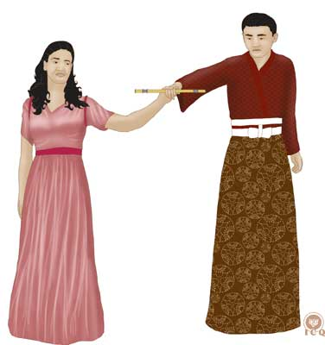
The marvelous force of love, which can help overcome all obstacles and make us impervious to the thorns of problems, is what allows us to comprehend the majesty within all that exists.

Yet we must merge love and wisdom as these are the two columns of the White Lodge. Gnosis is represented by the symbol of the Magical Flute because as we play it, or “as we live the teaching intensely in every moment”, it allows us to transcend the difficulties of life.

The Magical Flute was carved by Pamina’s father, namely “the Father who is in Secret”, as gnosis is the wisdom of the Being and of the Spirit as a divine particle within each one of us. The flute was carved from the depths of a millenary Holm Oak, which we should understand as a symbol of the Tree of Life or the collective of the various parts of the being.

Pamina invites us to play the flute, which is the same as putting to practice gnosis as a timeless wisdom, because in the union of gnosis and love, there are no barriers love cannot overcome. It is the intense work upon oneself what allows us to develop the necessary qualities and virtues that empower us to confront the tests of life. These virtues have been represented in various symbols across various cultures and they are related to the four elements.

The Qualities of the Sphynx
The sphynx brings forth the four fundamental elements of nature: the fire represented by the claws of the lion, the air as the wings of the eagle, earth as the legs of the bull and water as the human face. These are the same four elements represented in the gospels, because the apostle Luke is always presented next to a bull, Mark to a lion, Matthew to an angel and John to an eagle.

The sphynx shows us the qualities that are necessary to pass the tests of the four elements of nature, thus we must become like the sphynx: its superior qualities must become an integral part of us here and now.

The man must embody the four characteristics of the sphynx: the claws of the lion as his courage and nobility; he must be tenacious as the bull – represented by the bull legs, the wings of the spirit – represented by the wings of the eagle, and the intelligence of the Man – represented by the head of the sphynx.

Man must learn to stand serene before his worst enemies. Man must learn to be tenacious in all of its endeavors and not faint and falter before the inconveniences that will inevitably arise. Man must display the majesty of the eagle to never succumb before its own mistakes. Man must learn to develop its intelligence so that he can know how to adapt himself, without difficulty, to the different circumstances of life.

When the man has developed these four characteristics of the sphynx, he demonstrates he is ready to go through the four tests of the elements of earth, fire, water and air. It is through these four tests that the morals of the disciple are examined. This is thus, a symbolic exam that corresponds exactly with the level of morality of the disciple.

Those who have not developed serenity will not pass the tests of fire. Those who succumb before a financial failure will not be able to pass the tests of air. Those who have developed neither altruism nor the ability to adapt to the circumstances of life, will not pass the tests of water. Those who have not learned to be tenacious will not pass the tests of earth.

The sphynx is man himself. Man must earn the wings of the eagle, the intelligence of Man, the claws of the lion and the tenacity of the bull. These four characteristics of the sphynx are what allows him to pass the four tests of earth, fire, water and air.
(Samael Aun Weor, 1950)

The Test of Fire
Holding hands, Pamina and Tamino walk towards the mountain spewing fire, they walk across threatening flames and are spared from harm because Tamino plays the flute.

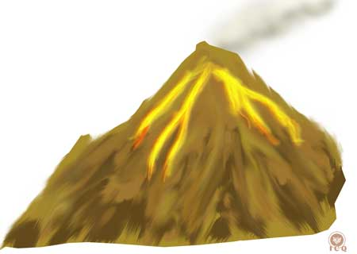
A succinct analysis of the element of fire suggests we must be “energetic”, spiritually strong, void of weaknesses, and certainly not easy to anger. The tests of fire seek to have the student demonstrate they have acquired the necessary serenity and sweetness of character to deal with the various circumstances of daily life. Of course, this becomes impossible for as long as we continue giving free reign to the various psychological aggregates of anger we carry within.

Simple direct observation of any given day will be enough to show how often we fail these tests. If we are running out of time and about to be late for work or school, we immediately become impatient and get angry with anyone around us. The moment events turn in a different direction than what we had planned, we explode in bouts of anger. Traffic congestions, our stressful lives, social commitments, are just some of the things that when not knowing how to approach and live them consciously, become an obstacle for us to transcend this test.

It is correct for us to act with severity at one time or another, but this is very different to being cruel, which is very common on the way we treat animals, our children and lamentably these days, even our parents.

Whenever you find yourself in dreams (the astral plane) being persecuted, slandered or insulted, whenever you see yourself being sacrificed to the max and you react in anger, it is because here in the physical plan you have not been able to acquire the claws of the lion that stand for that spiritual strength and nobility. Thus we must be alert and focus our work in the identification and comprehension of the aggregates of anger.

Those who do not know how to remain serene will not pass the ordeals of fire, because during that test the disciple sees himself persecuted, slandered, insulted and sacrificed to the max. It is logical that if the disciple allows himself to be overtaken by anger and reacts violently against its enemies, the result will be a failed test. In addition, without the faculty of serenity, the disciple will react horrified before the fire. So it becomes necessary to learn to overcome anger. The choleric will not be able to pass the test of fire.
(Samael Aun Weor, 1950)

The Test of Air
Meditating in the characteristics of air and equating them to those qualities that would be beneficial to us, we come to discover that in the same way air travels to and fro, without attachments, so should the human being learn to live life in contact and harmony with their material belongings, but without the attachments we have developed.

Material things are certainly necessary, and we must work to earn them as we need food, clothing and shelter. Every human being needs a home to live and certainly has the right to own one – and if it were possible for them to also add a flower garden, then so much better. But this is very different from the attachments we have developed for all material things; for many, all they require is to see a small scratch on the door of their car for them to suffer terribly. The same happens with our clothing; there is no wrong in enjoying our favorite garments, but what is not acceptable is the string of negative emotions that we manifest when something happens to our favorite garments.

Love is the most powerful force of the universe and as such, it is an integral ingredient for us to make a radical internal change. We can never be against love as that would be a grave mistake. We must all learn to love our spouse, without reservations and integrally, even reaching the heights of adoration itself. We must learn to love and honor our parents, just as we must be willing to give our lives for our children; but none of this is “attachment”. When we have attachments and we feel we cannot let go, what exists there is selfishness, vanity, fear and pride. In realty for as long as there is attachment, true love is unable to manifest.

So when life presents us with the loss of someone or something and we become desperate, it is obvious we have not earned yet our wings of the eagle, the wings of the spirit of the sphynx. Whenever we find ourselves in the astral plane, the realm of dreams, and we see ourselves falling into an abyss and reacting against it, we are failing this test.

Those who are afraid of the abyss will not pass the test of air. It is logical that any individual who suffers in desperation before a financial ruin or a failure of any nature, will fail the test of air, will tremble horrified the moment they see themselves tossed into a bottomless abyss.
(Samael Aun Weor, 1950)

The Test of Earth
In the element of earth, rocks show us fundamental stability and in the sphynx, these are the legs of the bull. This firmness equates to the tenacity that is necessary to make the most of the different adverse circumstances of life.

In our laziness we dream about a life without problems, we would like an ideal world tailored to our fantasies so that under those conditions, we could then work upon ourselves. We like to think that we would be able to help humanity if we only had so much more money in our bank account, just as we tend to think that the day we retire we will then have enough time to dedicate ourselves to the practice of gnosis.

These are all illusions of the mind and justifications to not do the necessary internal work; life is the psychological gymnasium where we can know ourselves and we must learn to see that which is good in what we think is bad, just as much as seeing that which is bad in those things we see as good.

The great master Jesus showed us this path the time he was walking with his disciples and they came across a dog that had died and was decomposing; different than the apostles, who negated the situation by focusing on what they disliked, the great master was capable of seeing and admiring the whiteness of the dog’s teeth.

Each moment of our lives bring forth a marvelous opportunity for the internal work and when things appear to be the most difficult and complicated, having the necessary alertness would allow us to make a correction to our behavior, as we would have the opportunity of discovering some of our most unsuspected defects; and if we were to comprehend them in detail, we would be able to see them eliminated and make progress in our path.

When we have earned the legs of the bull of the sphynx, we have developed the tenacity that is necessary to make the most of our most difficult circumstances in life. It is then that we can find ourselves in the realm of dreams and receive the test as we confront two mountains that threaten with crushing us. If one becomes desperate, afraid, or cries, we will fail this test and demonstrate we have not yet learned to capitalize on the adversities of life.

Those who have not learned to be tenacious and make the most of the worst inconveniences will tremble horrified the moment they see two great mountains closing upon themselves to crush them.
(Samael Aun Weor, 1950)

The Test of Water
Pamina and Tamino make themselves ready to walk up to a mountain that has a waterfall and with infinite faith and emotion they tell the magical flute:

We have walked through flames,
fought the danger bravely.
May your sound protect us in the floods
as it has in the fire.
(Mozart & Schikaneder, 2011-2016)

Just like water adapts its shape to the shape of its container, we as humans must learn to adapt to the various circumstances life offers. It is indispensable to give shape the head of the sphynx, a symbol of intelligence, so that we can develop the capacity to adapt to every circumstance of our existence; to learn to live in the country as well as in the city, in richness or poorness, in what is simple as much as in what is complicated.

There are many people who know nothing about esoteric knowledge, and yet they have learned to live without complaints and rather than rebelling before the many different situations they come across, they adapt just as water adapts; thus these people are closer to initiation than any other student who spends countless hours in the library studying books without applying any of the knowledge they are acquiring.

Those who have earned the head of the sphynx have developed the necessary intelligence to learn to live any event and circumstance in life without complaining; complaining about the government, or their parents, or their children, or money, or life, etc. It is then that they are put to the test in the astral plane and see themselves floating in the middle of the ocean, with no chance of survival; those who give up on their efforts fail the test, an indication they still have plenty more to learn how to live.

Those who have not learned to be altruistic or who have not learned to adapt before the difficult circumstances of life, will be terrified before the threat of drowning during the test of water.
(Samael Aun Weor, 1950)

Pamina and Tamino cross the waters and because he plays the magical flute, the waters do not hurt them, they descend to ascend again, and emerge triumphant from the test.

It is here they once again emphasize the need to live gnosis (playing the flute) in every instance of our lives. Whenever we apply the gnostic postulates to our circumstances in life we carry forth the necessary wisdom that will allow us to adapt to the various changing conditions we may face.

Their descent and ascent are an indication that before any exaltation there will be a humiliation. The student must learn that before we ascend, we must learn to willingly and willfully face the challenges that come from the descending itself.

Chelas or Lanus
As Pamina and Tamino pass the tests, they come across an illuminated temple and with emotion they exclaim

PAMINA, TAMINO
You gods, what a moment!
The joy of Isis is granted to us!

CHORUS OF PRIESTS
from within
Victory! Victory! You noble couple!
You have overcome the danger,
the consecration of Isis is now yours,
come, enter the temple!
(Mozart & Schikaneder, 2011-2016)

Those who successfully complete these four tests are accepted as a disciple of the White Lodge; in Sanskrit they are known as Lanus and in Tibet, as Chelas, which translates as “child” or “beginner in esoteric studies”.

Something similar happens to the gnostic student as portrayed in the Magical Flute. After the successful completion of each one, the student is received in the hall of children (initiates) to celebrate their victory before the test and enjoys a celebration with music and flowers.

Once the four tests are completed, the aspirant is accepted as a disciple of the white brotherhood and receives a cape in the astral plane and a jewel with the ray to which he belongs; the cape distinguishes him across the universe as one who is capable of receiving the teaching without disrespecting it and from that point forward, any master or angel would be able to teach them things that are transcendental.

Certainly it is a long path to initiation, but these celebrations are an indication that the disciple has indeed started.

Chaper 12 – Papageno and Papagena
Act Two, Scene 9

Aside from what is happening with Pamina and Tamino – those who follow the path of initiation, Papageno finds himself on a garden, sad, as he has lost his Papagena. He acknowledges the loss comes as his own fault, because of his actions and ways of being, and with little consolation, he calls her by blowing his panpipe.

PAPAGENO
calling with his panpipe
Papagena, Papagena, Papagena!
Little wife, little dove, my pretty!
No use! Ah, she is lost!
I was born for misfortune.
I have been chattering, and that was wrong,
and so I am getting my deserts.
Ever since I tasted that wine ...
since I saw the pretty little woman,
my little heart has been burning,
with twinges here, twinges there.
Papagena, little wife of my heart!
Papagena, dear little dove!
It's no good, it is useless;
I've had enough of my life!
Death puts an end to love,
however much my heart is on fire.
He takes a rope.
I will grace that tree there,
tie my neck to it;
because life is not to my liking;
good night, false world.
Because you treat me ill,
sending me no pretty child,
it's all over, I shall die.
Pretty girls, think of me.
If in my misery one of you will
yet take pity on me before I hang,
well and good, this time I'll leave it at that!
Just call yes or no!
No one can hear me, everything's quiet!
So is it your will?
Papageno, up there smartly!
Put an end to your life.
Now I'll just wait, let's say
until we've counted one, two, three.
piping
One! ...
Two! ...
Three! ...
Right then! That's still how it is!
Since there is nothing holding me back,
good night, false world!
He goes to hang himself.
(Mozart & Schikaneder, 2011-2016)

Without a doubt, negative emotions toy with us and keep us bound to the Law of the Pendulum; for as long as we do not control those negative emotions, we will continue to live out of harmony and equanimity. What would be ideal would be to live “the life of the center path” as the Chinese refer to in TAO, but the lack of gnostic wisdom leads us to behave as logs floating randomly in the raging waters of existence.

We are slaves of mechanicity; if someone pats us on the shoulder, we smile; if someone slaps us, we slap back; if someone praises us, we feel happy but if someone hurts us with words, we feel terribly offended. We are machines subjected to the motions of the Law of the Pendulum and others can do with us as they wish.
(Samael Aun Weor, 2000)

Like many human beings, Papageno is far from the path of initiation and void of spiritual longings, and what worsens his condition is that he lives his life identified with his own sufferings which in turn, take him further away from finding happiness.

Karma is not the consequence of all our sufferings; but the actions that we take in ignorance are what take us down a path of self-destruction. It all depends of our attitude in life; if we choose to be defeated before we even start our battle, then defeat will be inevitable.

Papageno’s attempt at suicide is the failure of our emotional life. This failure comes to us because of our constant chatter, our abuse of the word, of our sexuality, our self-considerations, self-compassion, and our sense of defeat.

From the heavens, the Three Boys descend and stop Papageno’s suicide attempt. As his consciousness, they make him aware of his mistake as he comes to realize that the answer to his prayers has been next to him all along and yet, he has forgotten about it: his silver carillon.

PAPAGENO
I'm a fool to have forgotten those pieces of magic!
takes out his glockenspiel
Ring, chimes, ring!
I must see my darling girl.
The three boys fetch Papagena.
Tinkle, little bells, tinkle,
fetch me my girl!
Tinkle, little bells, tinkle,
bring me my little wife!
(Mozart & Schikaneder, 2011-2016)

Silver is the metal that symbolizes the woman and represents attributes of comprehension, love and kindness of our Divine Mother; all elements necessary for a good marriage… and just like Papageno, as a humanity we have also forgotten about those are attributes.

We must learn to play our silver carillon with enthusiasm; act with tolerance before our spouse by seeing their perspective and feeling and thinking as they do. If we are single, the presence of these attributes will bring us a partner and if for those already married, these attributes will lead them down a life of marriage in plenitude.

As he plays his silver carillon, he makes an invocation three times; his action gives us an extraordinary clue: every time we invoke the help of the superior forces of nature, we must always invoke three times.

The Three Boys bring his Papagena and leave her with him. As they ascend to the heavens they ask Papageno to look around and as their eyes meet, they are both filled with love and happiness.

Mantra for the Development of Clairvoyance
Among the many secret teachings offered by the Magical Flute, Mozart gives us a mantra (a word of power) for the development of clairvoyance during the initial interaction of Papageno and Papagena; both of them, filled with enthusiasm vocalize: “Pa, Pa, Pa, Pa, Pa, Pa, Pa”.

A mantra is a wise combination of sounds purposed to help us at a physical, animic and spiritual level. Sound is what gave birth to the universe and as such, the word carries an intrinsic amount of great power. When we couple the right use of the word with a state of physical, mental and emotional relaxation, we will certainly gain extraordinary benefits.

Clairvoyance is the translucent of the soul, a faculty that exists in potentiality that allows us to see the ultra of nature, but to develop this faculty, we must first eliminate anger.

The syllables MA, MA, PA, PA, BA, BA are the very first syllables we articulate as infants. With these syllables we can start our path to initiation. Chant them assuming a state of being infantile and innocent. In Mozart’s Magical Flute you can learn how to intonate these syllables.

Mozart added these syllables to his marvelous work.

Lull yourself seeking to become an infant, remembering the initial years of your life and mentally intoning the sacred syllables. The word PAPA is vocalized intoning the first PA at a high pitch and the second PA at a lower pitch. Articulate the syllable PA many times and repeat just as much with the syllable MA.

Lull meditating in your childhood. Relive with your imagination all of your childhood. Mentally chant these sacred syllables.

Know that all children are clairvoyant until four years of age. Soon afterwards the atoms of clairvoyance sink into the Subconsciousness. If you want to reconquer your lost clairvoyance, mediate in your infancy and lull yourself articulating the first syllables MA, MA, PA, PA, BA, BA.

Meditation and the sacred syllables will awaken the infantile atoms of clairvoyance. It is then that you will raise in imaginative knowledge. You will learn to think in living images. This race only thinks in terms of concepts and ideas. Ideas are the results of desires.

When some man wants to conquer the love of a woman, he starts coming up with ideas. Ideas belong to the ‘self’. You will learn to think with vivid images. Meditation in your infancy and the sacred syllables will awaken your infantile atoms to start a new round of activity.
(Samael Aun Weor, 1960)

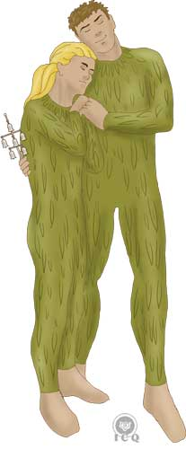
The encounter between Papageno and Papagena is one full of joy and happiness, they come together in a powerful embrace and immediately invoke the heavens asking for a little Papageno and later, a little Papagena, knowing very well these will be the greatest blessings for them.

This coming together is a teaching in positive clairvoyance; it becomes necessary to be as children, to be innocent as children, to end with all mental formations that make us astute and perverse, for as long as we are prone to anger, we will damage the harmonious development of this faculty.

106. Clairvoyance is imagination. Clairvoyance is the most beautiful flower, the most simple and most pure of spirituality.
107. When we conquer our lost infancy, then all the images that come to our minds are accompanied by vivid astral colors.
(Samael Aun Weor, 1953)

Positive clairvoyance is presented in the Magical Flute because the translucent of the soul is the very first step towards initiation. Samael insists by saying: “Imagination, Inspiration and Intuition are the three obligatory paths to initiation.”

There are three scales we must develop through daily meditation; first we develop creative, positive imagination (which must not be confused with fantasy), then wisdom based on inspiration and last, intuitive wisdom.

Chapter 13 – The Temple of the Sun
Act Two, Scene 10

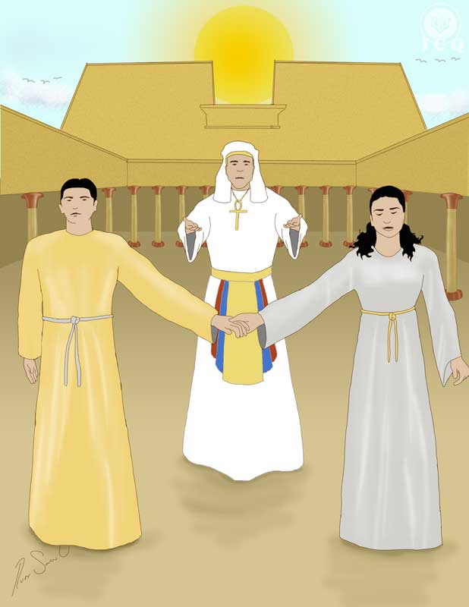

As we have come to see, the Magical Flute reminds us that we are the architects of our own destinies and that we choose the existence we choose to live; life is not more than the aggregate consequences of our actions; as the Apostle Paul says: “what you reap is what you sow”.

Initiation is only for the very few who are decided to work intensely upon themselves and willing to selflessly help others and yet, we have also come to comprehend that if someone chooses to not seek for their interior path, then there is nothing wrong with that; for as long as they are not committing offenses against others, they can live their lives in plenitude. But those who choose to follow the mistaken path, those who lie, hate, steal, adulterate, deceive, etc., with no doubt, as they sow lightning, they will reap storms for their lives.

In this last scene, Monostatos as a symbol of lust, anger and greed, unites forces with the Queen of the Night (fanaticism, ignorance and error) and the Three Ladies (the incorrectly used sexual creative power) to destroy the temple of the Sun.

The Queen of the Night has promised Monostatos (our animal impulses) the hand of Pamina (the virtues and values of the soul). They seek to enter the temple to dethrone Sarastro…

There let us surprise them,
wipe the bigots from the face of the earth
with burning fire and strong sword.
(Mozart & Schikaneder, 2011-2016)

The Ray of Cosmic Justice
They enter the temple decided to exterminate all the devotees; a scene that shows us the times in our lives where we have no room for mercy and justice. Monostatos, the Queen of the Night and the Three Ladies break in with an apparent advantage in the battle.

But once they are inside the temple, thunder and lightning become the indication that the Ray of Cosmic Justice is present to bring all actions to equilibrium. Every good deed is rewarded just as all negative action has its consequences.

It becomes necessary for people to understand the meaning of this Sanskrit word ‘karma’. Dear friends there is a law called the Law of Karma and allow me to say that word by itself means the Law of Action and Consequence. Obviously there is no cause without an effect and no effect without a cause.

The law of the scales, the terrible law of karma, governs all of creation. Every cause becomes an effect and every effect becomes by itself a new cause.

You must comprehend what is the Law of Compensation. Everything done must be paid-for, as there is no cause without effect and no effect without a cause.

We have been given liberty and free will and thus we are free to do as we please, but it is clear we must hold ownership for all our actions. Any action in our lives, good or bad, has consequences. The Law of Action and Consequence governs the flow of our lives and each life is a consequence of the previous one.
(Samael Aun Weor, 1978)

Nothing escapes the law, as the law exists within each and every one of us; sooner or later we will receive exactly what we give. We cannot hide from the law and when we act against truth and justice, the law, akin to a bolt of lightning, fulminates us leading us to fall into the abyss.

Our strength is shattered, destroyed,
we are all plunged into eternal night!
(Mozart & Schikaneder, 2011-2016)

The Death of the Ego
The demise of Monostatos, the Queen of the Night and the Three Ladies is the symbolic end of the consequences of our negative deeds and it is also a symbol of the need we have to experience a mystical death that would eradicate the inhumane aspects of our nature.

This part of the drama allows the characters to also be a representation of other symbolic dimensions; Monostatos is clearly the psychological ego, he is the Goethe’s Faust, the Black Magician Klingsor of Wagner’s Parsifal, just as he is also the Egyptian red demons of Seth, and the Lords of Xibalba of the Maya underworld.

The Queen of the Night takes the aspect of the negative fire, which is the tempting serpent in the Garden of Eden; she is the demon Mara who fought the Buddha in the Buddhist traditions; in the Aztec story of Huitzilopochtli she is his murderous dark sister Coyolxauhqui. As a temptation, the Queen of the Night is the origin of the ego.

The Three Ladies are a symbol of the three traitors of the Christ; the demon of desire (Judas), the demon of the mind (Pilate) and the demon of ill will (Caiaphas), but they are also a symbol of the three daughters of Mara who tempted the Buddha, as well as the three traitors who murdered Hiram Abiff, builder of the temple of Solomon.

The collective of these teachings tells us that the path of initiation is intimately related to the death of our defects; anything we do with the intent to reach illumination, if it is not related to the death of the ego is a miserable waste of time.

The Temple of the Sun
In the Temple of the Sun, Sarastro, Pamina and Tamino symbolize the Innermost and its two souls, the Human that is masculine and the Spiritual, which is feminine. In Kabballah they are CHESED (the Innermost or the Spirit), GEBURAH (the Divine Soul) and TIPHERETH (the Human Soul). In India these are ATMAN, BUDDHI and MANAS; all three dressed in ritual garments.

These garments are symbols of the superior existential bodies that are necessary for the manifestation of the Innermost, just as they are also a symbol of the moment the aspirant is accepted as a disciple in the ranks of the White Lodge. Soon after the disciple would have to undergo the ordeals of the Probationary Path and later-on three great stages of perfection called the Three Mountains, but nevertheless has achieved marvelous progress, which is that of becoming part of the White Lodge.

On this scene, the Three Boys also appear next to the perfect trinity and that is because the awakened consciousness must be “present” to reach the pinnacle of the self-realization of the Being. Sarastro verbalizes the way in which we must face the battles against the internal forces of the darkness:

The sun's rays drive out the night,
destroy the ill-gotten power of the dissemblers!
(Mozart & Schikaneder, 2011-2016)

The way in which we fight the negativity of our internal darkness is by our actions of diffusing and sharing the light of immortal wisdom with this ailing humanity.

We find the same teaching in the gospel of Buddha where he states:

Just as the rays of the Sun sweep the darkness of the world, the one who perseveres in their search for wisdom will find the Truth and Truth itself, will illuminate him.
Siddhartha Gautama

And the same teaching is also offered by the Great Master Jesus the Christ:

Know the Truth and it shall set you free.
Jesus

We do not get rid of the darkness by a show of hands, but rather by bringing the light, and neither have we vanished our errors by hand to hand combat, but by the diffusion of Truth with no need to attack the error itself. For as much as Truth progresses, mistakes retreat; thus we must not resist evil, but unconditionally practice what is right and show we must, the advantages of such practice. When we attack our errors, we foster the hatred of those who also make the same mistakes and just like that, they will eventually turn evil. When we attack the wrongdoings of others we only incite their rancor and in turn those who are evil, will become worse. What we must do is diffuse the light so that darkness will dissipate.
(Samael Aun Weor, 1964)

The Supreme Crown
Our ultimate end is the incarnation of our blessed Ancient of Days; the Mercy of mercies, the Kindness of all kindness, our Father who is in Secret represented by the KETHER (Crown) of the kabbalah.

This is the Crown referenced in the book of Revelations when the Apostle John transcribes the words he receives in vision: “remain faithful until the end and I will give you the crown of life”; when we follow and live the gnostic teachings, as we remain faithful to the immortal wisdom, it becomes obvious that we can incarnate the most elevated part of our Being.

This crown is also Arcanum 22 of the Tarot; our goal is to incarnate the Truth and return into the Light. That is our Great Work and the reason why we are here today; we must return through the same door we exited, but if we were walked out as a spark of light, we must make the effort to return as a flame full of spiritual power and with the light of wisdom actively manifest in each particle of our Being.

Our mission is that of walking through the darkness in which we are now trapped by virtue of our psychological aggregates and direct ourselves into the light of wisdom; this is all work that ends with the incarnation of the Crown of Life, which is why the chorus at the end of Mozart’s work says:

Hail to you on your consecration!
You have penetrated the night,
thanks be given to you,
Osiris, thanks to you, Isis!
Strength has triumphed, rewarding
beauty and wisdom with an everlasting crown!
(Mozart & Schikaneder, 2011-2016)

Just like a drop of water becomes one with the ocean, our ultimate achievement must be that of integrating and becoming one with Divinity, and the path to achieve that is living our lives as the path to initiation; our guides are our Innermost (Osiris) and our individual and particular Divine Mother (Isis).

The words of wisdom state that when the student is ready, the teacher shows up; if we happen to be among the fortunate who come across Gnosis in our life it is because we have reached a level of spiritual maturity to walk the path of life itself. In your hands you have the Magical Flute of Gnosis; start walking your path with love and courage…

Appendix A – The Path of Initiation

The Trials of the Guardian of the Threshold
Each one must face oneself and recognize their own mistakes;

- The Guardian of the Astral Threshold: recognition of our desires.
- The Guardian of the Mental Threshold: reflection of our mental delinquencies.
- The Guardian of the Causal Threshold: reflection of our ill will.

The Trials of the Hall of Fire

The Tests of the Four Elements
The aspirant must go through the tests of Fire, Water, Air and Earth. These tests are meant to measure their Level of Being or their level of Moral Quality. The successful completion of these tests qualifies the practitioner as a Disciple (Lanu in Sanskrit and Chela in Tibetan). The teaching of the Magical Flute focuses on these four basic levels.

The Probationary Path
Consists of nine initiation of Minor Mysteries; in this stage the real work has not yet started as the practitioner is still being put to the test. This probationary path qualifies the level of love of the aspirant; each initiation requires the completion of certain tests and demands certain level of development of the practitioner’s virtues.

The Test of Justice is the stage where the disciples see themselves physically insulted and unjustly accused. The main requisite to pass this test is that of holding and expressing true love for those who accuse and insult.

The Test of Dyrene is the final test of the Probationary Path where the disciples demonstrate they are ready to overcome any temptation; there is no room in superior mysteries for those who adulterate.

The Three Mountains
This is where the work truly starts and it is divided in three stages or purifications.

- Initiation. There are eight great initiations of Major Mysteries. These are the ones that result in the creation of the superior existential bodies of the Being and where the degree of ADEPTUS of the White Brotherhood is achieved.
- Resurrection. In the Second Mountain, the Adept realizes the first nine works of Hercules, all associated with the destruction of undesirable psychological aggregates from deep within the consciousness.
- Ascension. In the Third Mountain the Adept completes the final three works of Hercules. This is work of the most superior nature and is only for Great Initiates.

Appendix B – The Gnostic Myth
Analysis of the work of Mozart from the perspective of the elements that make of it part of the myth of Gnosis. This appendix is directed to advanced level students.

The characters that both specifically address the gnostic myth and complement each other are the following: 1. Supreme Divinity; 2. Emanation and pleromatic fall; 3. The Architectural Demiurge; 4. Pneuma in the World; 5. Dualism; 6. Savior; 7. Return.
(Samael Aun Weor, 1974)

Supreme Divinity
The Supreme Divinity, unknowable but to itself and unmanifested, because of these specific attributes, in some instances is represented by Sarastro and in when referred-to as intangible forces, by Osiris and Isis.

Emanation and Pleromatic Fall
Teachings have seven interpretations; when speaking of the origin of the world, the dragon-serpent is the ELOHIM. They chase Tamino as they precipitate the essences (or monads) into the tridimensional realm of creation because of their imperfections. This is the symbol of the pleromatic fall or the emanation off the Absolute: the essence (Tamino) arrives lacking wisdom (i.e. with no arrows). It then connects to the primordial chaos or cosmic night (The Queen of the Night), and from her, the emanation of the three primary forces of creation (the Three Ladies).

Architectural Demiurge
Clearly defined in the hymns of praise to Osiris and Isis. This is the dual divinity, the creative ELOHIM, Lords of the Light (Dhyan Chohans) and internally, our internal Father-Mother.

Pneuma of the World
Pneuma is “spirit” or “soul” symbolized by Tamino in his fights and in his incessant work to successfully complete all his tests.

Dualism
Clearly presented by the entities of the darkness in the forms of the Queen of the Night and Monastos and in the aspect of the light, Sarastro.

Savior
The incarnation of the divine gnosis, when lived from moment to moment, enables us to manifest these superior forces that ultimately lead us to defeat of the ego and leads us to salvation.

Return
Upon completion of all the tests in the path of initiation, Tamino and Pamina receive their ritual garments and the Temple of the Sun opened its doors before them; this is the crowning with eternal wisdom and the return to the light.

Appendix C – The Twenty Two Arcana of the Tarot in the Magical Flute
The hermetic wisdom of the arcana of the tarot is present in the Magical Flute, whether in the symbols of the characters, the sound of its music or explicit in both dialogues and songs. The 22 arcana give us the keys to the path of initiation.

Arcanum 1 – The Magician: The Father, the Ancient of Days; Osiris amongst the Egyptians. This Arcanum is present in each of the hymns of the Magical Flute.

Arcanum 2 – The Priestess: is represented by the Divine Mother Isis, the unfoldment of Osiris, present as that which is “most sacred”.

Arcanum 3 – The Empress: The Magical Flute is based on this specific Arcanum; Three Boys, Three Ladies, three Temples. The attributes of Arcanum 3 are reflected in Pamina as a principal character.

Arcanum 4 – The Emperor: This is the Arcanum of mercy and is present in the aria of forgiveness intoned by Sarastro when Pamina begs for her mother.

Arcanum 5 – The Hierophant: the law of Karma symbolized by Sarastro when he designates Papagena as the complement of Papageno, when he separates Pamina from her mother and when he orders the punishment of Monostatos.

Arcanum 6 – The Indecision: the Lover of the Tarot represented by Papageno who is both indecisive and flirtatious.

Arcanum 7 – The Triumph: this is the chariot of war in which Sarastro arrives, a symbol of the dominion over the forces of nature.

Arcanum 8 – Justice: Tests and Patience. We see these in the armor of both guardians at the threshold of the mountains where the tests of the elements are to take place.

Arcanum 9 – The Hermit: Initiation; this Arcanum is present throughout all of the play as it is symbolized by the work of initiation, but it is also present on the nine peculiar sounds in the overture and played again during the tests of initiation.

Arcanum 10 – Retribution: This is the Wheel of Lives and Deaths that is symbolized in the 10 years of difference between the ages of Papageno and Papagena. It is also present in the ups and downs of the tests of water and fire.

Arcanum 11 – Persuasion: This Arcanum is notable in the scene where Papageno and Pamina defeat Monostatos and his minions; they are able to dominate them only with the chime of the bells in the silver carillon, which is a symbol of love, comprehension and persuasion.

Arcanum 12 – The Apostolate: This is the sacrifice for humanity demonstrated by the priests of Osiris, who are present to serve the characters without the expectation of anything in return for their service.

Arcanum 13 – Immortality: The Arcanum of Death, but obviously death of the ego.

Arcanum 14 – Temperance: Matrimony and association, present the duet of Pamina and Papageno as they praise the wonders of love between a man and a woman and how the power of love is capable of raising them to a state of divinity. It is also symbolized by the flute (gold, man) and the carillon (silver, woman).

Arcanum 15 – Passion: Represented by the character of Monostatos; this Arcanum stands for danger, lust and his color being black, associated to Typhon Baphomet.

Arcanum 16 – Fragility: the fulminated tower of the Tarot, law in action, the ray of justice defeating Monostatos, the Queen of the Night and her Three Ladies as they try to destroy the Temple of the Sun.

Arcanum 17 – Hope: represented by the scene where Tamino is in deep sadness, and transitions into a state of joy after playing the flute.

Arcanum 18 – The Twilight: These are occult enemies and black magic. This is represented by the scene where Monostatos stands and signs before the Moon under the enchantment of the Astral Light, exactly as the Arcanum depicts two canines howling at the moon. This Arcanum is also present in every action of the Queen of the Night and the Three Ladies.

Arcanum 19 – Inspiration: The image of this Arcanum is that of a man and a woman holding hands as they are irradiated by the light of the Sun, in this case, by Tamino and Pamina when they have the opportunity to come together.

Arcanum 20 – Resurrection: psychological death is necessary for the resurrection of the Spirt. This particular Arcanum is symbolized by the moment Tamino and Papageno are taken into the darkness of the night (death), as they faced the test of silence when lured into temptation by the Three Ladies. The arrival of the priests with torches (the light) symbolizes their triumph (resurrection) on this test.

Arcanum 21 – Transmutation: This is the Fool of the Tarot. We see this Arcanum is the character of Pamina, specifically at the time she goes desperate thinking Tamino has stopped loving her and in her despair, she considers committing suicide.

Arcanum 22 – The Return: Arcanum 22 is the Crown of Life that appears at the end of the play, when Pamina and Tamino (dressed in their ritual garments together with Sarastro) have triumphed by overcoming all tests, defeated the darkness and become crowned with “the Truth”.

In the Magical Flute, besides the twenty two arcana of the Tarot, we also find the seven petitions of the Our Father Prayer.

Appendix D – Comments from VM Samael Aun Weor

Any gnostic who would like to reach the wisdom that comes from Inspiration, must concentrate in music. Mozart’s Magical Flute reminds us of an Egyptian initiation; the nine symphonies of Beethoven and many other great classical works amongst them Wagner’s Parsifal, will raise us to Inspirational Wisdom.
Revolution of the Dialectic

The disciple who seeks to reach inspirational wisdom must deeply concentrate in music. Mozart’s Magical Flute reminds us of an Egyptian initiation. The nine symphonies of Beethoven and many other great classical works raise us into the superior realms of consciousness.

As the disciple concentrates in music, he must allow himself to be absorbed into it as the bee to honey, product of its own work. When the disciple has reached inspirational wisdom, he must them prepare himself for Intuitive Wisdom.
Treatise on Criminology and Endocrinology

The Initiate loves the music of the great masters and feels repugnance for vulgar music, which only denigrates the personality. The Initiate loves the music of great composers, as for example Mozart’s Magical Flute that reminds of an ancient Egyptian Initiation.

The Soul holds communion with the music of the spheres whenever it listens to the symphonies of Beethoven or the ineffable melodies of Chopin…
The Perfect Matrimony of Kinder

The Church of Ephesus is located between the sexual organs and the anus. This is the coccygeal church. Within this church the sacred serpent lies dormant, trapped within its stillness and awaiting the supreme moment of awakening. The marvelous serpent awakens with the magic of love. Mozart’s magical Flute reminds us of the profound mysteries of the sacred serpent.
Message of Aquarius

109 – We must comprehend what is music, happiness and optimism.
110 – We remain in ecstasy when we listen to Mozart’s Magical Flute, as it reminds us of an Egyptian Initiation.
111 – We become overwhelmed when we listen to the nine symphonies of Beethoven, just as when we listen to the ineffable melodies of Chopin and Liszt.
112 – The ineffable music of the great composers comes from the exquisite regions of Nirvana, where only happiness reigns, beyond the boundaries of love…
Igneous Rose

The disciple who seeks Inspirational Wisdom must concentrate in music. Mozart’s Magical Flute reminds us of an ancient Egyptian Initiation. The nine symphonies of Beethoven and many other great classical compositions raise us to the superior realms. The disciple must concentrate in the music and must allow himself to be absorbed into it as the bee is to honey, a product of its own work.
Esoteric Treatise on Tarot and Kabballah

Bibliography
Bhagavad-Gita, n.d. Srimad Bhagavad-Gita. [Online]
Available at: http://www.bhagavad-gita.org/
[Accessed 1 January 2017].
Bhikkhu, T., 1997. Dhammapada. [Online]
Available at: http://www.accesstoinsight.org/tipitaka/kn/dhp/dhp.06.than.html
[Accessed 7 August 2016].
Blavastky, H. P., 1889. THE VOICE OF THE SILENCE. 1992 ed. Pasadena, CA: Theosophical University Press.
Geneva Bible, 1599. BibleGate.com. [Online]
Available at: https://www.biblegateway.com/passage/?search=1+COR+10%3A13&version=GNV
[Accessed 25 March 2017].
Geneva Bible, 1599. BibleGate.com. [Online]
Available at: https://www.biblegateway.com/passage/?search=1+COR+10%3A13&version=GNV
[Accessed 25 March 2017].
Geneva Bible, 1599. BibleGateway. [Online]
Available at: https://www.biblegateway.com/passage/?search=1+Cor+3%3A2&version=GNV
[Accessed 11 January 2017].
Krumm-Heller, A., 1930. Esoteric Rose. October 1, 1998 ed. s.l.:Kier Editorial.
Mozart, W. A. & Schikaneder, E., 1791. Dmitry Murashev Opera Site. [Online]
Available at: http://www.murashev.com/opera/Die_Zauberfl%C3%B6te_libretto_English_Act_1
[Accessed 29 December 2016].
Mozart, W. A. & Schikaneder, E., 2011-2016. Operas Arias Composers. [Online]
Available at: http://www.opera-arias.com/mozart/die-zauberfl%C3%B6te/libretto/english/
[Accessed 25 March 2017].
Samael Aun Weor, 1950. The Perfect Matrimony. 2002 ed. Mexico: Transcribed by Instructors of the Quetzalcoatl Cultural Institute (ICQ).
Samael Aun Weor, 1950. The Perfect Matrimony of Kinder. 2002 ed. Mexico: Transcribed by Instructors of the Quetzalcoatl Cultural Institute (ICQ).
Samael Aun Weor, 1951. The Zodiacal Course. 2002 ed. Mexico: Transcribed by Instructors of the Quetzalcoatl Cultural Institute (ICQ).
Samael Aun Weor, 1953. Igneous Rose. 2002 ed. Mexico: Transcribed by Instructors of the Quetzalcoatl Cultural Institute (ICQ).
Samael Aun Weor, 1956. Major Mysteries. 2002 ed. Mexico: Transcribed by Instructors of the Quetzalcoatl Cultural Institute (ICQ).
Samael Aun Weor, 1959. Logos, Mantra, Theurgy. 2006 ed. Mexico: Transcribed by Instructors of the Quetzalcoatl Cultural Institute (ICQ).
Samael Aun Weor, 1959. The Yellow Book. 2002 ed. Mexico: Transcribed by Instructors of the Quetzalcoatl Cultural Institute (ICQ).
Samael Aun Weor, 1960. The Aquarian Message. 2002 ed. Mexico: Transcribed by Instructors of the Quetzalcoatl Cultural Institute (ICQ).
Samael Aun Weor, 1963. Matrimony, Divorce and Tantra. 2002 ed. Mexico: Transcribed by Instructors of the Quetzalcoatl Cultural Institute (ICQ).
Samael Aun Weor, 1964. Christmas Message of 1964-65 - The Dissolution of the I (title given by students). 2002 ed. Aguascalientes, AGS, Mexico: Transcribed by Instructors of the Instituto Cultural Quetzalcoatl (ICQ).
Samael Aun Weor, 1964. The Social Christ. May 2002 ed. Mexico: Transcribed by Instructors of the Quetzalcoatl Cultural Institute (ICQ).
Samael Aun Weor, 1969. My Return to Tibet - Christmas Message of 1969-1970. 2009 ed. Mexico: RenaSer Editors, Imperator Gomez.
Samael Aun Weor, 1970. Christmas Message 1970-71: Parsifal Unveiled. In: E. Marte, ed. Parsifal Develado. Mexico: Editorial Marte, p. 127.
Samael Aun Weor, 1970. Fundamental Education. 2002 ed. Mexico: Transcribed by Instructors of the Quetzalcoatl Cultural Institute (ICQ).
Samael Aun Weor, 1971. Christmas Message of !971-71: The Mystery of the Golden Blossom. 2002 ed. Mexico: Transcribed by Instructors of the Quetzalcoatl Cultural Institute (ICQ).
Samael Aun Weor, 1971. Christmas Message of 1970-71. 2002 ed. Mexico: Transcribed by Instructors of the Quetzalcoatl Cultural Institute (ICQ).
Samael Aun Weor, 1971. Mistery of the Golden Blossom. 2002 ed. Mexico: Transcribed by Instructors of the Quetzalcoatl Cultural Institute (ICQ).
Samael Aun Weor, 1973. Aztec Christic Magic. 2002 ed. Mexico: Transcribed by Instructors of the Quetzalcoatl Cultural Institute (ICQ).
Samael Aun Weor, 1974. Secret Doctrine of Anahuac - GnosticTeachings.org. 2010 ed. Mexico: Transcribed by Instructors of the Quetzalcoatl Cultural Institute (ICQ).
Samael Aun Weor, 1975. Treatise on Revolutionary Psychology. 2002 ed. Mexico: Transcribed by Instructors of the Quetzalcoatl Cultural Institute (ICQ).
Samael Aun Weor, 1977. Book of Lectures No. 7 - Alcyone and Negative Emotions. 2001 ed. Mexico: Transcribed by Instructors of the Quetzalcoatl Cultural Institute (ICQ).
Samael Aun Weor, 1978. Tarot and Kabalah. 2002 ed. Mexico: Transcribed by Instructors of the Quetzalcoatl Cultural Institute (ICQ).
Samael Aun Weor, 1983. Pistis Sophia. 2002 ed. Mexico: http://gnosis.org/library/pistis-sophia/ps109.htm.
Samael Aun Weor, 1999. Lecture: Love. In: ICQ, ed. Book of Lectures No. 8. Mexico: Instituto Cultural Quetzalcoatl.
Samael Aun Weor, 1999. Lecture: The Mystery of the Moon. In: Book of Lectures - No. 4. s.l.:Transcribed by Instituto Cultural Quetzalcoatl.
Samael Aun Weor, 1999. Why Do We Judge Others (Translated). In: ICQ, ed. Book of Lectures No. 1. Mexico: Transcribed by Instructors of the Quetzalcoatl Cultural Institute (ICQ), p. Chapter 9.
Samael Aun Weor, 2000. Lecture #12: The Law of the Pendulum. In: T. b. I. o. t. Q. C. I. (ICQ), ed. Book of Lectures #7. Mexico: Instituto Cultural Quetzalcoatl.
Sturluson, S., 1220. Wikipedia - Jörmungandr, the Sea Serpent. [Online]
Available at: https://en.wikipedia.org/wiki/J%C3%B6rmungandr
[Accessed 29 December 2016].

Devolution: descent or degeneration to a lower or worse state.
Fulcanelli (fl. 1920s) was the name used by a French alchemist and esoteric author, whose identity is still debated. The name Fulcanelli seems to be a play on words: Vulcan the ancient Roman god of fire plus El, a Canaanite name for God and so the Sacred Fire. (https://en.wikipedia.org/wiki/Fulcanelli)

